Chapter 5 - Breakdown of the Old Story, Birth of the New Story

“It is quite normal to fear what one most desires.” ~Eisenstein

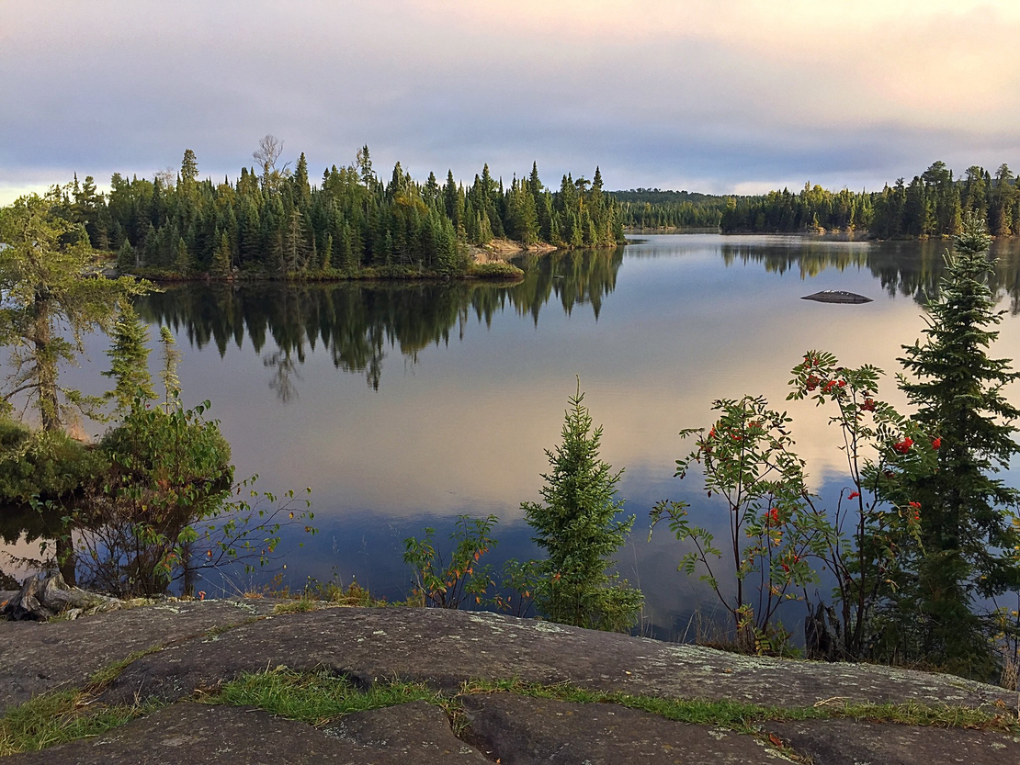
In the first three chapters we have been exploring the Old Story of Separation as opposed to the New Story of Interbeing in detail, and working with these stages of development and states of consciousness within ourselves.

Now let’s examine a little more closely the breakdown and death of the Old Story and the birth of the New Story – both in the world and, more importantly, within ourselves.

All of you in Minnesota are aware that the Federal Government has just stopped any copper mining operations in the Boundary Waters for twenty years. The mining companies are up in arms and have many arguments as to why their mining is cheaper and more environmentally friendly than importing from less developed countries. They rationalize and justify, minimize and deny, blame, and excuse their choices like all of us do when we are perpetrating to get our needs met. The argument in all these defenses is an appeal to choose the lesser of two evils.

In the story of separation, or duality, we are ruled by fear and so everything becomes a double bind. Everything becomes an evaluation of stacking up the cost and benefit of every choice. In every choice made from this state of consciousness you will suffer the repercussions of the karmic wheel of fate; what comes from fear creates more fear, what comes from unaware needs creates more and more needs, what comes from judgement and destruction creates more judgment and destruction. The arguments that support mitigating the damage done by mining (because "how we do it is better than how China does it") are short-sighted and rooted in fear and greed. There is only one long term solution: no more mining and raping of the land.

In the example of the mining operations in the Boundary Waters being stopped, can you see how frightening it would be to make a heart-centered choice for the common good of the environment and future generations? Can you see that this took the courage of the heart – a different state of consciousness? There will be pushback, anger, maybe even violence, deaths… And yet, by not succumbing to the old story of separation, long term solutions and creativity have a chance to emerge. Choosing from the heart results in long term good, not short term solutions. Biden making this choice might be an example of the shift in stories starting to happen.

Saying “No,” to mining in the Boundary Waters opens a gap – a space. It creates a rupture in the “way we do things,” and it creates short term upheaval in production of goods, jobs, and profits. The death of an Old Story is painful, and it creates short term difficulties and maybe even suffering. It also opens the necessity of thinking in a new way – a way in which no one and nothing is harmed. This is an uncomfortable place for humans to inhabit. And so, we resist living into the New Story.

If my ease and comfort come at the expense of the environment and other people, then it is unethical. So, to argue for mining in the Boundary Waters is to support an unethical position. In ego consciousness, or the
Story of Separation, this statement arouses rage and defense. From a Story of Interbeing and non-duality, it awakens excitement of possibility, wide circles of inclusivity and concern, creativity, co-operation.

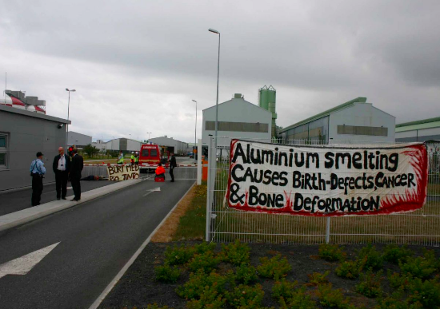
This is the same thing that has happened in Iceland in terms of aluminum mining. If you have not yet watched the YouTube video that Lorena sent, please do so. It is talking about the rape of the land to produce aluminum. This same story is being repeated and has been repeated in every part of the world.

Deconstructing the Old Story of “We have to have copper for all these reasons….” Means opening the deeper motivations of humans, the dark underbelly of fears and needs in the basement of our unaware souls. It is not comfortable. We resist. We fight back, we squirm and wriggle to avoid seeing. Why do we resist love, expansion, and creativity? Because we must face the reasons for the ways in which we have been living.

When we have the courage to allow our lives and motives to be revealed and laid bare, then, and only then, can a New Story be born. Only then can we become integrated and whole. Only then will the heart open to the creativity of what is truly possible on this planet, with all the beauty left unharmed, held as sacred, and loved. Remember this – the outer landscape reflects the inner state of consciousness of humans. We are one with our world. We ARE nature.

“The breakdown of the old story is kind of a healing process that uncovers the old wounds hidden under its fabric and exposes them to the healing light of awareness.” ~Eisenstein

EXERCISE:

Consider something you want with all your heart and then listen to the
- rationalizations
- yes, but’s
- justifications
- excuses
- denial
- and blaming
that occurs in your mind to not choose the heart. Is it a relationship? Is it a job? Is it something that wants to be heard deep inside? How are you blackmailed by fear, need, shame? Every act of perpetration against yourself, others, and the world is supported by these “rational” defenses.

Can you allow yourself to see this without judgment and relax into a more expanded state that seeks creative options? When you truly “see,” you will automatically stop all the arguments supporting your ego position. Then a gap of options opens up – a space of living in “not knowing” – until greater creativity is revealed to you through the heart. Can you pause long enough between your in and out breath to hear the voice of the sacred within?

Read the books The Wump World and Farewell to Shady Glade by Bill Peet, and buy them for every child you know.

Start researching copper and aluminum. Start being informed about the latest advances in the world of science so that you are not duped by the justifications of the Story of Separation. It is easy to be caught up in the dualistic arguments for and against, better or worse, and then to choose one of those sides, instead of making the choice of the heart that is non-dual and seeks the loving solution for all.

In your own personal life, how can you make a choice to not be a part of the Old Story in regards to copper and aluminum?

Read this article –

https://www.savingiceland.org/2017/02/a-nice-place-to-work-in-experiences-of-icelandic-aluminium-smelter-employees/

