Chapter 6 – The New Story of Interbeing – Principles

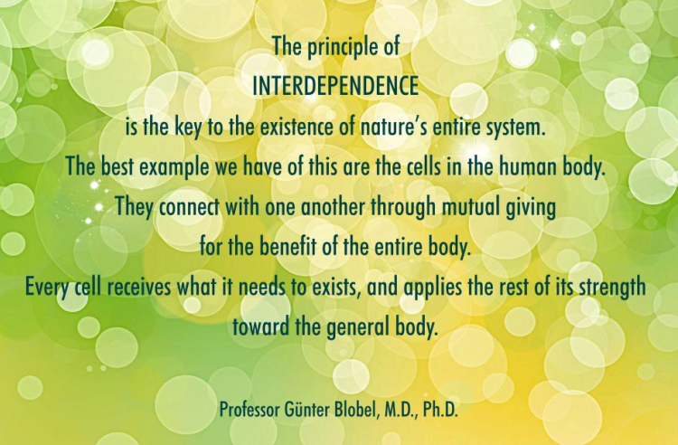

“We are not just a skin-encapsulated ego, a soul encased in flesh. We are each other and we are the world.”
~Charles Eisenstein, The More Beautiful World Our Hearts Know Is Possible

We have already explored some of the qualities of living a life in an expanded understanding of Interbeing, rather than being narrowly identified only with the functions and processes of survival of our physical being. We have explored how ego, is merely the soul identifying with the function of survival out of a young and limited understanding of thinking the function is the Self, instead of Self being aware of having the experience of duality – and all the emotions, thoughts, needs and behaviors that evolved because of being in a body. Living in duality is the experience of interpreting/judging experience, instead of KNOWING and accepting experience.

So, what are the principles and understanding of life when we have disidentified ourselves from function and use function in full awareness? Can we find a new creed of belief, even if we do not quite know how to live into it yet? What is it we believe in our New Story for the world? Listen to these songs by Deb Zemke and Alicia Keys and study this website – mutualresponsibility.org

https://www.youtube.com/watch?v=hFApWKZFMhE

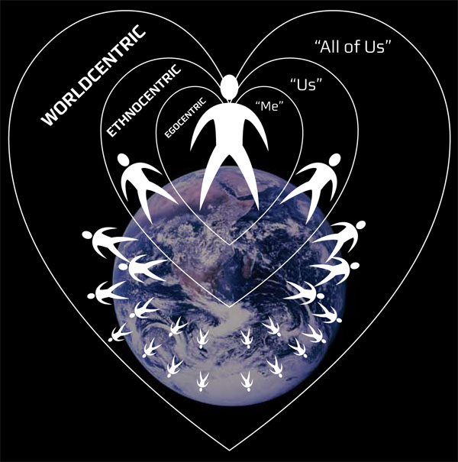
A New Creed – a New Pledge

- I believe that my being is interrelated with your being and all beings. I am related in every breath, thought, word, deed to everyone and everything else in the world and the universe.
- I believe that every thought, word, deed impacts not only me but others and the world
- I believe that I create separation and the illusion of non-relationship, and it is my responsibility to bring awareness to this divisiveness within
- I believe that every perception of the outer world reflects myself and must be related to with love
- I believe that relationship in love, harmony, joy and peace is the only purpose of Spirit
- I believe that Consciousness is inherent in Matter – it is not separate, it is One. I will strive in awareness to know myself as Consciousness incarnated as matter. I will realize that I am not just thought forms in matter attempting to control both matter and Consciousness.
- I believe that the relationship I have with myself is the same as the relationships with others and that I have a responsibility to be in right (loving) relationship with myself
- I believe that when I relate in love, all words, thoughts, deeds that arise from this state of Consciousness is my purpose in whatever form it expresses itself – in this way I am unique but not different
- I pledge to see all the ways in which I live in a dualistic, divisive, non-relational state of consciousness
- I pledge to understand and come to know what Love and Truth are in my lived experience
- I acknowledge that I do not know what Love and Truth are – what I have been taught is divisive and separates me from myself and others
- I pledge to become aware of all my addictions – what takes me up and out, away from pain, without awareness of the source, without relationship to the one who suffers within and without inner healing possible
- I pledge to stop judgment that idealizes self or other, or devalues self or other, acknowledging that “I would do what you do, if I were you.” My judgements create more judgments and more separation

“The state of interbeing is a vulnerable state. It is the vulnerability of the naive altruist, of the trusting lover, of the unguarded sharer. To enter it, one must leave behind the seeming shelter of a control-based life, protected by walls of cynicism, judgment, and blame.” ~Charles Eisenstein

EXERCISES:

- Read these beliefs and pledges carefully – can you feel your way into the beliefs -have you had experiences that let you know the veracity of these beliefs?
- Write your own creed and pledge for the pilgrimage and your life
- Start exploring stories of interbeing – think of the beautiful work of Sister Helen Prejean with prisoners – watch “Dead Man Walking.” What if your prisons were run with this kind of depth of love and insight?
- Share your own stories of interbeing and how you came to realize that you are one cell of the body if the universe. Consider this: it only takes one cancer cell to start the process of killing the body. How di you yourself turn in on yourself in hatred – it is this that can destroy the world.
- Consider if you were one of the cops that beat a young man to death in Memphis. Do you judge, or can you see those cops are you? Can you then relate to yourself lovingly. What would this look like? Do you feel superior to the cops, do you devalue them as humans? This is what you do to yourself. Find this dynamic within yourself and bring it into the light of love and truth. In a society that lives primarily in a paradigm of interbeing, how would the situation be dealt with?
- Read the quote below and then draw /paint the Tree of Life. What all will you include as part of the tree?

“A tree is alive, and thus it is always more than you can see. Roots to leaves, yes-those you can, in part, see. But it is more-it is the lichens and moss and ferns that grow on its bark, the life too small to see that lives among its roots, a community we know of, but do not think on. It is every fly and bee and beetle that uses it for shelter or food, every bird that nests in its branches. Everyone an individual, and yet every one part of the tree, and the tree part of everyone.”
~Elizabeth Moon, Oath of Fealty

“Interbeing: If you are a poet, you will see clearly that there is a cloud floating in this sheet of paper. Without a cloud, there will be no rain; without rain, the trees cannot grow; and without trees, we cannot make paper. The cloud is essential for the paper to exist. If the cloud is not here, the sheet of paper cannot be here either. So we can say that the cloud and the paper inter-are. “Interbeing” is a word that is not in the dictionary yet, but if we combine the prefix “inter-” with the verb “to be,” we have a new verb, inter-be. Without a cloud and the sheet of paper inter-are.
If we investigate this sheet of paper even more deeply, we can see the sunshine in it. If the sunshine is not there, the forest cannot grow. In fact, nothing can grow. Even we cannot grow without sunshine. And so, we know that the sunshine is also in this sheet of paper. The paper and the sunshine inter-are. And if we continue to look, we can see the logger who cut the tree and brought it to the mill to be transformed into paper. And we see the wheat. We know the logger cannot exist without his daily bread, and therefore the wheat that became his bread is also in this sheet of paper. And the logger’s father and mother are in it too. When we look in this way, we see that without all these things, this sheet of paper cannot exist.
Looking even more deeply, we can see we are in it too. This is not difficult to see, because when we look at a sheet of paper, the sheet of paper is part of our perception. Your mind is in here and mine is also. So we can say that everything is in here with this sheet of paper. You cannot point out one thing that is not here-time, space, the earth, the rain, the minerals in the soil, the sunshine, the cloud, the river, the heat. Everything co-exists with this sheet of paper. That is why I think the word inter-be -should be in the dictionary. “To be” is to inter-be. You cannot just be by yourself alone. You must inter-be with every other thing. This sheet of paper is, because everything else is.
Suppose we try to return one of the elements to its source. Suppose we return the sunshine to the sun. Do you think that this sheet of paper will be possible? No, without sunshine nothing can be. And if we return the logger to his mother, then we have no sheet of paper either. The fact is that this sheet of paper is made up only of “non-paper elements.” And if we return these non-paper elements to their sources, then there can be no paper at all. Without “non-paper elements,” like mind, logger, sunshine and so on, there will be no paper. As thin as this sheet of paper is, it contains everything in the universe in it.” ~Thích Nhất Hạnh

“The state of interbeing is a vulnerable state. It is the vulnerability of the naive altruist, of the trusting lover, of the unguarded sharer. To enter it, one must leave behind the seeming shelter of a control-based life, protected by walls of cynicism, judgment, and blame.” ~Charles Eisenstein, The More Beautiful World Our Hearts Know Is Possible

“When the sense of the earth unites with the sense of one's body, one becomes earth of the earth, a plant among plants, an animal born from the soil and fertilizing it. In this union, the body is confirmed in its pantheism.”
~Dag Hammarskjöld, Markings

