Chapter 7 – Cynicism and Insanity

“ … when you encounter a harsh, cynical critic (whether inside yourself or outside), remember that the cynicism comes from a wound. Then you might be able to respond in a way that addresses that wound. I can’t tell you in advance exactly how to respond. That wisdom comes directly from hearing with compassionate ears and being present to the hurting… the derision of the cynic comes from a wound of crushed idealism and betrayed hopes.” ~ Charles Eisenstein

Take a moment to pause and really think about this quote. Can you feel how the idealism, hope, passion, vision, boundless energy, and enthusiasm you felt as a child got squelched out of you? How did this happen? How were you taught to be “realistic?” Think of a story where this happened and share it with the other pilgrims. Realistic is a word used in the 2nd quadrant – in the story of separation. All kinds of rational explanations are given for why something is not possible. Living in the shadow, instead of the light of interbeing, is to live in the unaware darkness of “Yes but…” The interconnection is seen, but in the negative. For instance, a child says, “Let’s save the jungle in Borneo for the orangutangs.” Feel the energy, the joy, the love, the hope in that statement. Now listen to what the unaware egoic adult will say to the child….

We don’t have the power to stop corporations
We don’t have the time or energy it would take
We couldn’t get enough people to support that
If we don’t cut down the forests, we won’t have paper
If we don’t grow palm sugar instead of forests, we won’t be able to eat Nutella (The main ingredient in store bought Nutella is not cocoa powder or hazelnuts. It is palm oil and palm sugar which makes up over 50% of the product together with skimmed milk, whey, soy lecithin and vanillin – artificial flavor)
That is an impossible dream
Nice idea, kid, but totally impractical
Cutting down the forests gives lots of people jobs and if they didn’t have them then they would starve

These arguments represent spinning in cause and effect rooted in fear, helplessness, and despair, which is the exact opposite of interbeing which sees connections in love, that sees creative options, is willing to sacrifice for the greater good, and to work towards long-term solutions (giving up Nutella for instance) and is born of passion and love for the forests, for the orangutans, and for the people of Borneo.

Interbeing solutions are rooted in love and include everyone in the equations of long-term solution. Consider the passion and love of the forest, the people, and the land in Brazil, where over 2000 activists have been murdered and untold native people have been murdered to slash and burn the forests for cattle ranching. This is a dramatic sacrifice of life for long-term life of the planet. It is not just giving up Nutella or boycotting a corporation, which just salves our conscience for a while, but does not mean expanding to the realm of interbeing in love.

Can you see the two paradigms – the “yes but…” mentality of seeing short-term cause and effect, and the “yes, and …” mentality of seeing long term interconnection and creative options?

Now consider how you yourself say “yes, but…” out of fear and refuse to see a bigger picture for your own life, cannot think of creative options, will not take risks in the short term to have a long-term outcome of your vision and dream. It is no good projecting this mentality onto the world instead of doing something about it internally. Consider how often you have said, “Well, the jungles, whether Borneo or South America or the Congo, are not my problem and there is nothing I can do about it.” This is a projection. You are really saying that the wounds of the past are not your problem, and that you cannot do anything about them. Recognize the self-limitation by which you live your own life, cut down your own resources for short term pleasure, and put responsibility for your life onto others.

Clearly the only solution is an inner one. Find the cynicism and despair you have internally for your own condition and stage of development. Dig deep and go to the wound under the cynicism. Heal yourself – you are one cell of the world body. Make sure it is functioning optimally for the rest of the body, which means bringing the presence and awareness of who you ARE to the wounds of the past.

One of the ironies of the Story of Separation is the belief that we can and should change and control the environment and other people, and then when it doesn’t work to say, "I can’t change anything" and go to despair. Of course – the focus in the Story of Separation is external instead of internal. When the focus is internal, we find we have all the love in the Universe to change and evolve ourselves. Work through the cynicism which protects you from the inner wound – notice how you use it as defense to not do your inner work.

“Anything that exposes this wound will trigger us to protect it. One such protection is cynicism, which rejects and derides as foolish, naïve, or irrational all of the expressions of reunion.” ~Eisenstein

https://www.savingiceland.org/2017/08/icelands-troubled-environment/

The story of Separation, individualism, competitiveness, capitalism and so on, is rational and sane in the short term. The story of Interbeing is rational and sane in the long term.

We cannot argue the limited rationality of cutting down forests to provide jobs and produce food for people that are suffering in the immediate present – but it is insane to do this in the long term when everyone in the world will die and starve to death when all the forests have been obliterated and the world is dying. From this perspective it is entirely insane to cut down the forests.

However, when we live with limited awareness that cannot see long term, cannot see deeply into the layers of consciousness, cannot see interconnection, only cause and effect, and when the heart has not opened, then the vision of interbeing seems irrational, crazy and insane.

From the limited perspective of the ego, there is no capacity to see that there is enough food for the whole world if our hearts are involved and that there literally is no reason to rape more of the earth to produce more food.

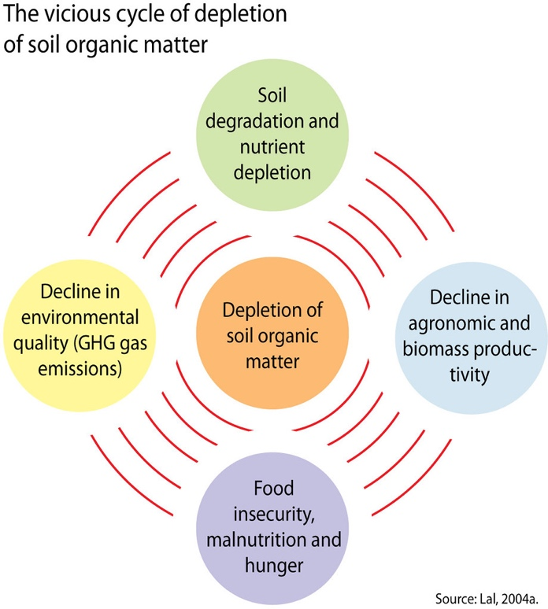
This kind of insane thinking happens everywhere. Think of the person who is depressed and goes to the doctor to get an antidepressant which produces side effects of weight gain and cholesterol and so goes to the doctor to get more drugs to counter-act these side effects that then produce more symptoms, that necessitate more drugs until the so-called cure kills the patient.

The root cause of the depression is never uncovered and dealt with. Symptom management is happening in every sector of society, but real presence and insight that could bring about a long-term cure is not even considered.

Consider the farming practices of insecticides to produce higher yields and more profits which causes cancer, which provides the means for new drugs to enrich the drug companies. Think of your own examples so that you can see the insane result of living in the head instead of the heart.

We are living in insanity – not an age of reason at all.

Exercises:

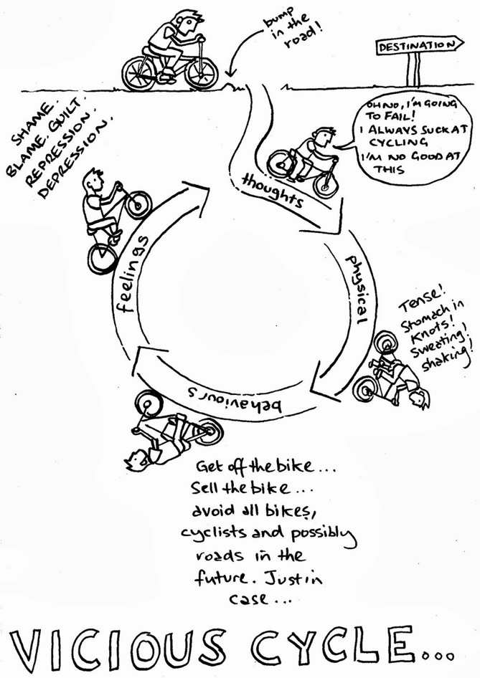
- Look deep within and find the vicious cycles you yourself insanely perpetuate within yourself. What do you do for short term gain, soothing of suffering, avoidance of responsibility? What have the long-term consequences been to your life? This is karma. What we do in unawareness results in more of the original problem. Shame begets more shame; fear leads to more shame. Draw a picture of your vicious cycles.

- What short-term sacrifice do you need to make for a long-term gain?

- Can you? Will you? If not, you cannot then be aware of your hypocrisy and ever again complain about what the health care system, or the legal system, or the educational system, or any other system, is doing

- Think of a way in which your vision, hope, energy was squelched and how it was done. What will you tell the inner child of yourself now to heal the wound and move forward with the vision, hope and energy you still have?

- https://www.savingiceland.org/2017/08/icelands-troubled-environment/ - Read this article on Iceland. If you had power, what would your social approach be to the problem of environmental degradation that is contributing to the demise of the planet? Think about whether you would be approaching this issue as an external or internal issue, and whether you would propose short-term and/or long-term solutions.

