Chapter 8 – Force – Power and Control

“You know,” he said, “sometimes all you need is twenty seconds of insane courage. Just literally twenty seconds of just embarrassing bravery. And I promise you, something great will come of it. ~ from the movie We Bought a Zoo

We have spent the first 7 weeks exploring Eisenstein’s first five chapters in more depth. We have reached the Chapter on Force. Have you been able to see how all these subjects are intellectually interesting, and notice the resistance to seeing how, in one way or another, you live this paradigm of separation every day? Are you starting to recognize when you say and act in the unaware ego (separation) column and when you are in the Soul (interbeing)? Are you able to bring them into relationship with one another lovingly?

My writing is for this purpose… to encourage you to take the teaching and apply the practice of witnessing, investigating, seeing, knowing how this paradigm works in you, so that you can be present lovingly and heal the separations within. Until we engage the practice of recognizing the paradigm of separation within ourselves in thought, word and deed, nothing can change in the world. It remains an unfulfilled vision and ideal.

In this chapter on Force, Eisenstein addresses the resistance we feel to expansion and why. We do not want to leave the safe, little bubble of power and control, self-limiting beliefs and defense that offers the illusion of safety, for something vast, unknown, and potentially dangerous from the limited perception of the ego. We must decide whether we will continue to live in an illusion of safety, or risk fulfilling a vision, hope or ideal for our lives. Will we risk all for something we do not know, but can only imagine for ourselves? Can we co-operate with the Grand Design before the old paradigm of our lives presents the decision to change in more dramatic ways? The karmic result of living from shame and fear, split off from awareness, will create more and more fear and shame and more and more defense until our ego lives crumble around us in divorce, death by alcoholism, destruction and fighting, distance and avoidance, and a thousand other ways. Inner separation from our wound creates outer separation and fragmentation of our lives.

Let’s look at the karmic cycle of cause and effect, the vicious cycle of destruction in our lives. And then let’s decide to face “twenty seconds of insane bravery” to change something in our lives.

An external threat is a need that is not met correctly in childhood.

It creates emotions of fear and shame

This results in a belief system of separation and disintegration of unity
e.g. “I am bad when…” “I am good if ….”

We act out of this belief system through mechanisms of force, or power and control to protect us from
being aware of the feelings, needs, and sensations of the body. It is so important to recognize that
our attempts to control, change, and blame others for our pain is an act of force and aggression, and it is what
we are doing internally to ourselves as well. We are blaming, attacking, controlling, trying to change and control the inner child’s feelings and needs. FORCE, as used by Eisenstein is Power and control which are the same as Fight and Flight, which are the same as Aggression and Passivity, which are the same as Perpetrator and Victim. All are tactics of defense against our own human experience of feeling and needing. As within, so without.

Let’s look and see what this looks like in the following example:

CONTROL BREEDS ITS OWN NECESSITY – Eisenstein

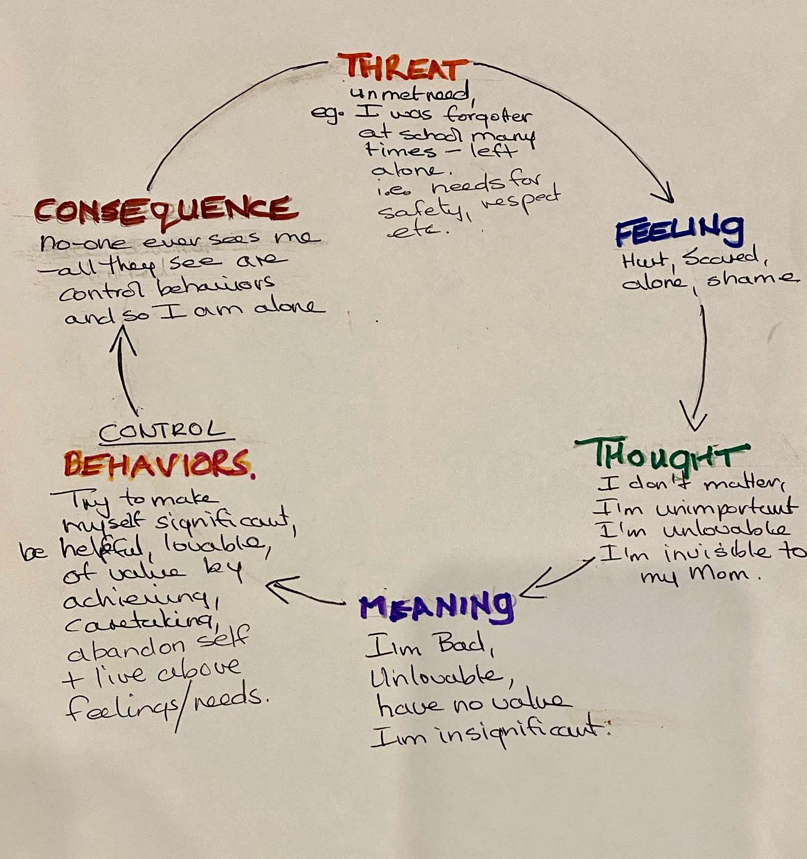

Now choose an example from your own childhood and see if you can create your own vicious cycle that you have continually lived all the way to the present. Where will you break the cycle? How have you recreated the same drama repeatedly, in complete unawareness? The example drawn here is highly simplified and uni-leveled – but it represents a good start to our investigation of our own ways of using force in the world.

For truly destructive Power and Control tactics, it is important to stop the behavior immediately and then work on the other links in the cycle of feelings, thoughts, meanings, and needs. E.g. violence, alcoholism, addictions of all kinds, suicide.

List defenses you are aware of and try to become aware of others you are not aware of – consult the chart below and see if you can identify some of them there.

Definition of Force/Defense

Defenses are tactics to control needs and feelings, or to overpower or avoid the perceived external threat.
Defenses are every behavior that:: 1. Protects us from external threat, real or imagined, and 2. Protects us from the full experience of how we have become the external threat internally in all the ways we learned to defend against our inner suffering of shame, needs, false beliefs. Defenses are learned in unawareness of the dynamic – they are instinctual movements away from threat – first externally, but then internally. The ways we find to do this are learned and cultural. They are all a desperate attempt to protect the young suffering soul. An animal knows only to Flee, Fight or Freeze. As humans we find many learned and highly intelligent ways of doing this and our brains have evolved to be able to do this. Every defense is a split away from experience – and so living in an unaware state in defense is the paradigm of separation and force about which Eisenstein is talking. The dynamics of defenses are all internal as well as external. Your unaware ways of using force internally result in the same tactics used externally.

Defenses – Behaviors in the Paradigm of Separation and Force

Fight Flight
Passive Aggressive
Defiance Compliance
Power over others Control of self
Perpetrator Victim

War and genocide Extreme pacificism
Plundering of resources Allowing it to happen
All -isms
All boundary violations
Homicide Suicide
Physical abuse against others Physical abuse against self
Emotional abuse of others Emotional abuse of self
Intellectual abuse of others Intellectual abuse of self
Sexual abuse of others Sexual abuse of self
Exploitation Addictions - substances
White collar crimes Caretaking
Advice giving (one-up) Enabling
Competitiveness to win over Perfectionism
Superior and idealizing self Inferior and devaluing self
Commanding Groveling
Projection and blaming Self blame
High achievement and winning Low achievement and losing
Judging, criticizing, controlling others Judging, criticizing, controlling self
Denial, minimization, rationalization, justifications, intellectualizing, fantasies of being saved, of ideal love, wealth and power, displacement, reaction formations, regression, sublimation, suppression, dissociation, avoidance, bargaining, altruism and helping, humor, people pleasing, impression management, hypochondriasis, somatizing, conversion of emotions to physical symptoms, obsessive thinking, compulsivity, whining, self-pity and acting the lame duck, good, right and perfect, brave, strong and stoic, acting the martyr, lying, cheating, stealing, perfectionism, procrastination, self-aggrandizing and boasting, self-entitlement, cold and callous

Sometimes it is easy to classify one thing as either Fight or Flight, but most often it is way more complex than that. If I kill myself, I am clearly turning against myself in a highly aggressive way because I experience myself to be the victim of others not meeting my needs. And so, it is the ultimate “fuck you” to everyone else too. And the other way around; if I am attacking you, it is because I am abandoning my own feelings and needs and so aggressing against myself as well. For example, if I continually self-criticize and condemn, I will do it to others when they exhibit the same behaviors that I internally hate about myself, and so on. See if you can find the ways in which your chosen defense is, at the same time, fight/flight/freeze.

All these behaviors will deplete all our inner resources and every time result in us feeling more alone, more shame, more fear, more hopeless, more out of control. And we are repeating this cycle internally and externally as well, as in the example of the pesticides and dieting examples in the book. Every defense is an addiction of temporary relief that has long term devastation to the body, mind, and soul as well as the planet. As Eisenstein says, “ … these escalating attempts at control eventually exhaust all available resources, whether personal, social, or planetary. The result is a crisis that the technologies of control can only postpone but never solve. And each postponement only depletes what resources are still available even further.”

Every defense is a form of dissociation from the emotions and body and every defense becomes addictive because it works for short-term escape from suffering but leads to long term destructiveness in every way.

“The process of dissociation (and any other defense) is an elegant mechanism built into the human psychological system as a form of escape from (sometimes literally) going crazy. The problem with checking out so thoroughly is that it can leave us feeling dead inside, with little or no ability to feel our feelings in our bodies. The process of repair demands a re-association with the body, a commitment to dive into the body and feel today what we couldn’t feel yesterday because it was too dangerous.”
~ Alexandra Katehakis

The Necessity of Defense

When we are little, our nervous systems are not mature, we do not have life experience, we have limited understanding, and we are in a state of self-referential consciousness that allows only for the interpretation of self as being the cause of experience in the world. When we experience the threat of our needs not being met correctly, we feel fear, we feel shame, and we believe the feeling means we are bad. The shame of believing ourselves to be worthless when we are traumatized is an annihilating experience for a child (annihilating of their sense of identity as good), and so they automatically defend against the experience within themselves through any number of tactics/defenses – from dissociation, to denial, to blame, to caretaking…. on and on…. to try to prove themselves worthy of being in the world. Until a human has the capacity for mature compassion and wisdom that can correct this inner dynamic while holding the suffering with equanimity, it is cruel and dangerous to rip away defenses. It is important to honor defenses until you can follow the formula below and be in a mature and loving relationship to the old wounds of the past. The goal is not to judge the defenses but to SEE THEM and how they are interconnected with every aspect of our inner being. The seeing will lead to the transformation.

Many of the defenses learned from our unaware fear of feeling shame are amazing accomplishments and not to be judged in any way – e.g., high achievement and accomplishment, scientific developments etc. The task is merely to be aware of MOTIVE – not necessarily to change the behavior. For instance, if you learned to get very good grades to get your parents approval, this is a wonderful accomplishment. All that we must see is that it was driven by shame and now can be done in joy as we meet our own needs for approval through inner relationship with our hurt child self. When we are not aware of motive, all our accomplishments will back-fire – literally. Think of your own examples. How have you achieved highly, but at the expense of your health, your family life, your own well-being, and the well-being of others? How have you achieved highly and yet people sense the neediness and underlying compulsiveness and so avoid you instead of meeting the need for approval? As you internally abandon yourself, so you abandon others.

Awareness of motive brings inner peacefulness, choice, balance, and sanity to our lives.

So what to do?

Turn inward.
Stop using force. The goal is not to judge and force control over the defenses, but to SEE THEM and how they are interconnected with every aspect of our inner being. The seeing will lead to choice, and the loving choice will be limit and transformation.
Be curious and investigate all components of the vicious cycle.
See, name, and validate the feelings.
Correct the meaning you made of the messages you received when your needs were not met.
Start meeting your own need for loving presence – you are the Love and Truth you are seeking.

