Chapter 10 – What is Sacred? What is Truth?

“Where then, do we find the Truth? We find it in the body, in the wood, in the water, in the soil. We find it in music and dance and sometimes, poetry. We find it in a baby’s face and in the adults face behind the mask. We find it in each others eyes, when we look. We find it in an embrace, which is, when we feel into it an increbily intimate act. We find it in laughter and sobs, and we find it in the voice behind the spoken word. We find it in fairy tales and myths, and the tales we tell, even if fictional. Sometimes embroidering a tale enlarges it as a vehicle for truth. We find it in stillness and silence. We find it in pain and loss. We find it in birth and death.”~Eisenstein

The “truths” of the world are all relative, not absolute. Every story, every map is only a small window into the vast and invisible Truth, that is the same as Love, that is the same as Consciousness. Dogma, beliefs, maps are all just representing a stage and state of consciousness – it is not Consciousness, just a small and limited understanding of a part of Truth. When we read sacred texts, we must always read them as myths about inner human dynamics, as symbolic, metaphorical, and about processes and of being human. To read them as literal and external “truths,” is a superficial and meaningless task, leading to all kinds of abuses.

Apparently my first prayer as a little girl started, “Gentle Jesus, meek and mild, look upon a little child.” It is a
famous poem by Charles Wesley. I changed it into "Gentle Jesus, milk, and Milo (chocolate powder for milk),
give to me, a little child.” So, clearly, I thought of this god person as someone nice and gentle who gave
me treats. My first understanding of the goodness of God was the hymn, “All things bright and beautiful, the
good Lord made them all.” I was very much in love with animals and flowers and nature, and so to me the
creator of all this was quite amazing. I am grateful for these young experiences because the doctrine,
dogma, and outright abuse from the religious institution later in life could have made me throw the whole
enterprise out of the window. However, what people said and what I knew in my young heart was not the
same, and it led to a life-long search for an understanding of what God is, what Love is, what Spirit is. All children have a universal and essential need for some kind of spiritual foundation of understanding that there is something beyond our physical experience, and that this is inherent within us as a basic goodness.

Repeatedly, as we ask people to find the essential, the pure, the love, the truth of their suffering, and awaken to bringing wisdom and compassion to it, we realize there is a pervasive spiritual bankruptcy. There is no inkling of what love is, what truth is, what spirit is, and no understanding that consciousness itself is the Force of God within. There is no realization that it is This from which life arises, and that it is within our own being. That it is this Spirit within that can hold and know and experience physical life in reverence, awe, and love. So, it seems important to look at the ways in which there was religious abuse in your lives and at least introduce the idea, vision, hope, that this Consciousness is within you. It is this that is eternal and that can be brought to the finite experiences of your life. It is this that is YOU.

You are one drop of the infinite sea of Love in which you swim and that moves through and in you, in which
you have your source and your ending. And it is this that you must recognize and bring to your human life
experience.

When you were a child:

- Were you taught and reassured that no matter what you did, no matter how the world treated you,
nothing could touch your intrinsic value.
- Did you learn you have intrinsic value or was it all conditional on achievement?
- Did you have any foundational teaching on Love, Spirit, God?
- Were you taught about a God of Wrath or a God of Love?
- Were you taught that you are bad, and God is good?
- Were you taught that the only way to heaven is through trying to be good, and that you would go to
hell if you were not good?
- Did you learn that God is out there - somewhere - separate from you?
- Did you learn that women were inferior and created from man?
- Did you learn that women are responsible for all the evil in the world?
- Did you go to Sunday School? Church? Were you confirmed into your religion? Did you have to state beliefs that you did not understand or believe, but had to state anyway?
- Consider what you learned about yourself from the religious teachings you received

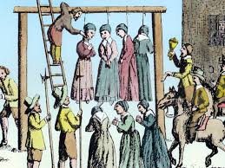

Consider the ways in which your spiritual boundaries were violated and how your spiritual needs were
not met, by examining the list and diagram below – All power and control tactics create inner separation from Truth and Love – from Spirit within

• living in a family that’s over religious
• excess of rituals in religion or no rituals in religion
• no spirituality, no spiritual guidance
• empty shell religion - prayer offered as mindless repetition or forced prayer
• no sense of prayer or gratitude
• excess of religious rules, anti-sex, anti-pleasure, legalistic religious practices, and inconsistent enforcement
• a fearful god image - punishing and judgmental - fear based religion - religious terrorism
• no sense of right and wrong
• not having our own or differing beliefs allowed
• being punished for rebelling against the family religious practices
• being punished for having the “wrong” religion or the “wrong” beliefs
• not being allowed to choose your friends because of their religious beliefs
• overzealousness, obsessiveness, and fanaticism
• being involved in religious hate, religious wars
• overly mystical
• being involved with cults
• anti-religious sentiments
• satanism and abuse
• living with no beliefs, no exposure to religious beliefs
• religious cynicism
• women-hate in religion
• religion as a form of pro-family activity that is anti-women and anti-child
• too much focus on a father-God image or having a father who acts as God in the system, and therefore our
image of God is affected by the behavior of our father
• a one-sided, gendered God
• religious wars within the family, religious intolerance
• excess of religious cliches
• over emphasis on evil, focus on the devil
• seeing children as evil, sinful, possessed, and bad
• puritanism - we are pure, chosen - evil must come from outside forces
• not seeing the duality of humankind as good with a potential for doing harm
• religious restrictions regarding gender, race or sexual orientation
• narrow and rigid interpretation of religious tenets and/or sacred texts
• religious extortion and exploitation
• being taught to believe in a meddlesome God of power and miracles rather than a creator of harmony and
balance
• isolation because of rigid, weird, or different religious practices
• religious leaders acting out, including seduction and sexual abuse
• denying the reality of the real people issues by religious leaders
• unapproachable ministers
• arrogant ministry
• over emotionalized religion
Adapted from Broken Toys Broken Dreams
~Terry Kellogg

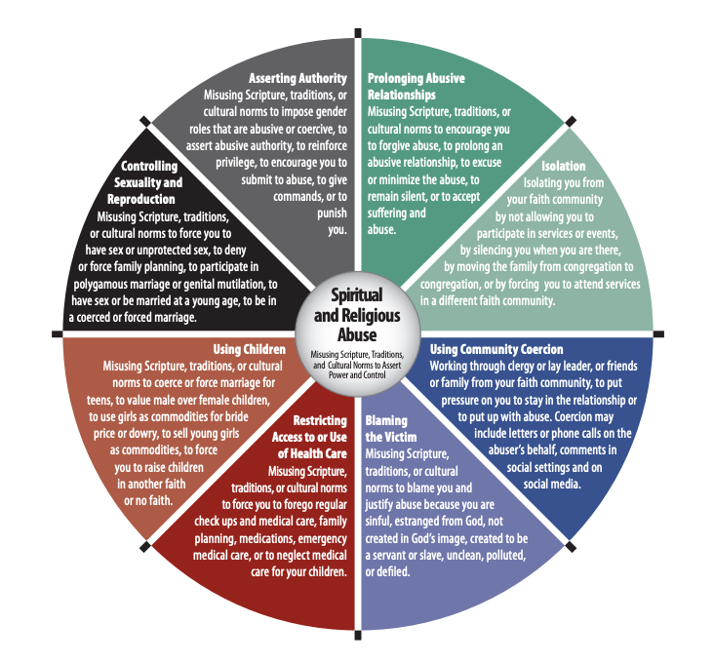

Exercises:

- Write a list that starts with, “I was separated from my Essential and True Self by these experiences that led me to believe that …………………………. and made me feel …………………….. As a result I ………………….. and so lived – and still live – in the Old Story of Separation instead of interconnectedness with the universe.”

- Journal about these experiences and share them with one another.

- Draw a spiritual timeline. How has your understanding of the Sacred (God), changed over time as your belief system has changed, and the story of your life has changed? How has your role in relationship to the Sacred changed? What is the New Story you now have? Write a statement of belief or Creed about the Sacred. This too is just a story because Truth, like Love, cannot be named. However, notice how this creed of belief is different to the one you would have written as a child. Writing this creed represents the next step on a ladder that, when you reach the top, you will discover never existed. What you seek is already attained. And yet, to realize this we must take the next step on the imaginary ladder.

I believe …

- Write and share about how, as your story changed about the sacred, you had to leave groups and people, and how this left you self-doubting, alienated, and alone on your journey.
Cherish this group – because, without support, old structures and ways of believing will pull you back into the crab pot of conformity to the old Story of Separation.

- How have these beliefs of domination and separation translated into the rape of the planet instead of reverence for every aspect of the Universe?

“Our efforts as healers and changemakers evolve as we go through the loss, the breakdown, the pain on a personal level. When one’s own personal subsector of the Story of Separation dissolves, one can see the story for the first time for what it is.” ~Eisenstein

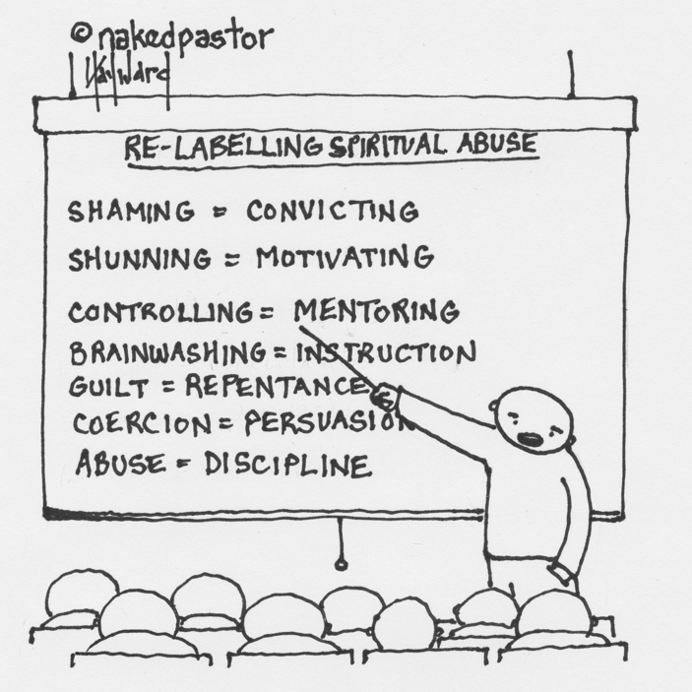
https://nakedpastor.medium.com/why-the-church-is-the-perfect-culture-for-spiritual-abuse-7caeb2d6b472

Read this article on the Old Story of Religion in which we were all raised. He offers a free guide for deconstructing old beliefs and how to survive this deconstruction!

https://www.youtube.com/watch?v=oGwTVbrzKs4 – watch this beautiful video

