Chapter 13 - Spirit and Evil

“Evil is a response to the perception of separation.” ~Eisenstein

In 1940, the world’s population was 2.26 billion people. During the Second World War between September 1, 1939, and September 2, 1945, 65 million people were killed.

I went to the National World War II Museum today in New Orleans with my 16-year-old grandson, Ethan. All the way through the experience, I felt the enormity of the horror of this stage of human development that represents a state of consciousness that is split off from its Source, floundering in self-destruction. Both the East and the West in the grips of evil megalomaniacs – destroyed and broken humans with an endless thirst for power rooted in childhoods of deprivation and abuse. I kept imagining my sweet, innocent, and naïve grandson being sent off to be bullet fodder for the psychopathic cravings of these men. And here we are, nearly 75 years later, still in the same hideous situation in the world.

Below is a map of armed conflicts/wars occurring in the world today. And let us not forget that the US is a nation at war with itself with over 100 mass shootings already this year.

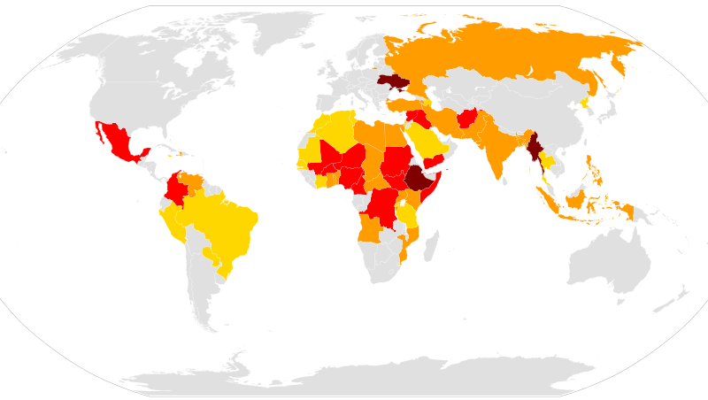

Map of ongoing armed conflicts (number of combat-related deaths in current or past year):

Major wars (10,000 or more)
Wars (1,000–9,999)
Minor conflicts (100–999)
Skirmishes and clashes (1–99)

We are currently, in general, at the stage of development where we can see all of this externally and be moved by it temporarily. We feign horror, sadness, and compassion. We have liberal agendas and wonder what we can possibly do, and then we forget about it all and fall back asleep. We pretend we are aware and see how awful it all is. But we do not. We do not see it within, we do not feel it within, and we do not change it within – and then it carries on, generation after generation. Change is a nice idea. World peace is a nice idea. Not exploiting the planet and the people of the planet is a nice idea. But nothing will change until we bring it inside of ourselves and know it internally. Use every ounce of your effort to recognize how you perpetrate against yourself and so victimize yourself – how you wage internal war that becomes an external war. Until we see this, we are lost. How do you indulge yourself, feel sorry for yourself, believe you are righteous, berate yourself, hate yourself and so do the same externally?

New Orleans is complicated, dirty, messy, struggling, charming, eclectic, for the most part liberal, with massive social issues. In-between the broken infrastructure, the filth and pollution, the drunks and drug addicts, the victims and perpetrators, are the beautiful, magnificent Southern Live Oaks.

Unlike most other deciduous oaks which drop their leaves in the winter and might look dead, live oaks lose and replace their leaves gradually throughout the year and so look "live.” Many are well over 200 years old, and they stretch their branches into vast canopies that shield the city from treacherous summer heat. The contrast of the human mess and the natural trees is stark and compelling. My gaze shifts from the human litter to the trees. Many are garlanded with streamers and beads from Mardi Gras parades, but they bear the indignity with good grace. If these magnificent trees were cut off from their Source, both in the soil and in the heavens, then they could not exist. They would die. And so it is for all of us. If we are not deeply rooted and aware of the nutrients in the dark underworld of our lives and are not able to synthesize the light of the Sun, we die. Can we be constantly shedding dead leaves and sprouting new leaves because we are deeply internally connected and fully aware of our dependence on the dark and the light to bring about new growth? Our own live greening depends on integrating the water and nutrients that are in the soil of our lives and synthesizing the radiance of Love that reigns down on us and has it’s rising within us. The mighty oaks of the sugan cane plantations have survived hundreds of years. The humans who were, and still are, split off from their suffering and also from their Light, have long since come and gone, and in this condition have caused nothing but more misery and suffering for the world. The oaks stand silent witness to it all, organically co-operating with the process of growth and providing a safe harbor for birds, lizards, microbes, insects, people and animals.

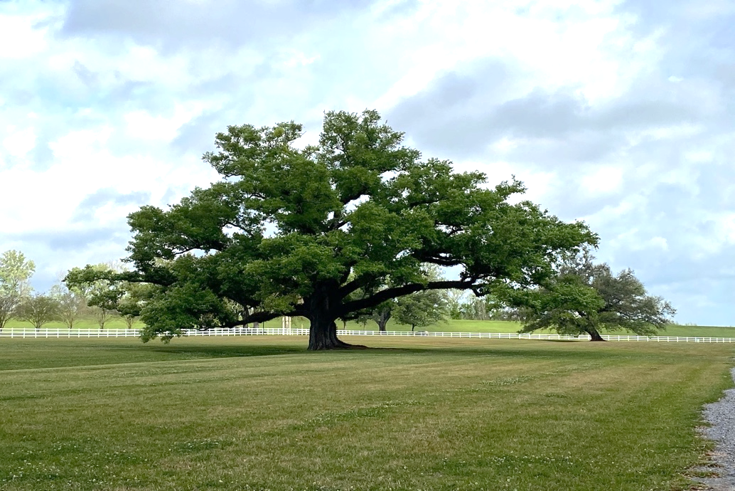
Oak Alley Plantation

A nation that destroys its soils destroys itself. Forests are the lungs of our land, purifying the air and giving fresh strength to our people." ~Franklin Delano Roosevelt
"I breathe in rain
I breathe out green"

EXERCISES:

Using the metaphor of the tree, consider how you are aware of using the nutrients from the ground of your life (your early years) for growth. Have you extracted every bit of food from the diet you were fed as a child? The earth is full of decay – it is the decay that makes it rich food for all of life. Have you brought the patterns and dynamics into awareness? How have you remained aware and connected to the radiance of Love within? How do you use this radiant light to synthesize and work with suffering to bring about new twigs and branches, leaves and flowers?

How are you aware of the process of growth through the integration of the underground, the earth, and the heavens in your own process?

Consider the tree as a symbol of yourself, as a symbol of the cross of dualities. Are you a dead cross or a live oak?

Write about all the “peak” experiences of your life, when you awoke briefly to the radiance of Love shining within yourself. When you felt a very deep sense of peace. A moment of complete joy. Everyone has had a moment when something external activated the remembrance of this state of Consciousness within themself – the birth of a child, falling in love, nature, a pet…. Consider the brief experience of the god within yourself and see if you can analyze how you distracted yourself from this awareness of yourself as Consciousness.

A simple meditative practice is to observe, describe and participate in your external world in some simple task, like cooking a meal. What do you observe (see)? Describe the seeing fully in terms of sight, smell, hearing, tasting, touching, and then participate fully with every aspect of the external task as you consider the internal experience you are having. Notice discrepancies. For instance, making a beautiful cup of coffee could evoke and awaken the inner simplicity, beauty, and joy of the experience, or you could be mindlessly distracted by thoughts and never observe, describe, or participate in the experience; in which case you are not ONE with the experience and the external world, you are alone, alienated, and suffering in your head. And then extend this practice to your interactions with others.

Consider how this is not domination of the environment, it is participation and connection with the environment – a collaboration in intimacy, an interbeing with all that is without and within. How could one be alone? How could one be lonely? The mighty oak is not alone in her field – she is deeply internally and externally connected, and is in a state of interbeing both externally and internally.

If you were a Live Oak, who all and what all would find shelter in your branches? What all would you know, and see, and experience? Unlike the oak, you are capable of being aware of the integration of heaven and hell within you. Unlike the oak, you are distracted from your natural processes of growth and get stunted and misled by thought.

Another simple meditative exercise:

A Meditation on Breath ~ by Arnoldo Garcia

I breathe in rain
I breathe out green
I breathe in wind
I breathe out sky
I breathe in laughter
I breathe out happiness
I breathe in her
I breathe out poetry
I breathe in daughters and sons
I breathe out hope
I breathe in words
I breathe out mountains
I breathe in sage
I breathe out clarity
I breathe in dust
I breathe out the bones of my people
I breathe in oppression
I breathe out liberation
I breathe in fire
I breathe out clouds
I breathe in ink
I breathe out veins
I breathe in Buddha
I breathe out Mexican

Like trees that breathe in carbon dioxide and breathe out oxygen, are we willing to breathe in oppression, feel it in every cell of our body in solidarity, love and empathy for all those that are oppressed, and breathe out – on a wing of heart prayer – liberation for all those oppressed? Can we transform the world with our prayer and intention?

Can we breathe in Buddha consciousness and breathe out the knowing of the oneness of all people united in their Buddha nature?

Use this beautiful poem as a meditation and expand it. What else do you breathe in and out?
Contemplate what the poet means and then write what your in-breaths and out-breaths will be today, so that the very cells of your body may be transformed by the love of your intention.

It's the little things citizens do. That's what will make the difference. My little thing is
planting trees.~Wangari Matthai

In considering the quotes by these amazing humans, do you feel curiosity about their lives, wonder how they got the wisdom they have? Do you feel like researching them?

Do you wonder what photosynthesis really means? Research this and find out how utterly miraculous the natural processes of nature are.

“What kind of people take refuge in sprawling suburbs? What kind of people work at jobs that satisfy no desire, but the desire for security? What kind of people stand passively by while their nation prosecutes one unjust war after another? The answer is: fearful people. Alienated people. Wounded people. That’s why spiritual work is political if it spreads love, connection, forgiveness, acceptance, and healing.” ~Eisenstein

