Chapter 14 – Lichen, Attention and Mindfulness
“Because of this delicate interconnectedness of life across time, space, and being, any littlest fragment of the universe can become a lens on the miraculous whole. Sometimes, it is the humblest life-forms that best intimate the majesty of life itself.” ~ Maria Popova

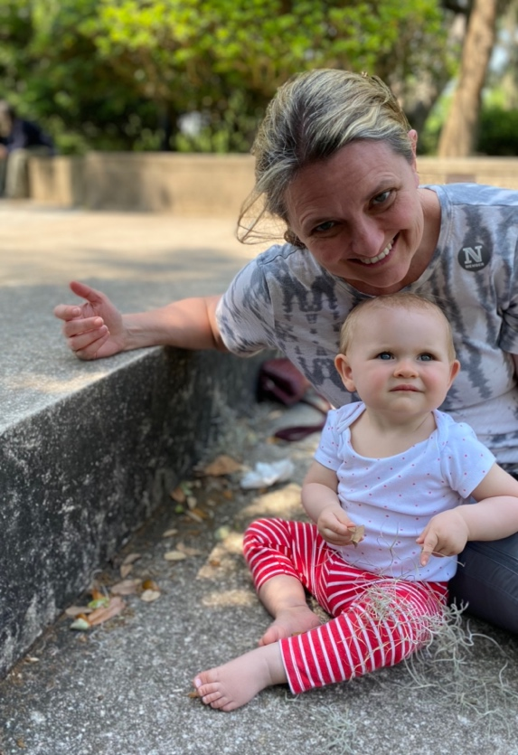
I sat on the steps going down to a lake in the sculpture garden in New Orleans, watching our granddaughter play with a long strand of Spanish Moss. She was totally absorbed, peaceful and calm. Her investigation of how it moved through her fingers lasted nearly half an hour. She didn’t know she was absorbed, calm, peaceful and in a state of consciousness that we all long to find again. She awoke in me, however the feelings that I had been feeling every time I looked at an Oak tree dripping with Spanish moss – awe, calm, peace, a sense of the ages, joy at the beauty, absorption as I listened to the bird song in the trees, and watched the little lizards running up the trunks – joy as I watched the shadow and light dance on the ground beneath the tree, wonder at the length of time they had been there. I could be aware that I was aware. What a gift, what a joy, to realize that in looking at the tree, it is you that is awake, joyful, calm. The awareness of this state of being is exponentially deeper and richer than being in this state but not recognizing it in you, as you.

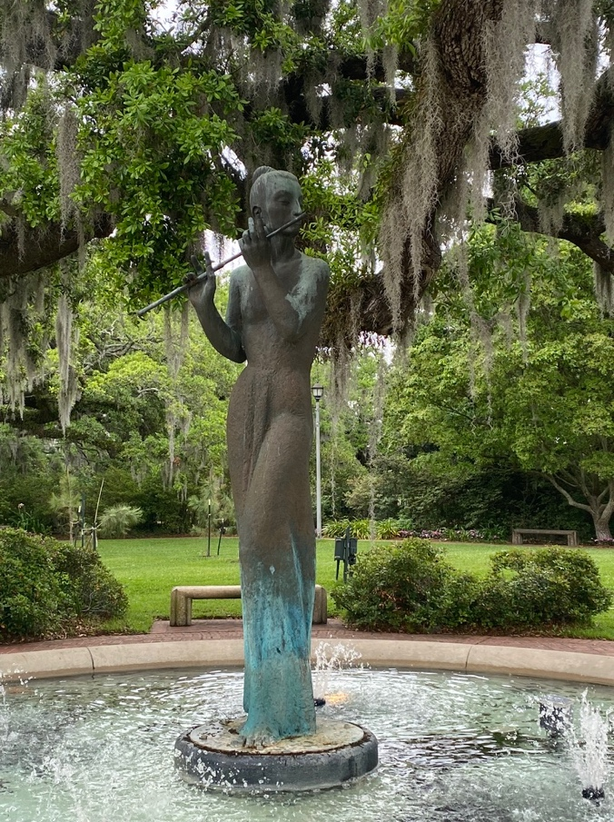
Spanish moss is not a moss, or a lichen. It is a bromeliad and like most bromeliads is an epiphyte – meaning that it grows on other plants but does not rely on them for nutrients and so is not parasitic, but interdependent with the tree. They take nutrients from the air and windblown debris, for which they are a perfect net. However, it did remind me of the lichen you will experience in Iceland, which activated the same inner joy and peace, and wonder that is mine. Attentiveness to our externals, and attentiveness to what is going on within ourselves in relationship to other species, plants, and people, is to recognize our interbeing with everything. But without this awareness and attentiveness to the external and the internal we are like a baby – just absorbed in life without awareness. The lichen in Iceland is phenomenal. Iceland is the newest land mass on the planet and still has some of the oldest life-forms on the planet, evolving from the sea and part algae, part fungus, part bacteria. They exemplify interdependence. Read what David George Haskell says in his beautiful book, “The Forest Unseen.”

The quietude and outer simplicity of the lichens hides the complexity of their inner lives. Lichens are amalgams of two creatures: a fungus and either an alga or a bacterium. The fungus spreads the strands of its body over the ground and provides a welcoming bed. The alga or bacterium nestles inside these strands and uses the sun’s energy to assemble sugar and other nutritious molecules. As in any marriage, both partners are changed by their union. The fungus body spreads out, turning itself into a structure similar to a tree leaf: a protective upper crust, a layer for the light-capturing algae, and tiny pores for breathing. The algal partner loses its cell wall, surrenders protection to the fungus, and gives up sexual activities in favor of faster but less genetically exciting self-cloning. Lichenous fungi can be grown in the lab without their partners, but these widows are malformed and sickly. Similarly, algae and bacteria from lichens can generally survive without their fungal partners, but only in a restricted range of habitats. By stripping off the bonds of individuality the lichens have produced a world-conquering union. They cover nearly ten percent of the land’s surface, especially in the treeless far north, where winter reigns for most of the year.

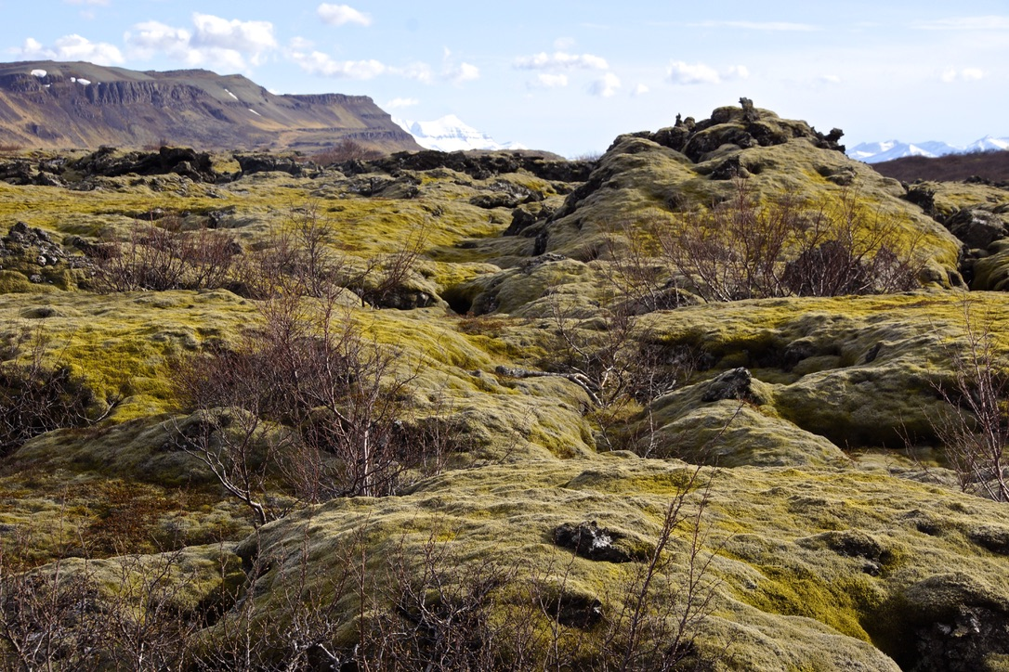
There are over 800 kinds of lichens in Iceland with new ones discovered every year. They are a source of food and have medicinal qualities. I have never seen beds of lichen like the ones in Iceland – sometimes many feet deep. You can lie on it and it feels like a Sealy Posturepedic mattrass.

As we experience these natural wonders, the practice is to be deeply attentive to what you are seeing, and deeply attentive to what is occurring within yourself. You could be mindlessly absorbed in the experience, or you could be making the mistake of thinking the experience you are having inside yourself is caused by the experience instead of it being that you are cleansing the lens of your perception, or waking up, or you could simply see everything without any recognition or interest in what you are seeing, or interest in your own inner experience. Let’s all commit to a deep attentiveness, externally and internally so that we can start interbeing. Notice the deeply ingrained habits of judging, of spacing out, of not being attentive, notice the mistakes I outlined here in being disinterested and fast asleep to your outer and inner experience. Just the seeing is immediately a moment of awakening to be celebrated.

Eisenstein says, “If you do notice the habit of self-righteousness (for instance), you know what to do: give it attention. Give attention to any feelings of embarrassment or frustration, without intending to stop those feelings. Let the attention you give your habits and the underlying feelings be as gentle as you can make it: loving, forgiving, and peaceful. You can even thank the habit for having done its job for so long, knowing that it is in a late stage of its life span and will soon pass on.”

Exercise:

Pay attention and accept the great gift of awareness. Pay attention to your external world and inner world. Share with one another what you noticed. What old habits and patterns of separation got in-between the relationship you have with Spirit, Self, and others? Being able to share this would indicate an awareness!

