Chapter 16 – Doing and Not Doing

All things return to their root.
Returning to the root, there is stillness.
In stillness, true purpose returns.
This is what is real.
Knowing the real, there is clarity.
Not knowing the real, foolish action brings disaster.
From knowing the real comes spaciousness,
From spaciousness comes impartiality,
From impartiality comes sovereignty,
From sovereignty comes what is natural.
What comes naturally, is the Tao.
From the Tao comes what is lasting,
Persisting beyond one’s self.
The Tao Te Ching verse 16


“Doing nothing is not a universal suggestion; it is specific to the time when a story is ending, and we enter the space between stories. I am drawing here from the Taoist principle of wu-wei. Sometimes translated as “non-doing,” a better translation might be “non-contrivance” or “nonforcing.” It means freedom from reflexive doing: acting when it is time to act, not acting when it is not time to act. Action is thus aligned with the natural movement of things, in service to that which wants to be born.”

~Eisenstein

The teaching above is very similar to Ecclesiastes 3:1 – read again the famous teaching on, “Unto everything there is a season….”

Whatever we do from our unaware motives rooted in childhood difficulties is defense, and will result, in the long term, to negative consequences. On the other hand, whatever is done with full awareness of the ego’s fears, needs and conditioning will be done with clarity of motive and understanding of consequence. The choice will be to act in true service, from a loving place for self and other. This may result in short-term persecution, but will always be correct, creative, and life-giving in the long term. Study the two maps below carefully and see if you can apply the maps to situations in your own life. The question is not “to do,” or “not to do,” but “Am I choosing action or non-action from a loving, wise place?”

- Introspect deeply about choices in your life that resulted in long term negative consequences to you, even if at the time they seemed to glitter with hope and excitement (e.g., falling in love). How aware were you, at the time, of your true motives, needs, feelings, beliefs, and underlying memory states in relationship to your parents?
- Consider choices in your life that came from a still and silent place at your core that you knew without a doubt were correct but that resulted in judgment from others in the short term. (e.g., divorce)
- What choices do you face now that require deep introspection into motive to make a clear decision?
- Can you be still and quiet, in a waiting stage on the bridge, and allow the answers to come from deep within? It is hard to be at peace with non-action in the middle of a transition.
- At what points in your life have you refused to do the loving thing out of fear of immediate consequences, attempting to “keep the peace,” to the detriment of your long-term freedom and peace?
- How have you rationalized, justified, and denied your true motives? If you find yourself explaining yourself, this is what you are doing!

The more we uncover our hidden motives, rooted in past trauma, the less we will be reactive in the world and our lives so much more peaceful as the karmic, or fateful consequences of unaware choice diminishes.

As we transition to more awake and aware states of consciousness, so the ripple happens in the world too. Can you see how this is true in a very literal and concrete way? Think of an example of you losing your reactivity to another person because you have done the inner work of reactivity … what has happened in the relationship and so in the world? It is important to see both the increasing freedom in your life as well as the ways you are still in bondage to unawareness.

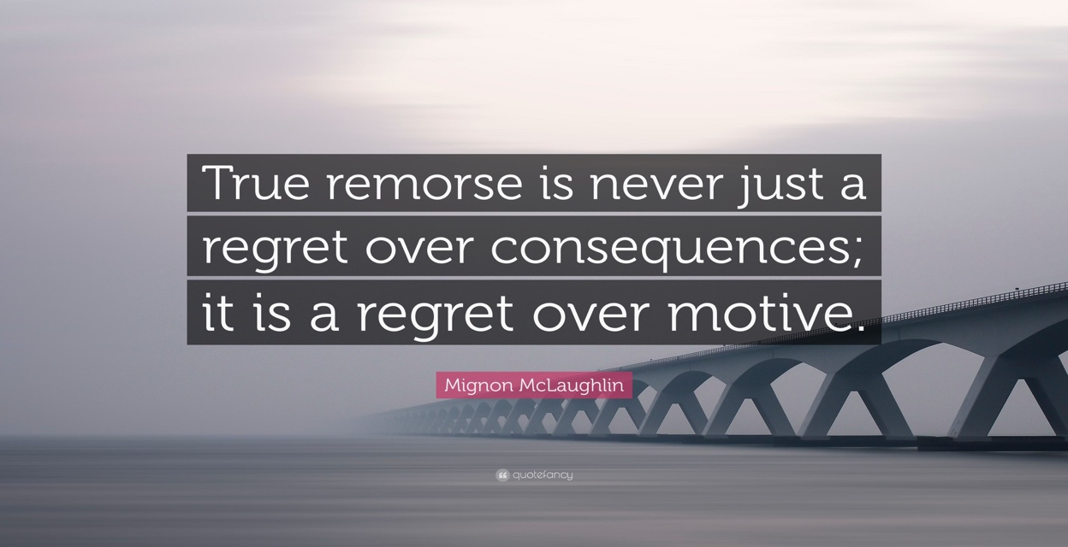

“The affairs of the world are no more than so much trickery, and a man who toils for money or honor or whatever else in deference to the wishes of others, rather than because his own desire or needs lead him to do so, will always be a fool.”
~Johann Wolfgang von Goethe, The Sorrows of Young Werth

“When motives are prettily packaged, they are much more easily obscured.”
~ Ashley Weave

Ego Motive

Unaware feelings of fear, shame, helplessness all accompanied by beliefs of not having value or being lovable in one form or another.

Doing / NonDoing

All tactics to control or overpower, to appease the unaware feelings attached to need.
All these behaviors fall into the category of Fight/Flight, or Aggressive/Passive, or Perpetrator/Victim, no matter how subtle or well-meaning the action may seem to be.

Consequence

Endless cycles of destruction and more hurt in the world, disintegration, and fragmentation in the long-term, short term ego gratification

In this state we need to stop “doing,” until we have turned inward and reflected on motive, behavior, consequence to get out of the maze of self-destructive behaviors and patterns.

++++++++++++++++++++++++++++++++++++++++++++++++++++++++++++++++++++++++++++++++++++++++++

Soul State of Being

Awareness in alignment with Spirit of Love and Truth – our essence
Human experience held in embrace of love and truth with full awareness.

Doing / NonDoing

Behaviors become loving and correct, even when the world does not agree.

Consequence

Deeper intimacy, greater creativity, sacred service, greater unity, and interconnectedness in interbeing in the long term. Possible short-term judgement from others, requiring great certainty of the soul to hold the shame and to not be plunged into shame.

In this state we need to stop non-doing and move into “doing” which will be sacred relationship with self, others, and the world. Self-awareness without external action is still representing a split state.

