Chapter 17 – Story and Disruption

“The more firmly we stand in a larger Story of Self, a Story of Interbeing, the more powerful we become in disrupting the old Story of Separation. I think questions of violence and non-violence, ethics, and principles, right and wrong, lead us into a conceptual maze…. Every evil deed and every cowardly inaction that has ever been perpetrated on this earth has been justified by principle – the logic of the story. As we sober up from our long intoxication with the story of Separation, we have the chance to enter a 'more comprehensive mode of consciousness' – the consciousness of story. If it, we ask ourselves, “What story shall I stand in?”
~ Charles Eisenstein

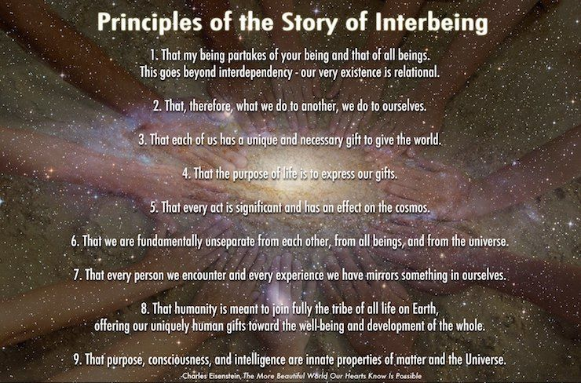

Stories change as we evolve. When we were very little our story was one of unaware dependence on someone outside of us that was bigger, stronger, smarter, to meet all our needs. This created an inner story about who we were that changed with time as we learned to do things and became more capable in our bodies.

We then learned in a very unaware way that our parents, family, and teachers had needs and feelings, and that we were responsible for them. Their needs and feelings made us anxious, shamed, guilty and so we learned to do things correctly for them so that they would be “happy” with us. This was the stage of learning to be co-dependent and we created an entire story about ourselves around this experience of life. We learned a new story about ourselves as being generous and helpful, kind and good.

As we reached our teen years, we started asserting all the ways in which we saw ourselves as separate individuals who had to earn their own living and make themselves in the world without the support of other adults, and we learned to be fiercely independent and start our own lives. We had a new story of being accomplished or not, successful or not. We developed preferences and told the story of our uniqueness.

All these stories had a relative truth – relative to the stage and state of consciousness in which we found ourselves.

However, none of this happened in full awareness (Absolute Truth) and we then found partners with whom we could play out all the unresolved and unaware issues of dependency, co-dependency, and fierce independence.

And finally, you have all reached the stage in life and the state of consciousness (more awareness about early stages and states) that you can ask the question of “what would interdependence actually look and feel like?”

It is important to recognize that all early stages occurred in unawareness of the deep motives of fear and shame from which they arose.

As you do your work and become aware, you are learning to be intra-dependent – in other words, to be in relationship to all the frightened, anxious, shame-based, compliant, and rebellious parts of yourselves. You are learning to be in relationship with younger stages and states with understanding, empathy, detachment (this is just normal development), and some humor, and as you do so your relationships with others shift and change too. This kind of intra-dependence and being with oneself (intra-being) – i.e., meeting one’s own needs, bringing our mature love and truth to past stages and states – leads to the capacity to inter-be with others and to recognize our deep connections to everyone and everything on the planet.

The new story you are evolving within yourself is of unity, not separation. It is about recognizing similarity instead on focusing on “special” and “unique“ and "different" from others. As you recognize similarity with others, your newfound compassion and wisdom for yourselves is extended to others and other species.

The more faithfully you listen to the voice within you, the better you hear what is sounding outside of you.
~Dag Hammarskjold

And so, as you work internally the work is:

- To notice when you separate from yourself with judgment, opinions, stories about you being “worse,” or “better,” than others.
- To remind yourself that you cannot get worth from others, nor is your worth diminished by the judgments of others, and so all judgments and opinions about yourself and others are an irrelevant story.
- To remember that your worth is intrinsic, given, and irrefutable, and to come from that place of intrinsic worth and unity, to be in relationship to yourself first, and then others in a new story instead of feeling alienated, alone, empty, and separate internally and externally.

Social Activism is to live this – to shift and expand into this New Story is the most powerful change agent in the world today – this is how you disrupt the old story – by living the NEW STORY. Disrupting the old story depends on you and your own inner expansion.

You cannot change something from the same level at which it was created. So, any activism that is based in judgment of right or wrong, any attempts to control and over-power, or convince, help, advise or change people from your own fears and unawareness is still the old story of separation.

“Independent thinking alone is not suited to interdependent reality. Independent people who do not have the maturity to think and act interdependently may be good individual producers, but they won't be good leaders or team players. They're not coming from the paradigm of interdependence necessary to succeed in marriage, family, or organizational reality.” ~Stephen Covey
© Lyndall Johnson

THE NEW STORY OF INTERDEPENDENCE AND COLLABORATION

Interdependence is and ought to be as much the ideal of man as self-sufficiency. Man is a social being. Without interrelation with society, he cannot realize his oneness with the universe or suppress his egotism. His social interdependence enables him to test his faith and to prove himself on the touchstone of reality.
~Mahatma Gandhi

- Interdependence and collaboration do not mean consensus or even democracy - this might or might not be subsumed under the idea of interdependence. For instance, a democratic vote might mean choosing the most unloving outcome for the most people by the most people. Eg. to go to war out of revenge. Interdependence seeks the most loving solution for all parties concerned and seeks the best interests of all even if it does not win the popular vote or does not seem “fair.”
- Nor is interdependence about fairness or even equality in how we are treated and what we get in life. It is about learning to meet the genuine human needs of another freely and lovingly from a place of awareness and deep understanding, including our own, and meeting people where they are at. (For example, a toddler may not think it is fair that mom spends more time with an infant.)
- It is to not submit to bullying or to comply with what another person decides they want from us to prove that their need is being met. It is not demanding that others comply with behaviors that we think will prove to us that our needs are being met. It is recognizing the difference between our genuine needs and our wants. Eg. I might want you to do some chores for me and then I will interpret this to mean that my need for love is being met. Wanting someone to do chores and needing love are two different things.
- Interdependence is about learning to meet our own needs by reconnecting with ourSelves and our Source. If we are not internally interdependent, self-loving, and self-respecting, chances are we will not be with other people either.
- It is dependent on the ability to have empathy and compassion for the experience of self and other without feeling the anxious desire to control, fix, rescue, enable, help, advise, change, self or other, trusting that presence, listening, and awareness are all that are required.
- Interdependence has a focus first and foremost on relationship and process, not commodity and outcome.
- Interdependence requires knowledge of the difference between control (trying to change self and other to manage my own fears) and limit setting (protecting self out of self-regard against the abuses of others and self)
- The capacity to be comfortable and non-threatened by difference - whether this is a stage of development, race, ethnicity, culture, or world view. The capacity to heal and bridge splits and breaks without being threatened by difference in any way .
- The capacity to act in an interdependent and collaborative way presupposes an expanded state of consciousness that can understand and hold in awareness the paradox of both/and instead of slipping into the dualistic thinking of either/or, black or white, right, or wrong.
- It is based, not on the morality of the dualistic mind, but the spirituality of embracing all as holy/whole with love and acceptance. This does not preclude but includes judgments (morality) - of behaviors, not persons. This is paradox that is hard for the intellect to grasp.
- The capacity to hold the “ both/and” in consciousness with the intention to be loving to myself and to the other. To be conscious of what is best for you and for me. To see that I have both masculine and feminine energies, whether male or female, that I operate at many different levels of awareness and am neither good nor bad by identity or definition, but might act in ways that can be considered “wrong/bad/destructive” - in other words, again, to be comfortable and have insight into the realm of paradox.
- The ability to observe ego transactions in self and other with compassion, lightness, humor, and firm limit setting when necessary. The ability to have fierce compassion for self and other.
- To be able to express with authenticity and humility ego functioning (fear, shame, need, dualistic thoughts and defenses) – neither owning them as identity, nor blaming others, rationalizing, excusing, projecting, or denying (etc.) these inner ego functions.
- The capacity for self-observation with acceptance of self and willingness to change and grow.
- To not be abusive to self or other
- To not allow another to be abusive either to self or other
- Interdependence does not mean a lack of initiative, leadership, or hierarchy. It does mean that leadership, initiative, and decision making is done with respect, from a “win/win” attitude, and from a clear and loving space that is not hindered by ego issues. Hierarchy is subsumed under a larger state of consciousness that sees all people as of equal value no matter what the differences in capacity or ability might be. Expertise is valued and there is a hierarchy in terms of education, knowledge, stage of development etc., subsumed under the value of mutual respect and value.
- The ability to listen deeply and be fully present to self and other with an understanding of motivation and the circular nature of cause and effect.
- The ability to think creatively and out of the box to connect and find solutions, build bridges and create connection.
- The ability to understand similarity and difference, but to find the common ground of our humanity.

© Lyndall Johnson

“Interdependence is a dynamic of being mutually and physically responsible to and sharing a common set of principles with others. This concept differs distinctly from "dependence," which implies that each member of a relationship cannot function or survive apart from one another. In an interdependent relationship, all participants are emotionally, economically, ecologically and/or morally self-reliant while at the same time responsible to each other. An interdependent relationship can be defined as an entity that depends on two or more cooperative autonomous participants (e.g. - co-op). Some people advocate freedom or independence as a sort of ultimate good; others do the same with devotion to one's family, community, or society. Interdependence recognizes the truth in each position and weaves them together.” ~Wikipedia

“The basic thought that guides these specific means of national recovery is not narrowly nationalistic. It is the insistence, as a first consideration, upon the interdependence of the various elements in all parts of the United States – a recognition of the old and permanently important manifestation of the American spirit of the pioneer." ~Franklin D. Roosevelt

“When we try to pick out anything by itself, we find it hitched to everything else in the Universe.” ~John Muir

“...for many of our white brothers, as evidenced by their presence here today, have come to realize that their destiny is tied up with our destiny. And they have come to realize that their freedom is inextricably bound to our freedom.” ~Martin Luther King Jr.

“Moreover, I am cognizant of the interrelatedness of all communities and states. I cannot sit idly by in Atlanta and not be concerned about what happens in Birmingham. Injustice anywhere is a threat to justice everywhere. We are caught in an inescapable network of mutuality, tied in a single garment of destiny. Whatever affects one directly, affects all indirectly. Never again can we afford to live with the narrow, provincial 'outside agitator' idea. Anyone who lives inside the United States can never be considered an outsider anywhere within its bounds.” ~Martin Luther King Jr

“Hence, international co-operation and solidarity and the relentless search for consensus become an absolute imperative. They are the only possible alternative for all nations, whose interdependence is being made increasingly manifest by the rapid development of production technology, of transport and communications, as well as by the overhanging threat of deterioration of the environment and exhaustion of natural resources. And what is one to say of the frightful accumulation of means of destruction in a world facing the no less frightful problems of hunger, disease, and ignorance?” ~Federico Mayor

Again, and again the Master would be seen to discourage his disciples from depending on him,
for this would prevent them from contacting the inner Source.
He was often heard to say, “Three things there are that when too close are harmful, when too far are useless and are best kept at middle distance: fire, the government and the guru.”
~Anthony de Mello

