Chapter 20 – Miracle, Consciousness, Destiny

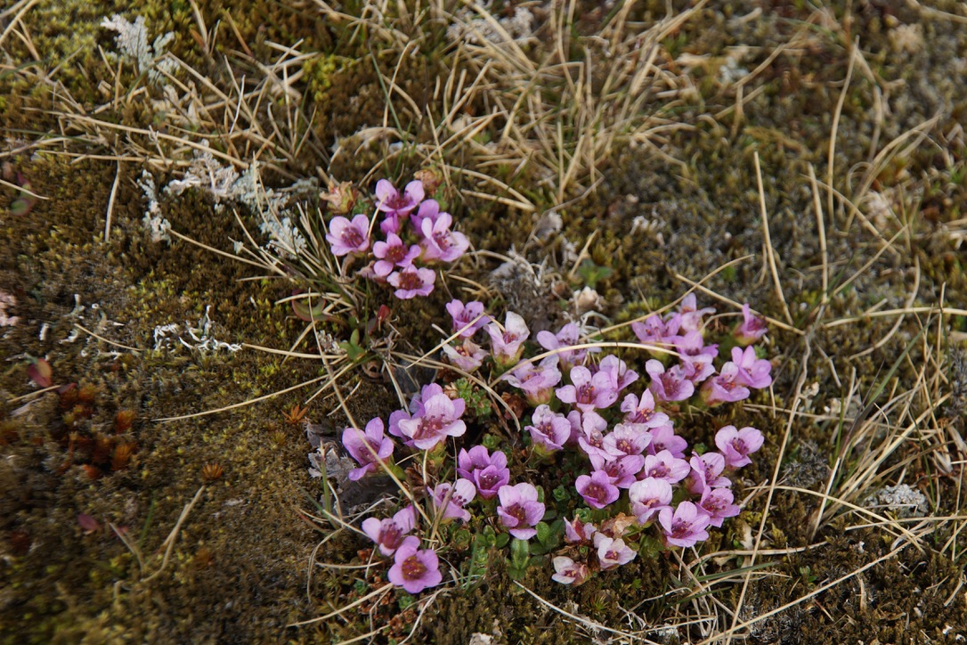
“Working on the level of story has two dimensions. First is to disrupt the old, which says, “What you thought was real is just an illusion.” Second is to offer the new, which says, “The possible, and the real, are much grander than you knew.” The first, we experience as crisis and breakdown. The second, we experience as miraculous. That’s what a miracle is: not the intercession of an external divinity in worldly affairs that violates the laws of physics, but something that is impossible from within an old Story of the World and possible from a new one.” ~ Eisenstein

What is the miracle of our times? What is our destiny?

In the paradigm of the unaware ego, one of the temptations is to go to despair – despair for ourselves, and for the world. We see how huge the difficulty is to be in alignment with Truth, with Love, in our inner relationship with ourselves and in our outer relationships with others. The way we are internally, is the way we will be externally.

Despair is another way to separate from the Love and Truth of Consciousness. Consciousness itself is infinite, eternal, omnipotent, omniscient, omnipresent – even when we forget and collapse into the paradigm of separation, fear, shame and lies. All of time and space is like a tiny pinprick in the Consciousness of God and all of time and space is the Consciousness of God in form. The volcanic rock and the flowers growing out of it, the trees and the Vikings who chopped them all down to make ships in Iceland. All is held in the ultimate truth and love of Supreme Being. All is already redeemed and saved, held, and loved. All of time and space can be re-created in an instant. The Blueprint of creation is in the mind of Consciousness, it cannot be destroyed. All the destruction we do as a species to ourselves, and the planet are just a pinprick in Eternity. We are like children devastating the playroom and strewing all the toys around, messing everywhere, breaking down the blocks and throwing them around, and crying and whining about everything, until we get bigger and know how to take care of ourselves, the space, and others. We are not ultimately in charge. All destruction is held within CREATION.


A miracle is the one who wakes up to this reality within themselves. Miracles are YOU. Each of you over the last months has practiced JUST SEEING, practiced being yourselves, so that you could see that all the little ego struggles, upsets, issues, fears, beliefs, judgments, tantruming, controlling, whining, and complaining are just a pinprick in the eternity of your own consciousness, held in love not judgment, correction and truth instead of indulgence of lies, and firm limit when instinct wants to rule the day. What a miracle. What hope for the continued existence of our planet. Can you see that as you become more aware of YOURSELF (SOUL that you are), all the ego issues seem to become smaller? They didn’t – you just got bigger so that they seem like a little pinprick in the vastness of the ocean of love and truth that you are. You might think I am overstating this, but I have watched each of you face an inner fear, an inner lie, a way of behaving, and with devotion to yourselves you have gained awareness and expanded your seeing so that the silly idea that you are “always wrong and bad,” or that “no-one will like me,” or “ I have to control everything to be perfect,” and on and on, has been seen. There is a distancing, a correction, and a holding so that “issues” recede into the background and become smaller and smaller as you get bigger and bigger. You have lost your allegiance to the story of separation. You have set the path of your own destiny instead of being ruled by the causes and effects of the world’s paradigm. You have accepted the challenge to live into a new and larger reality. The old story can still have a grip, but the grip is weakening the more you grow in awareness. Finally, you will surrender it, just drop it and laugh at the silliness of your fears, your shame, your petty lies about yourself and others. You have chosen. And so you have chosen to follow your true destiny instead of being determined by the story of separation. And you understand that this change in yourself results in changes in other people, because your consciousness is never separate from theirs or God’s. You are becoming co-creators instead of living the old story of breaking everything apart and scattering the building blocks around the playroom. This is a miracle.

Out of the devastation of our lives, a new life springs forth and flowers. This is a miracle of consciousness and your destiny – if you choose.

“According to Vedanta, there are only two symptoms of enlightenment, just two indications that a transformation is taking place within you toward a higher consciousness. The first symptom is that you stop worrying. Things don't bother you anymore. You become light-hearted and full of joy. The second symptom is that you encounter more and more meaningful coincidences in your life, more and more synchronicities. And this accelerates to the point where you experience the miraculous.” ~Deepak Chopra

When we know our true nature,
we have no fear of authority.
When we forget our true nature,
we depend on the rules of others
and become their willing slaves.

We do not become arrogant anarchists;
we simply obey a deeper rule of virtue.
Our guidelines emerge from the awareness
that we are not separate from other beings.
That is our inner guide.
The Tao – Verse 72 William Martin translation

Exercise:

Draw a picture of your Soul. Draw a picture of your ego. Draw the relationship between them.

