The Killing of Cecil
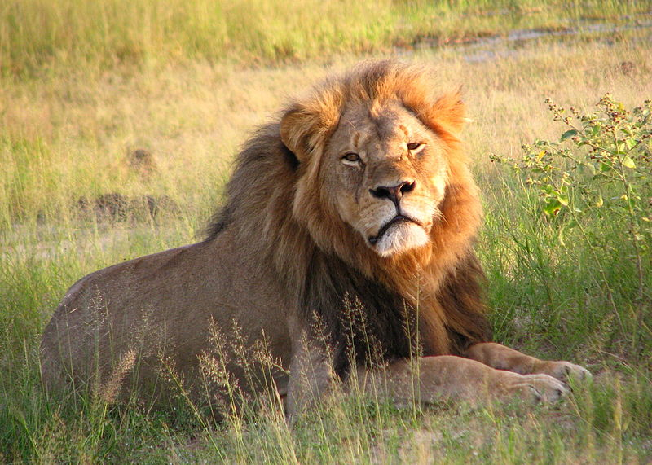

The killing of Cecil has been particularly challenging for me and has clearly touched the souls of people across the world. Zimbabwe, the land in which I grew up, and with which I have been strongly identified, is a war-torn country, with a sordid political history struggling to survive the grips of poverty, Aids, poaching, environmental destruction, racism, xenophobia, and war. It currently has an 80% unemployment rate. Hwange National Park is a place of wild beauty and Cecil was a magnificent male lion. It is in Zimbabwe as a child that my heart first awoke to the plight of wildlife that teeters on the edge of existence all the time.
Lions happen to hold a particularly tender spot in my heart – they were my mother’s favorite animal. Archetypally they have a complexity of meaning, but perhaps the most well know is that, as a solar symbol, they represent the qualities of justice, majesty, strength, and courage. Qualities that seem to be the opposite of those acted out by Walter Palmer and the men that set up this heinous crime. And yet, I wonder if Walter rationalizes that his cowardly destructive acts are the qualities of strength. courage and manliness?
In Buddhism the lion represents, ironically, the defender of the law, the wisdom of Buddha and enlightenment. Perhaps this is why Cecil’s murder seems utterly unacceptable to us all. Much like in the story of “The Lion, the Witch and Wardrobe,” goodness – the lion Aslan, is sacrificed by evil having the upper-hand. Instead of the base instincts and egoic behaviors being subservient to a loving and wise soul.
And how is this battle alive and well in each of us? We all struggle to make our egos subservient to our Higher Selves. How many times does the banal win over integrity and love within us? This event is deeply archetypal as it represents the inner struggle of all humanity.
My own initial response to hearing about Cecil’s barbaric slaying was “I don’t want to hear … this is happening all the time. I can’t stand it.” I recognized my immediate flight defense as a way of distancing from the pain I knew I would feel if I allowed myself to be fully aware. Observing this instinctual withdrawal allowed me to surrender to the sorrow. I allowed myself to hear the story and read everything obsessively for an hour or so…. And I felt the pain of the rape of Hwange, and the slaughter of her wildlife, the slap in the face to the Oxford researchers – the university where C.S. Lewis wrote the Narnia series.
I know Hwange. I remember as a little girl lying awake in a chalet as a herd of elephants browsed outside my window, watching lion at a waterhole, learning to keep very quiet in the wild, smelling and feeling and knowing the signs of the bushveld to find animals – not to kill them but to learn to love, appreciate and live with them. I know the kind of people dedicating their lives to research and preservation. These are real men and women who are truly alive, awake, committed, and compassionate. They are truly tough, strong, and courageous. I felt their sorrow and despair. Despite their best efforts they could not protect Cecil against the relentless onslaught of poaching – not hunting – poaching. Poaching not for food, but for greed and building up the insecure egos of frightened and hurt little boys in dangerous men’s bodies still playing with bows and arrows and guns – but now they are not toys.
Of course, the next reaction I had, once I allowed myself to fully feel the pain and grief, was to distance from it again – this time with rage. A rage that stops the flight and makes me want to turn and fight. I observed my mind turning to revenge fantasies. How about something like the Hunger Games, I thought, where the poachers are all hunted by one another with a bow and arrow – this seemed like a good plan in my anger! It didn’t end there – it is amazing how many vengeful ideas I came up with. The recognition of myself as no different to every other despot on the planet is sobering and humbling. I watched my mind go to every nasty torturous solution to the “problem “ – perceived by my primitive brain to be Mr. Walter J. Palmer.

My animal instincts were having a field day – flight/fight, fight/flight.

Seeing this inner reactivity within ourselves is the way to freedom. We are fully animals – these reactions within will never go away. But to also be fully human and fully divine means having self awareness of the animal within and transcending this level of functioning. Only by seeing and owning, accepting, and having some humor about our own little inner despots and victims, can we ever live into the potential of our Being. Pretending you do not have this within means the chances of it being acted out are high. Knowing this dynamic within is almost a certain guarantee that you will not act out of this young and primitive stage of development. And you cannot skip moving through all these stages in your own processing – although with practice it goes by very quickly!
I do not want to be either a victim or a perpetrator in this sad drama of victim (Cecil)/perpetrator (Walter). To align myself with one of these options is to live in the same paradigm. And this IS a hopeless, doomed, and short-lived paradigm for every sentient being on the planet.
I want to see deeply into the situation, understand what is happening and find a creative solution to the social problems leading to this symbolic and archetypal event.
To understand, I need to ask many, many questions about the intricate inter-weaving of cause and effect that led up to this event.
It is easy for me to understand how poor people get caught up in illegal poaching – both for food and money. The temptation for poor Zimbabweans to accept huge payments from wealthy Americans makes sense to me. It is easy for me to have compassion for the desperation of their lives. For all of us, it is easy to live a reasonably good life when you have a reasonably good life. It is far harder to live a principled life when daily life is a struggle for survival. However, in this case the people setting up the hunt were not poor and desperate people and nor was Walter Palmer. They were all unaware and so not fully human, beings. Their unawareness renders them dangerous.
What is our own inner work as we look at this external event that represents an internal dynamic, we all know well?
Perhaps the inner work is to test ourselves daily. Where do we compromise our integrity to get what we need? Is it really a need or just a want? What self-entitlement gets in the way, for instance, of not eating meat from corporate farms? We all know of the immense cruelty and corruption of this industry. It is not a need for us to eat corporate beef, pork, and poultry. Perhaps if we lived in dire poverty, it might be. If we compromise ourselves for selfish wants – not even needs, we certainly cannot point a finger. A daily examination of our own integrity and where our personal breaking point is, is the most important place to begin.
Given that there is immense poverty, leading to corruption, war, and social ills of every kind, in Africa, the next question might be, “how do we facilitate the political, economic, social (Primarily, education and health) and physical upliftment of the African continent?” “How do we help the populace start feeling a non-tolerance for people exploiting them and their country?” “How do we help them set limits with greedy landowners and so called ‘Hunting Operations.’ Perhaps we can start by examining our own self entitled consumerism and greed that does nothing to mitigate the issues of world hunger and poverty and start setting limits with ourselves. One of the most basic human needs is to feel the security of limits. Can you set limits lovingly with yourself? With others?
How can our hearts open to the plight of most of the world’s population? The work is to open to our own suffering when our needs are not met. Examine all the ways in which your physical and emotional needs have not been adequately met or overly met (which means another need was NOT met). Can you feel at least a little empathy for yourself. Until you do, you will not have any for others – you will not even recognize the depth of their suffering and deprivation.
Understanding Walter and the poachers that set up this murder, may be a little more challenging – but until we do, we cannot have empathy and will not see how best to support them in their own awakening. If they do not awaken, they will not grow – they will stay the same.
It is imperative that we understand deeply what gives rise to destructive behavior? We recently had the example of a young man in North Carolina killing innocent people. We have Walter killing an innocent and beautiful animal. Why? What is wrong in our society? How were these men raised? Can you be a perpetrator if you have not been a victim? What was the air they breathed growing up? What belief systems and social milieu have supported their actions. How are each of us complicit in them being the kind of men they are today? What needs did they have as children? Did they need love, attention, admiration, acceptance? Did you? How did they get their needs met? How did you? Was Walter lucky or unlucky? And you? How much shame do you believe drove him to killing in a tragic attempt to get childhood needs met? How much shame is he still trying to defend himself against? What would help him face his shame and start healing? How is Walter a victim? How are both Walter and Cecil sacrifices for the world? Is their sacrifice going to awaken us to a higher state of consciousness? Or will we too just sink into the old paradigm of hate and greed, revenge and judgment, superficiality, and quick fixes?
Only when we start asking these deeper societal and personal questions will we find our heart. Only our heart has creative and loving solutions to save and redeem both victims and perpetrators – within and outside of ourselves. Only by saving ourselves will we save the world. How will you save yourself today? How will the lion and the lamb learn to live in peace with one another – internally and externally?
As I worked my own process, I was strangely heartened by the public response that seems to represent a new awareness – a reaching for a different way of being in the world and an awakening in the population. It was good to hear that there was a call to compassion for Walter’s children, not only Cecil’s. Can we also find compassion for Walter, not just Cecil? And if we can – what do you see would be compassionate limit setting? What would represent justice with mercy that benefits him and the entire world community? If we can move beyond the victim/perpetrator paradigm within ourselves, I believe the world will take a huge step towards creating peace and abundance instead of reaction and destruction.

P.S. Every rationalization for trophy hunting is merely in support of the paradigm of ego consciousness (fight/flight). It is important not to get caught up in the clever rationalizations of the ego mind that even conservationists will sometimes propose.
I mention the example of corporate farming because at the next movie night we will be watching the movie, “The Peaceable Kingdom,” about this very issue. Watching it will challenge you to be very observant of the victim/perpetrator mentality within yourself.
© Lyndall Johnson 2010
,

