Chapter 5 – What Mindless Habits get you into Trouble?

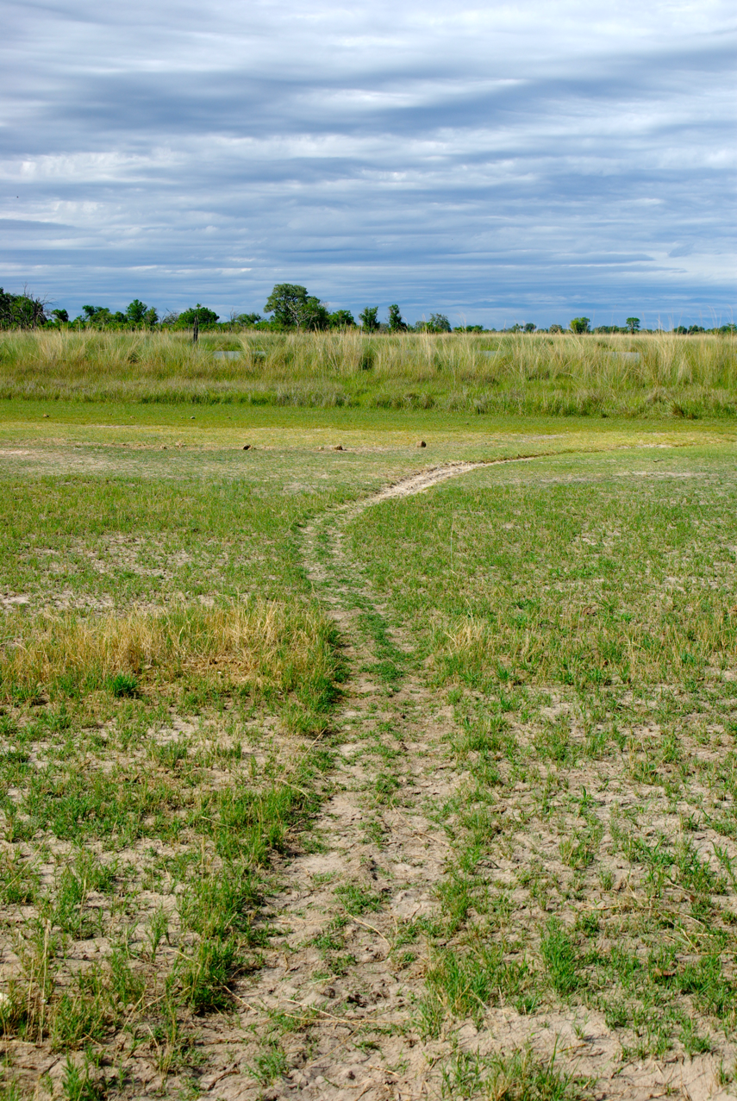
On this trip you will encounter people that grew up with wildlife and their lives have depended on reading the signs, tracking, understanding the weather and what it means to animal behavior, animal behavior and movements, plant, and herb medicine – they have a wealth of knowing without necessarily knowledge – but a deep knowing of the environment. Listen carefully, ask questions about everything you see. I totally missed seeing these tracks in the grass, a well-worn hippo path down to the water. I was as dumb as the hippo in the story below!

Once on a trip to the Okavango Delta in Botswana, we had a guide called Coca (Cola), who knew wildlife better than any guide I have ever encountered.... and he had a marvelous sense of humor about the animals and human nature.

(Very often the guides adopt very amusing names for Westerners, so that they can pronounce them)

One morning Coca pointed out to us a track leading down to the river and commented, “Hippo Highway.” We looked at him enquiringly, knowing there was more to come. “You can see there are two tracks because hippos do not cross over their legs. Their left front leg and their left back leg go in the same track and their right front leg and back leg go on the other track - and every day they go the same way. They are very stupid! And you will ask me now, ‘How is the hippo very stupid?’ So, I will tell you how the hippo is very stupid.”

“If you always go along the same track, then you can easily get caught. The fisherman will dig a deep hole in the middle of his highway and cover it with sticks and leaves and then the hippo that always goes the same way and doesn’t see very well, falls into the pit. Now it is very easy for the fisherman to kill him and cut him up in the pit.”

It was a rather grizzly picture he painted, and I felt a pang of sorrow for the stupid hippo, who was caught, not so much by the fisherman's cleverness, but by his own mindless and habitual nature.

And I thought of how we are not that different. We tend to go along the same path in life and if it is comfortable and meets our short-term needs, we seldom pause to consider whether it is leading us to long term destruction or to a well examined and creative, aware life. We have habitual thought patterns of judgement of ourselves and others, unexamined opinions about all kinds of things; we engage in addictive behaviors of drinking, overeating, overspending, overindulging. We fall into the same old ways of feeling and complaining. We give in to repetitive compulsions and needs without thinking about the pitfalls of our patterned thinking, feeling, and behaving - we just follow the deeply rutted grooves of our customary way of walking to the watering hole or to the patch of grazing that satisfies our immediate cravings.

Coca’s story had the flavor of an Aesop’s fable and with the same effect. It woke me up a little to consider of which patterns I need to get aware, and how I can change course in the new year, risk another path, and find a different way instead of sticking to the same old way of doing business – and especially those that lead to a deep pit! I encourage you to do the same; what patterns of thought and reactivity have led to you being caught in a deep pit? How do you mindlessly go along the same well-worn and unconsidered paths of your life? Consider this as inner baggage to bring with on the trip so that it can be unpacked. As you prepare, you will start realizing the inner baggage is far heavier than the outer baggage with which you can be so consumed and worried about. Let’s turn our eyes inward – something the poor hippo cannot do.

© Lyndall Johnson January 2013

