Baboons

Baboons are both very smart and very stupid at the same time – much like human beings. In fact, we share 94% of the same DNA. What baboons do not have is the capacity to be aware that they are aware sentient beings. Humans do have this capacity but very often resist the knowing and act just like baboons. Here is how:

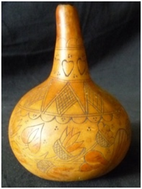
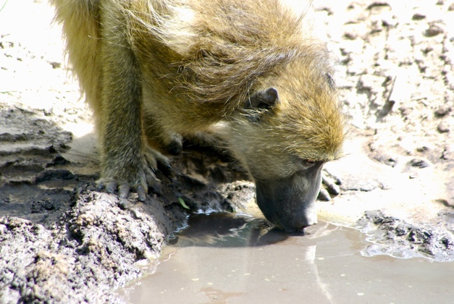
In the hot Kalahari Desert, water is scarce. Baboons always know where it is, but they are very wily and will never reveal its location. They are cautious to not give away the secret. The Bushmen who live in the Kalahari know this and have outwitted the baboon into telling them exactly where the water is. They secure a calabash (gourd) to a rock or a tree, and they put some seeds into the hollowed-out calabash. They make sure the baboons are watching them work with the calabash, and then they leave. As soon as they leave, the curious baboon – who loves the seeds of pumpkins –cautiously approaches, sees no-one, and sticks his furry little paw into the calabash and grabs a fist full of seeds. And now he is trapped – completely, stupidly trapped. Why? Because to get his hand out of the calabash and run away, he would have to open his hand and let go of the seeds – and he will not do it. He clings to those seeds for dear life, never realizing that not letting go will endanger his life and the life of his troop. The Bushmen put a nice piece of rock salt nearby (every animal in the desert craves salt) and then just sit and wait him out. By the third day in the hot sun, exhausted by the struggle to pull his hand out, and horribly thirsty from the rock salt, the Bushmen come and release him. The baboon, mad with thirst, no longer cares about revealing where the water is and rushes straight to it, with the Bushmen following closely. The secret stash is discovered!

Just like the baboon, we clutch cherished ideas, old habits and patterns, ways of thinking, worn out dynamics of inner interaction and outer relationships, and refuse to let go. The baboon could, if he was aware, say to himself, “Oh my goodness, I need to relax my hand and let go of these seeds, so that I can get free of this damn calabash.” If he was aware he would be in a hell of a conflict because his lower ego self would say, “No, then you won’t have those seeds to eat.” Only when the need for water becomes greater than the need for food would he agree to let go. This is why we say that people must suffer enough from what they are holding on to, to decide to let go. But the poor baboon cannot be aware, will never be aware of what he is doing to keep himself stuck and imperiled. The question is, can you? It is a simple process:

- Notice the thought, behavior, need and feeling in your body.
- Know what it feels like and what it causes in your body and in your relationships internally and externally.
- Relax and breath consciously – i.e., let go of the seeds!
- Notice when you tense up and clutch again and repeat – see, relax, and let go of tension.
- Grieve the loss of the seeds. You now have freedom and the water of life, but not the pumpkin seeds.

Relaxing is the letting go. Breathe into the relaxation, the calm and love of Spirit, and repeat as often as is necessary to gain your freedom from self-defeating patterns of behavior and thought – they are seeds that do not sustain life.

Consciousness is the ground of Being in everything and everyone. Animals are fully conscious, but they cannot become aware of themselves as consciousness. They cannot observe themselves. They can’t say “I am aware that I am aware of….” The gift you have in being able to know you are conscious is a priceless gift, not to be wasted or ignored. Look how much more advanced you are on the evolutionary path than the poor baboon – or are you? Work with this metaphor and the meaning of water, seeds, dynamics of greed and clutching, awareness and peace.

© Lyndall Johnson
Only being aware is being aware of being aware. ~Rupert Spira

