Chapter 7 – A Lesson from Giraffe – Processing Feelings

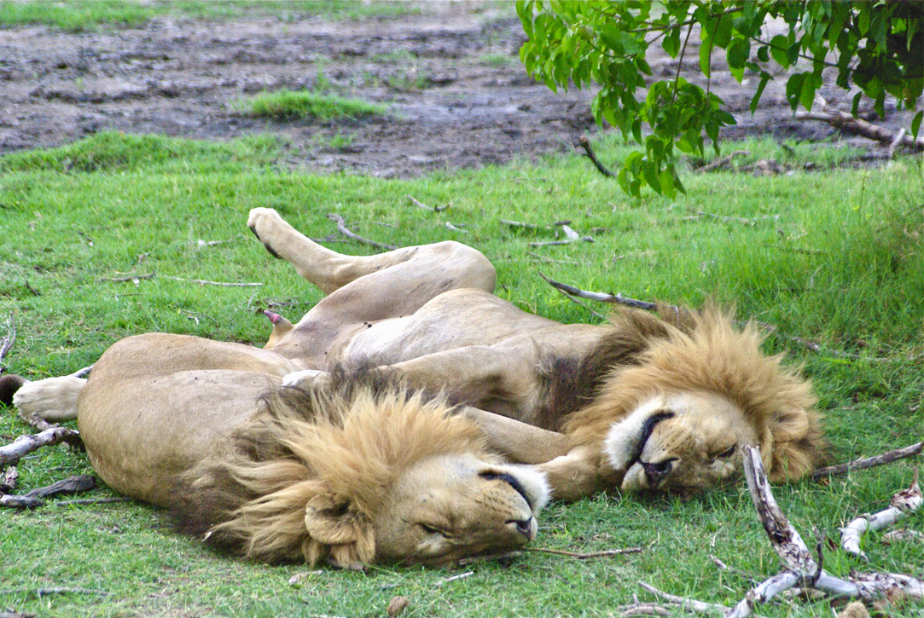
The bush veld is a wild, primeval place where you are either the hunter or the hunted. There is a savage, harsh beauty to the land and yet there is no place on earth that I feel a greater sense of tranquility. Death and killing erupt suddenly and is quickly over and then peace reigns again as if nothing happened.

Lions are notoriously poor hunters and miss their prey quite often. Like all cats they spend a lot of time sleeping and in the heat of an African drought food is plentiful and they are fat and sleek, which is why they are so hard to spot unless they are on the hunt. They blend into the grass so well you could drive right by them and not see them. If they miss the prey, they give up quickly, slump back down in the shade of an acacia tree, panting languidly and wait for something a little easier to come their way.

I was struck by one large bull giraffe, I saw on safari, who had a flap of his hide hanging from his hindquarters. The wound where four large claws had ripped him open was healing and he was stripping the tender new leaves off the topmost branches of a large umbrella thorn tree with his long black tongue, apparently unconcerned and non-anxious. There was no neurotic paranoia evident. He stopped a moment to peer down at us curiously and then went back to the earnest work of eating. This lack of fear is something I have witnessed often and yet never asked myself why animals do not live in a state of nervous terror at the prospect of suddenly and unexpectedly becoming dinner to a large, ferocious killer. Why do they not have post-traumatic stress disorder like humans? Clearly, they have instinct and memory and know that lions are out to get them.

When watching a hunt and kill it is easy to get caught up in the drama of paying attention to the lion.
However, if one watches the impala or zebra (the lions most common prey) when the lion has chased it but missed and given up, the animal keeps running, pronging, and kicking up dust. Then finally it will stand shaking and quivering all over. It will snort and toss its head. Saliva will run from its mouth and nose. It’s hide will quiver, tremble, and jerk spasmodically, sweating profusely. It will stamp its feet and nervously move around. The nose twitches, the tail flicks. Gradually, however, the movements decrease and finally cease and then within a little while, the animal will start grazing again, apparently unconcerned, even with lion still in the vicinity.

The reason for this is because it is allowed to complete the cycle of arousal and terror. There is
no mother or father zebra or impala stopping it from processing the body’s natural response to fright. There is no parent saying, “No stop that nonsense, there is nothing to be frightened about.” “Stop making such a fuss, the lion didn’t even scratch you.” “If you want to act that way, I will give you something to cry about.” And on and on…. Fill in the messages you got about feelings as a child.

Human parents, it seems are as much frightened by their offspring's feelings and physiological arousal to fright and pain as they are of a lion and will immediately attempt to stop the full expression and range of feeling and arousal that a child experiences when hurt or frightened. Parents will in any number or ways give their children the message that they must control their feelings. Controlling feelings means constricting, tensing up and holding it all in. Often it means repressing it so deeply that there is no connection between the feeling and the original event causing it. A sort of emotional potty training happens. Of course, just like any other bodily function, if it is all held in for too long, it becomes intensely uncomfortable, the tension and pressure become too big and eventually will result in a big mess happening, often inappropriately and in response to any stimulus that bears a resemblance to the original but forgotten cause of the feeling. The tension and pressure of repressed emotion results in stress with all its accompanying psychological and physical manifestations.

Or, on the other hand, the parent may, out of their own anxiety, feed the fear by giving it endless attention, soothing, giving food and rewards for the feeling, instead of being matter of fact about the feeling. To indulge feelings like this is to train a child to use their negative feelings to elicit attention, empathy, help, support and they become a pain in the neck as an adult because they have not learned how to process their own feelings. They have learned to use feelings as a control tactic to manipulate and frighten other people into meet their needs.

The work of identifying and feeling old feelings, linking them to needs that were over met or not met, beliefs, thoughts and images that belong to the past, feeling the tension held in the body, recognizing the defenses that one learnt in order to control the feeling, or use the feeling, becomes the work of becoming aware and completing processes that were not allowed satisfactory completion in childhood - a long and arduous task.

Understanding the origin of these pent-up constipated emotions, or why the emotions spill out in diarrhea all over the place, is the first step to becoming free. For those that learned to repress, feeling the feelings buried beneath anger, addictions and compulsions, destructive behaviors, avoidant behaviors, perfectionism, tension, and stress as related to the past is the second step. Those that learned to emote freely without constraint to get their needs met, must learn to hold and contain their feelings and know they are theirs to work through – not something other people have to pander to.

People that sustain hideous violence and abuse in adulthood, as in a war situation, that have very few unresolved issues from childhood and have fully processed old feelings recover quickly, process the event well without long term effects.

Adults who experience abuse in adulthood that have not resolved old traumas tend to take a much longer time to recover because it is so easy to concentrate on the current situation with no awareness of what old feelings have been activated and compounded by the current situation. They can be caught in a never-ending cycle of repetitious suffering if we falsely assume that big feelings are always the result of a current situation only, with no reflection or awareness of what might be being triggered and belongs to the past.

The solution to this then is simple, and difficult to do because to do it demands awareness, the capacity to be aware that you are aware of what is happening internally – a condition seldom attained by humans. Here are the steps.

YOU need to observe and question your emotional state?

What am I feeling?
How is the feeling related to my perception of not having a need met from the outside (another person).
What am I thinking? What are my beliefs and thoughts about feelings and needs? Eg. Are they someone else’s responsibility or my own?
I commit to being present to my feeling with compassion and correct my thinking with wisdom.
How have I defended against feelings or needs, or demanded others take care of them for me?
I can commit to being aware, awake, alive, and calmly present to my own inner experience neither being constipated or having diarrhea with my feelings and needs. I will live a life of tranquility. The experience happens – I will be present to it and breathe into it – and then carry on calmly, creating tranquility and peace in my life, like the giraffe.

© Lyndall Johnson January 2004

