Chapter 18 - Seeing with the Heart

“We need myths that will help us to identify with all our fellow beings, not simply with those who belong to our ethnic, national or ideological tribe. We need myths that help us to realize the importance of compassion, which is not always regarded as sufficiently productive or efficient in our pragmatic, rational world. We need myths that help us to create a spiritual attitude, to see beyond our immediate requirements, and enable us to experience a transcendent value that challenges our solipsistic selfishness. We need myths that help us to venerate the earth as sacred once again, instead of merely using it as a 'resource.' This is crucial, because unless there is some kind of spiritual revolution that is able to keep abreast of our technological genius, we will not save our planet.” ~Karen Armstrong
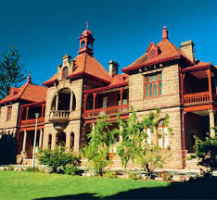

One of the Victorian era, Oudshoorn Feather Palaces

The ostrich is an animal that has dramatically born the brunt of the human species’ vanity, greed, and exploitation. At the end of the 18th century ostrich feathers were in high demand all over Europe as a fashion accessory used to make boas and hats. Huge ostrich farms sprung up in and around Oudshoorn, a small desert town in South Africa. Whereas there were only 80 ostriches being bred in 1865, by 1875 there were 200,000. Feather palaces sprung up in the area owned by the great feather barons. However, with the coming of the automobile, these kinds of accessories were highly impractical as the hats and feathers would blow away in the wind. By World War II, ostrich feathers were irrelevant and could only be used to make feather dusters. The industry crashed, and as a result the ostriches were decimated and regarded as useless. At the end of the war there were still 314,000 domesticated ostriches left in South Africa but by 1930 this number had declined to only 32,000, and to 2,000 by 1940.

The industry was revived by a Texan who found that the hide was excellent for making cowboy boots, and the flesh was healthy and virtually fat free. The ostriches were brought back from the brink of extinction again because of their usefulness to humans. Today the ostrich farms are thriving; they bring in revenue from their hides, meat, and tourism. This is the tragedy of the second quadrant development and state of consciousness. The greed of humans takes precedence over all else, and leads to a total disregard of other species, the land, and the inter-being of life. The entire industry is built on unaware ego demands, exploitation, disregard for the ostrich, and little understanding for its role and presence in the grand scheme of creation. The ego does not really see the value of something if it is of no use to its survival and pleasure. The soul, on the other hand, sees the intrinsic beauty in everything.

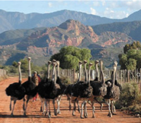
I am hoping that when you meet the ostriches you will fall in love with them; that you will see their magnificence and recognize that they have as much intrinsic value as any other living species. Their presence enriches the world and gladdens the heart. Can you learn to see the ostrich through the eyes of the heart instead of the grasping of the rational brain? Can you see the ostrich with your soul that seeks relationship and connection instead of through the lens of the ego that wants dominance?

Of course, the ostrich is just one small example of the massive exploitation of the planet. However, if we can just fall in love with one creature, we will never want to hurt, exploit, kill, destroy, disregard, or turn a blind eye to what is happening all over the world.

If the heart is awakened, we will seek to find a way to live in harmony with all other creatures. We will treat them with respect, have empathy, honor the role they can play, and give thanks for the gifts they give. We will want them around because when we see them, they make us laugh, our hearts will leap with the sheer thrill of seeing these huge, flightless birds, our imaginations will be aroused, the poet will be awakened, and our souls stirred as we see God expressed as ostrich.

We will understand that at the most essential level of Life in form, we and ostrich are one. We will not arrogantly see ourselves as superior to this animal, even though it has a brain the size of a pea. Instead, we will seek to humbly understand what we can learn from the ostrich. We will wonder why it eats some insects and not others, what vegetation it prefers and why, how its digestion works, what amazing qualities its eye has (the largest of all land animals). We will learn from ostrich which insects will make good food for us as humans, as the need for protein and the production of livestock reaches impossible ratios. We will be amazed and curious and delighted and open. We will see ostrich as our relative and friend instead of an object for our use. We will recognize its sacrifice as food for the lion, the leopard, the hyena, hunting dog, and the human, and be grateful for its contribution.

It is a tragic and pathetic thing to recognize that a species only continues to exist if it has some commercial use to humans.

“The more clearly we can focus our attention on the wonders and realities of the universe about us, the less taste we shall have for destruction.” ~ Rachel Carson

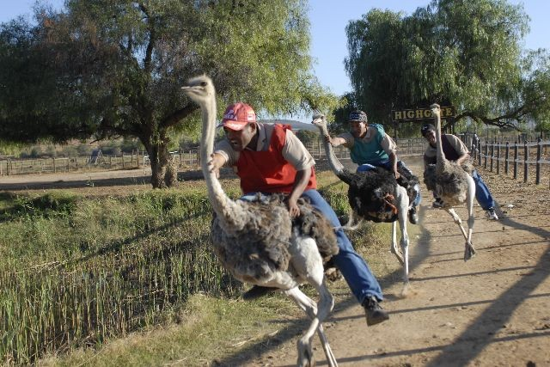

Exercise

Find within yourself that place that says, “What’s the point of having ...... (eg. mosquitoes? weeds?)”
Find within yourself that place that wants pleasure, comfort, enjoyment at the expense of another species.

Find the part inside of yourself that is willing to kill, destroy, exploit another species for your own gain, comfort, pleasure.

Find the part of you that gets defensive and says, “So what?”
Find within yourself the place of superiority, judgment.
Find the part inside of you that says, “It’s me or them.”
Find the part inside of you that says, “Animals are less important than people” ... the part that categorizes, labels, compartmentalizes, creates hierarchy and division, classification and difference.

Why do you have these beliefs and attitudes?
What is your fear?
What is your need?
What is your rationalization for this attitude?
How do you justify your attitude?
How does need become greed?
Where is the cut off place?
Does a lion kill out of greed or need?
Find the place inside of you that gives up and cannot see a solution to everything living in harmony.
Is there a part of you that seeks a creative solution and is willing to work to find one?
What do you really know about the ostrich?
Where did the idea that an ostrich buries it’s head in the sand come from? Is it the ostrich that lives in denial and does not want to see the truth, or humans?

“Ethics that focus on human interactions, morals that focus on humanity's relationship to a Creator, fall short of these things we've learned. They fail to encompass the big take-home message, so far, of a century and a half of biology and ecology: life is, more than anything else, a process; it creates, and depends on, relationships among energy, land, water, air, time and various living things. It's not just about human-to-human interaction; it's not just about spiritual interaction. It's about all interaction. We're bound with the rest of life in a network, a network including not just all living things but the energy and nonliving matter that flows through the living, making, and keeping all of us alive as we make it alive. We can keep debating ideologies and sending entreaties toward heaven. But unless we embrace the fuller reality, we're in – and reality's implications – we'll face big problems.” ~Carl Safina

