Chapter 18 (part 2) - Anthropomorphizing Animals

“But I learned at my expense that Father believed there was another animal even more dangerous than us, and one that was extremely common, too, found on every continent, in every habitat: the redoubtable species Animalus anthropomorphicus, the animal as seen through human eyes. We've all met one, perhaps even owned one. It is an animal that is ‘cute’, ‘friendly’, ‘loving’, ‘devoted’, ‘merry’, ‘understanding’. These animals lie in ambush in every toy store and children's zoo. Countless stories are told of them. They are the pendants of those ‘vicious’, ‘bloodthirsty’, ‘depraved’ animals that inflame the ire of the maniacs I have just mentioned, who vent their spite on them with walking sticks and umbrellas. In both cases we look at an animal and see a mirror. The obsession with putting ourselves at the center of everything is the bane not only of theologians but also of zoologists. I learned the lesson that an animal is an animal, essentially and practically removed from us, twice: once with Father and once with Richard Parker.
Martel, Yann. Life of Pi (p. 39). Houghton Mifflin Harcourt.”
― Yann Martel, Life of Pi

The harm that is done by anthropomorphizing animals is enormous. When we attribute human qualities to animals that they do not possess, then we have expectations of them that they cannot meet, and we punish them when they do not fulfill our needs.

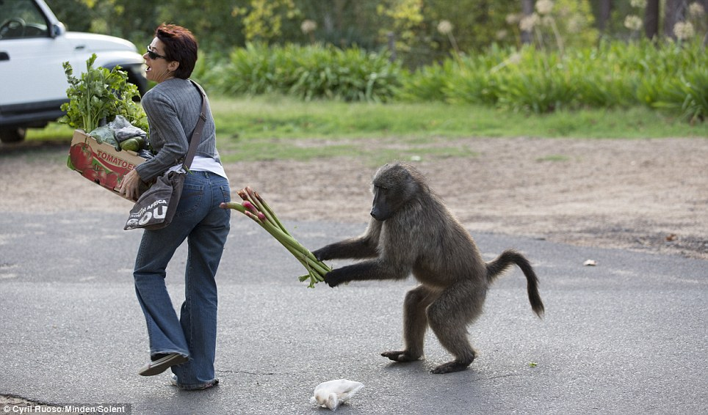
A recent example that I have experienced is the baboons that frequent the grounds of the housing and golf estate on which my sister lives, adjacent to a natural wilderness. The baboons have learnt how to get into houses and even open windows that are not latched down. They have discovered that inside these structures there is easily available food. To say that they are “naughty” or “bad” is to attribute human motivation and moral intention to a creature that is operating out of instinct, not ego. And it is “naughty and destructive” to elimination, which is what has happened in vast areas of Africa. It is not true that baboons are naughty, bad, evil, destructive or wrong. They are just doing what baboons do, which is to use their intelligence to forage for food to meet their need for survival. Because they might destroy human property in their foraging activity does not make them “destructive” animals. It just means that humans need to use their own intelligence to learn to live with the normal and natural behaviors of other species instead of themselves being destructive. In this picture is the baboon in Cape Town “stealing,” groceries? Is he “bad?” Of course not. He is being a baboon – a social animal that shares food with his troop.

Whenever we decide that one species is “good” and another is “bad” we are choosing one over the other. Mostly, “good” means the animal can be trained to do human bidding and “bad” means that they create some inconvenience or challenge to humans. The “good” animals get bred into “cuter” versions of what they originally were, and the “bad” ones go extinct – very much like a lot of parenting that happens. If a child meets our needs they are rewarded as “good,” and if they don’t they are punished and abused as “bad.” How on the earth is this respectful or honoring?

The number of examples of the damage done to other species as a result of attributing human characteristics to them are too numerous to mention, but another one that irks me is the attribution to dodos being stupid, slow birds being used as the reason for them being exterminated by humans. Really? They didn’t aggress or flee, they were just living dodo lives and we ate them all, and our domesticated animals ate the young and the eggs. How marvelous to be able to blame the dodo for our own stupidity and destructiveness. Mostly what we attribute to other species is merely a projection of some quality within ourselves that we don’t like, or that we really do like. We are not even seeing the animal – we are just seeing ourselves reflected in them. Nothing could be more dishonoring, disrespectful, and dangerous to other species.

Then there are those animals that are so “darling” and “cute.” Again we are not truly relating to the animal – only to our own projections. Recently my sister took her two dachshunds over to her daughter’s house. Before taking them in she asked her daughter if the cats were locked up. Her daughter dismissed her concern with “They will be fine.” Just because these dogs have been trained to live with humans does not mean that they are not driven by instinct. A cat appeared. It is furry and it moves, and the dachshund is an efficient predator. Luckily the dog only managed to grab the tail of the cat before it was rescued, but another minute and the cat would have been ripped to pieces; not because the dog is “bad,” but because that is what they do instinctively. And just because the dog can beg for food, and sleep with one on the couch, and whine for attention, does not make it “cute” or “human.” To not really see the dog is to not appreciate or really love it for what it is, which is God in dog form, not human form.

The use of our darling pets to meet our own needs instead of theirs is what leads to pet owners keeping suffering animals alive, spending ridiculous amounts of money to save their lives for a few months longer. We must ask how the lack of mercy, kindness, and plain humanity is “loving” a pet. It is not. It is nothing but selfish self-interest.

How many magnificent creatures have been reduced and diminished into being human toys and entertainment in circuses and homes? How many have been captured, trained, locked up, declawed, caged, bred out of their original form, eaten, exterminated, used – all to meet some perverted need in humans? When will we start taking back our projections and live in mutual and respectful harmony with the rest of creation? Only when we truly see and understand who and what they are and relate accordingly, with deep respect and reverence, instead of seeing them as useful to meet our needs only.

“’People will say we're being a little bit anthropomorphic?” I remembered Brendan's use of the word – “human-like”.
“Anyone who doesn't believe that animals are aware that they have family and friends, and care about them, must also be a paid-up member of the Flat Earth Society, or still think the sun revolves around the earth,” replied Dylan disdainfully. “I mean, how switched off can you be? How can anyone still believe animals don't have emotions? They're alive and emotions are a response to life. I've seen warthogs that are more intelligent and more responsible than some people I know. Not to say better parents.”
~ Lawrence Anthony, The Last Rhinos: My Battle to Save One of the World's Greatest Creatures

© Lyndall Johnson March 2015

