Chapter 21 – Awakening to the Sacred Space Within

Every inch of the world is sacred – there is no such thing as a “sacred place.” And there are places on the earth that activate states of consciousness within that are joyful and peaceful. These are places that resonate with the inner beauty and wildness within us, and the resonance awakens this state of consciousness briefly – and it is at this moment that we know the sacredness of our experience in form. It could be a place in which you felt this aware, awake, alive state as a child and so memories of this place immediately evoke the remembrance of the time and place, and yet, it is not the time or the place but the inner space that is remembered.

I have many such experiences of awakening, often activated by the experience in nature that opens me to my own inner peace, harmony, joy, love, and beauty. It is an electric, sensual, complete stillness – the outer matches an inner space of Self. One such event in Malawi was being alone on a hill that was mostly rocky outcrops, and coming face-to-face with a troop of baboons that regarded me suspiciously – the still, silent heat, with just the cicadas singing, and face-to-face with my relatives awakened me to a primeval joy and love within; standing in the middle of a vast swamp and suddenly realizing I am in the middle of a herd of elephants and the only sound these great beasts were making was the rumbling of their stomachs and the tearing sound of reeds as they fed peacefully all around me; being on the Indian ocean and a huge wave cresting with the outline of the whale translucent in the wave; seeing the Golden Buddha in Bangkok and feeling the inner space of nobility, solidity, dignity; or lying in a tent in the middle of Africa and hearing the lions roaring, the hyenas laughing – I am immediately home, within myself. So many experiences – all now sacred places for me because in these places I awakened to inner space. If we could only remember this inner state wherever we are, with whomever we are with. All we must do is Wake Up! With practice this becomes more and more of our experience of this earthly life – truly it becomes heaven on earth.

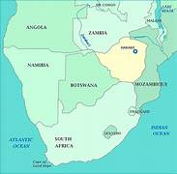
One of my most precious sacred spots is a wild and inaccessible part of Africa on the Letaba river where the countries of South Africa, Zimbabwe, and Mozambique converge. Standing on the banks of this great river you can experience yourself in three countries at once. Whenever I get caught up in the mundane grind of everyday experiences of pettiness, meanness, power and control, mindlessness, and cruelty, and distracted by inner shame and fear, I just think of this spot and I am immediately awakened to the still peace within, the electric potential of life, the pulsing movement of spirit in form, and I am home within myself in an infinite knowing of joy. Although I can most immediately awaken to this part of myself in the African bushveld, it can happen anywhere on the planet – in an art gallery or a ghetto, the north woods or the Arizona desert, the sea or the mountains, the bustling of Times Square or the inner sanctum of a great cathedral. This place then becomes a place of pilgrimage, a sacred site – for me. Others will walk through it with no such awakening… but will find their own spots of awakening.

Perhaps you too can find the awakened state within yourself that was activated by an external reflection of your own inner space Or at least you can watch for when you feel this inner space, and instead of attributing it to something external to yourself, recognize the awakening within, on this trip. Think of places that have resulted in an opening of space within you and start marking them on a world map with a gold star.

The Pharisees

I stand before the pharisees.
My restless thoughts
search for an escape
from the pounding of my heart
the agitation of fear
the agony of shame,
… instinctual, unwarranted.

How do I stay in a place of compassion – but not weakness ...
outrage – not anger ...
clarity – not confusion ...
determination without defensiveness ...
peace not lacking power ...
stillness and well
considered action...?

Awake to my anxiety ...
instead of consumed by it.

And nothing helps.

Until,
I remember
that deep within
the recesses of my own heart
is a holy, sacred place of peace.


I am standing on high ground.
The Great Letaba River winds lazily
through the juncture of three countries.

The hot African sun
filters through the leaves of the mighty fever trees
their smooth, lime green trunks reaching high above me
providing refuge for a flock of turquoise and yellow bee-eaters.
I feel the powdery, warm, silky sand of the earth beneath my feet.

As I watch the ancient, waiting crocodiles basking on the banks,
nervous, delicate impalas approach the water’s edge
alert to the slightest alarm
ready to bolt back to the underbrush of Lala palms.

And then
I hear the wild, wild haunting call of the African fish eagle
as she majestically glides through the river valley
and my heart soars free with joy
and I am home.

I am
Home,
free of the last judgments,
facing the pharisees before me and in me
with compassion and outrage,
clarity and power,
determined and at peace,
still and strong and awake.

© Lyndall Johnson

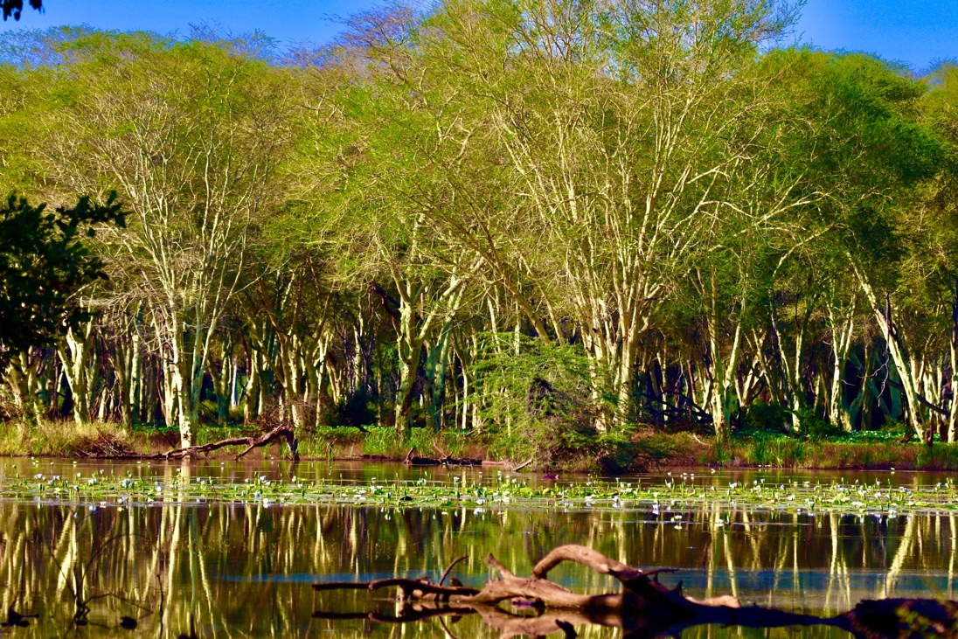

Fever Trees – food and home to many animals and pollinators –
hence the bee-eaters being around this part of the world in abundance.
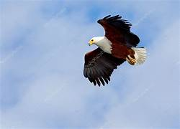

Fish Eagles

The African fish eagle has a haunting, primeval cry – and evokes the same feelings as the north American loon. It is not a “true” eagle. It belongs to the Haliaeetus genus of sea gull eagles – like the American bald eagle and the Eurasian white-tailed eagle. This is one of the most ancient genera of all living birds.

