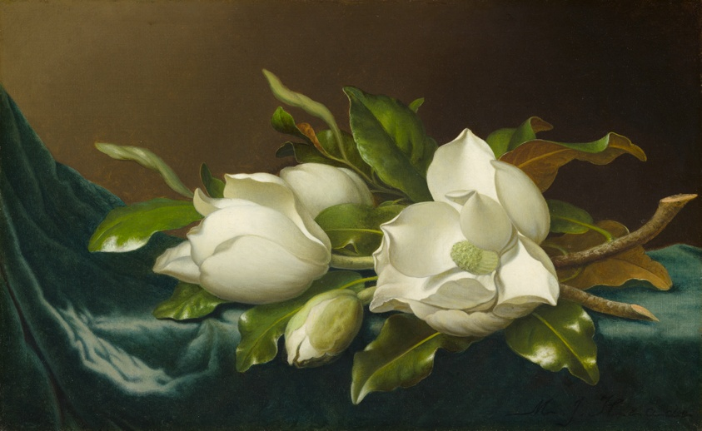
Magnolias on Light Blue Velvet Cloth - Martin Johnson Heade
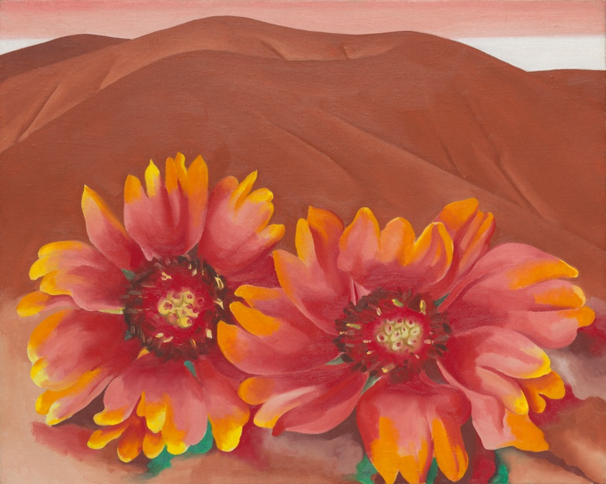
Red Hills with Flowers - Georgia O’Keeffe
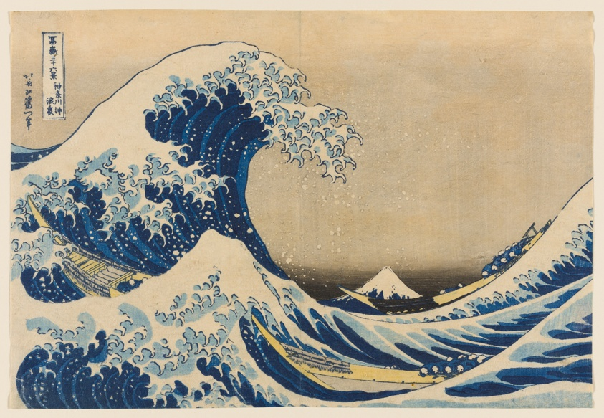
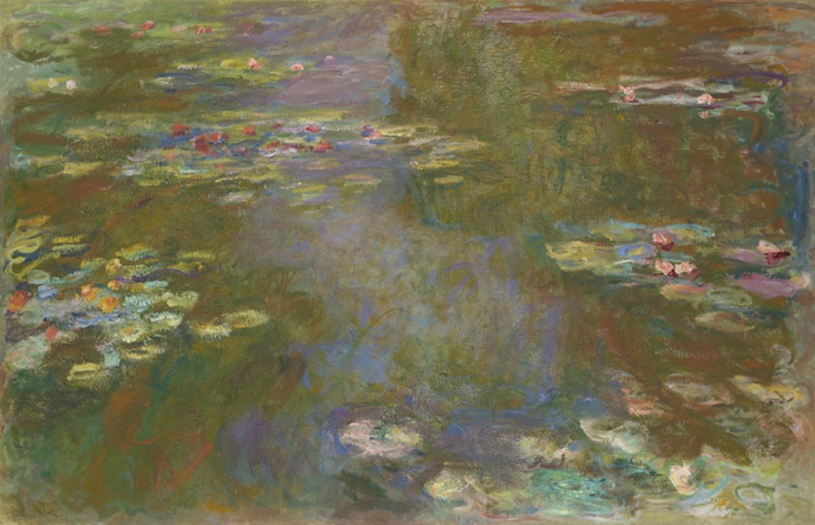
Under the Wave off Kanagawa - Katsushika Hokusai

Waterlily Pond - Claude Monet
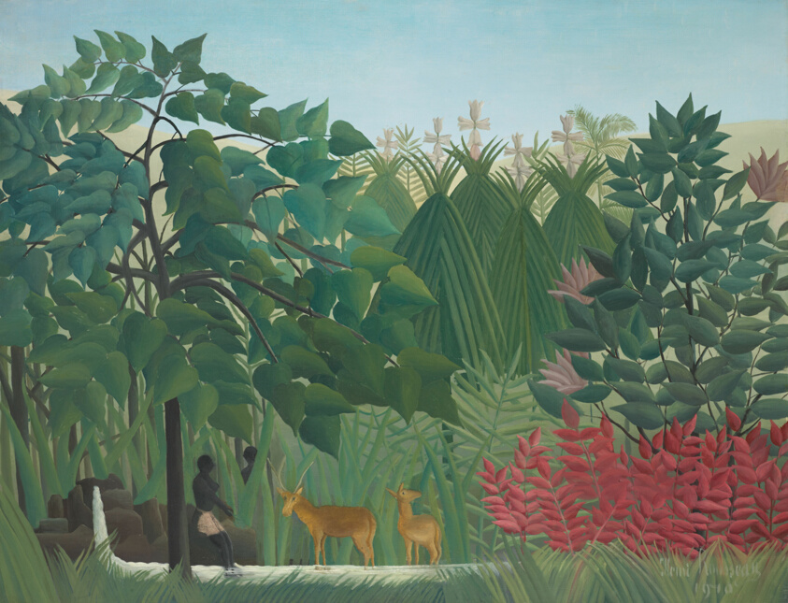
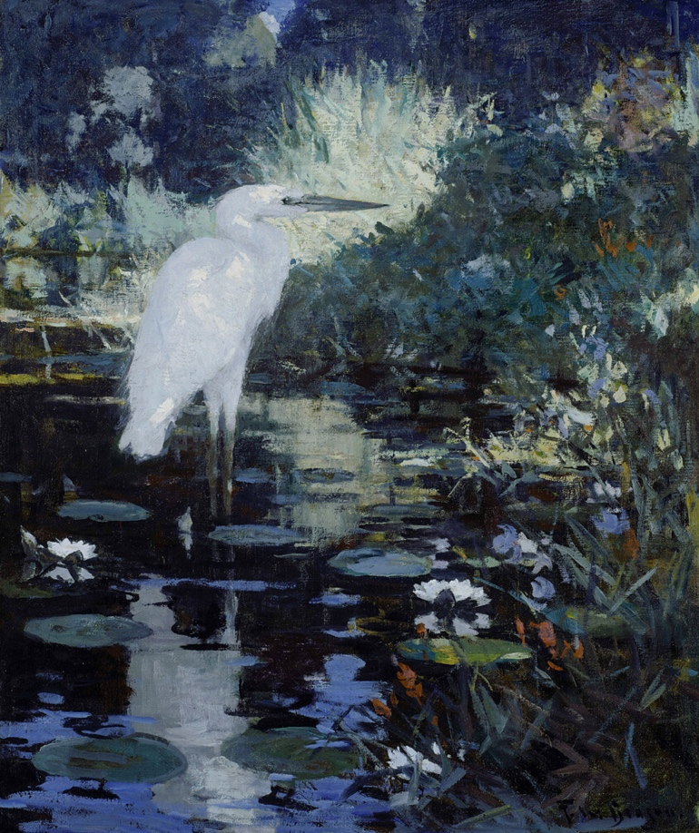
The Waterfall - Henri Rousseau

White Heron in a pool in a garden - Frank Weston

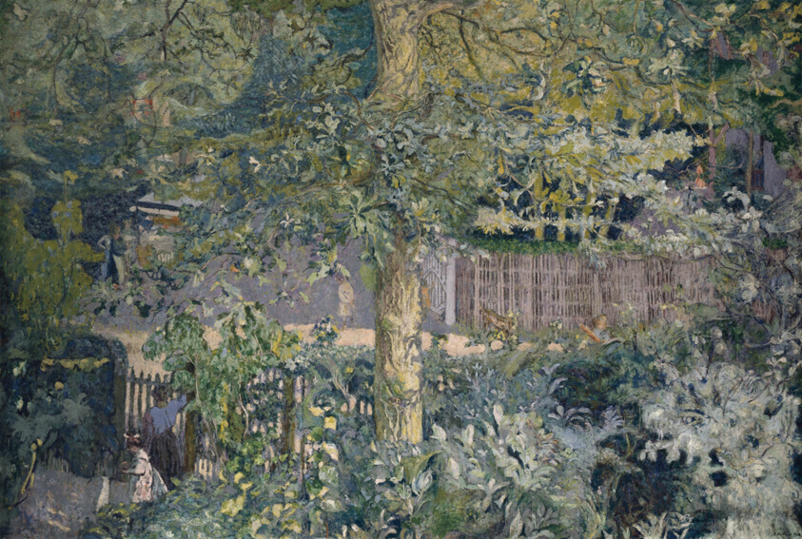

Foliage - Oak Tree and Fruit Seller - Edouard Vuillard

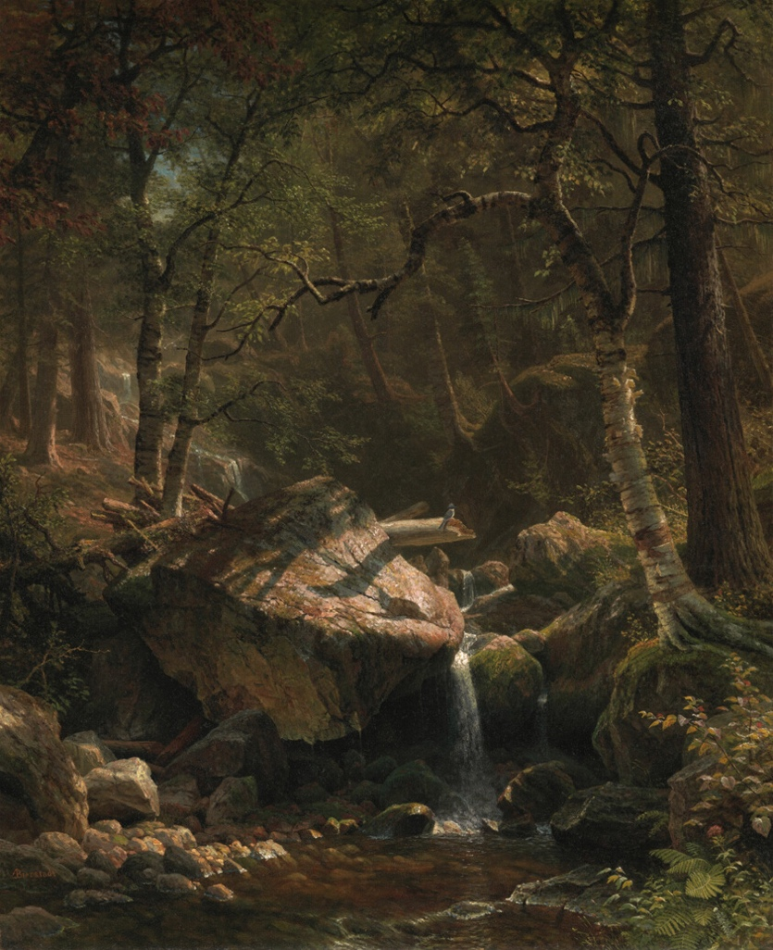
Mountain Brook - Albert Bierstadt
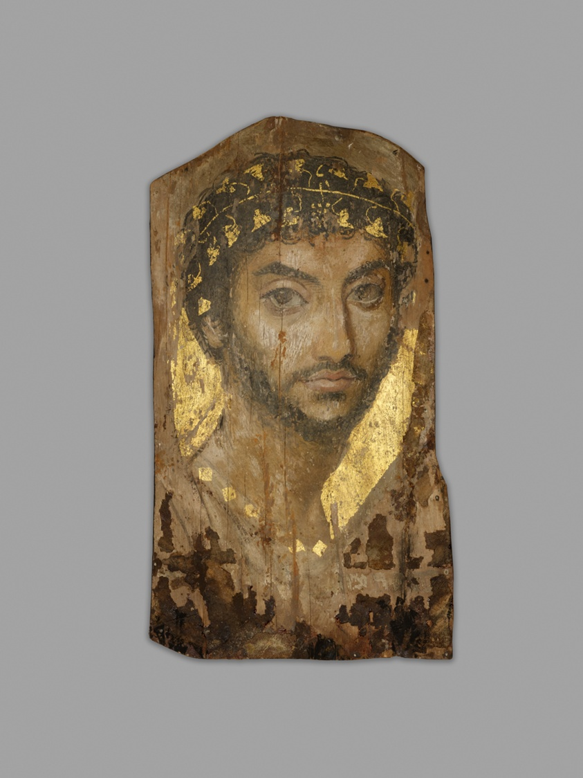
Man Wearing an Ivy Wreath - Ancient Egypt

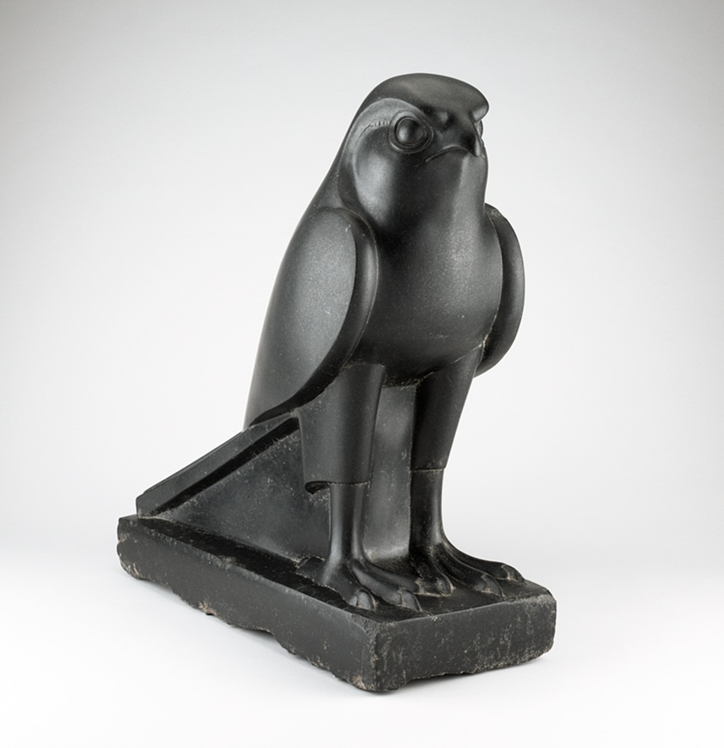
Statue of Horus - Ancient Egypt

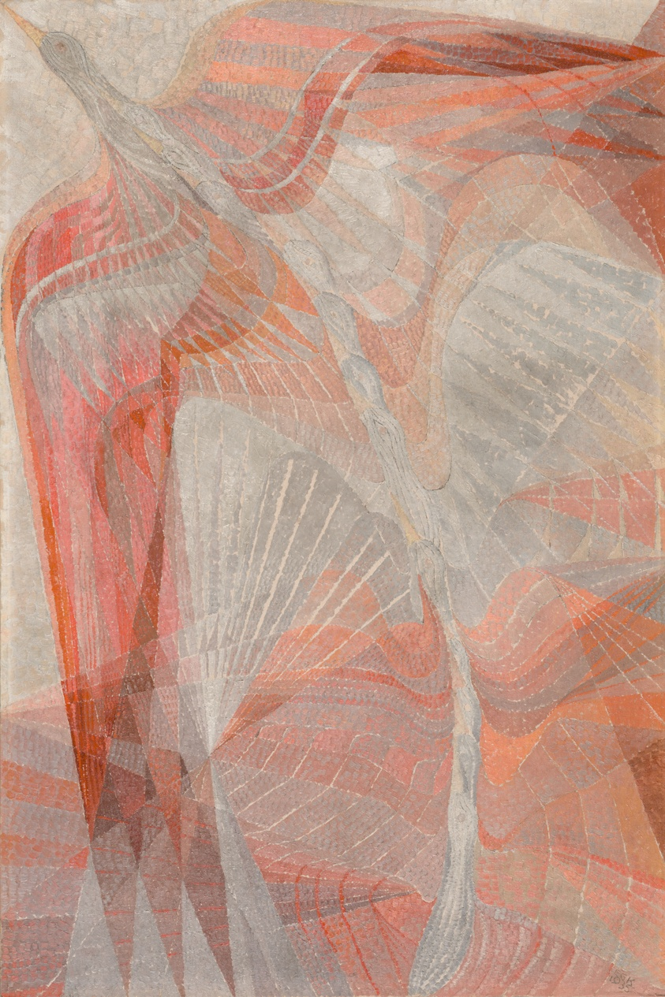
Rhythm of Bird Flight - Giovanna Klien

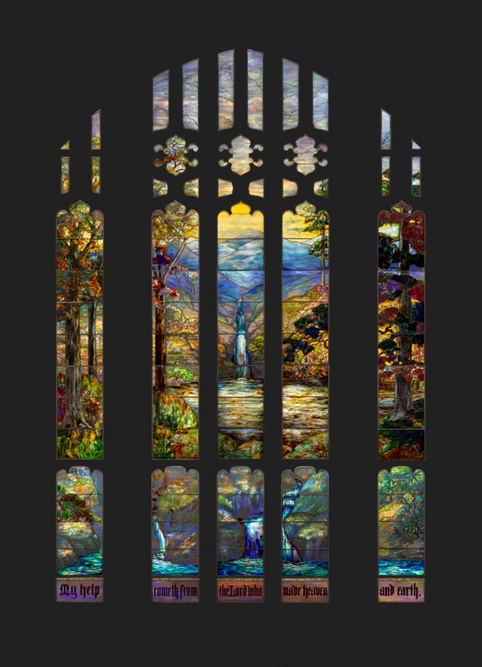
Hartwell Memorial Window - Tiffany

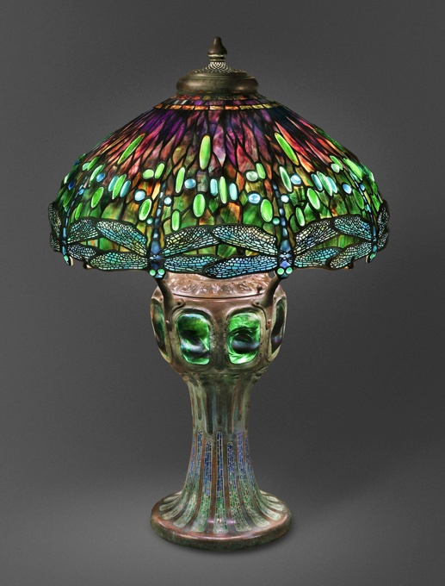
Lamp with Hanging Head Dragonfly - Clara Driscoll

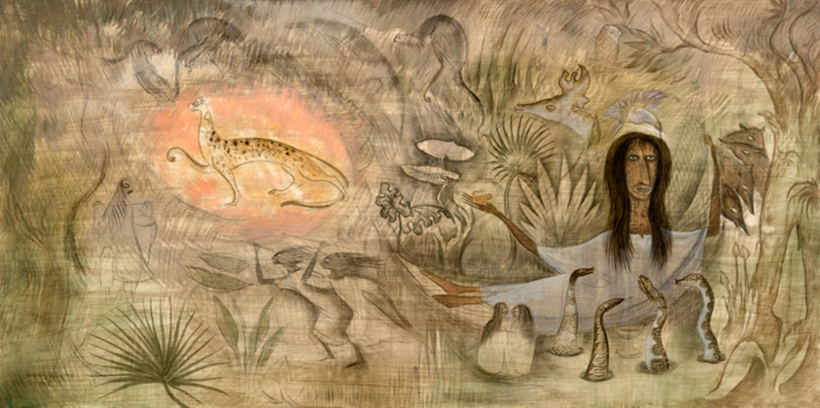
Juan Soriano De Lacando - Leonora Carrington

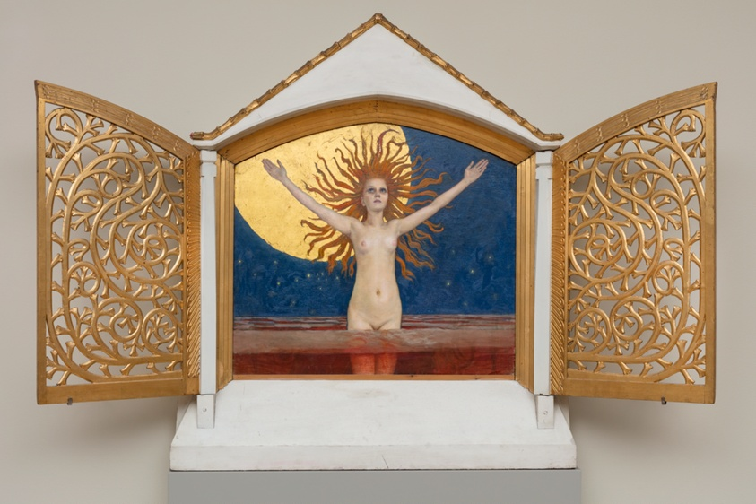
Ad Astra - Axeli Gallen-Kallela

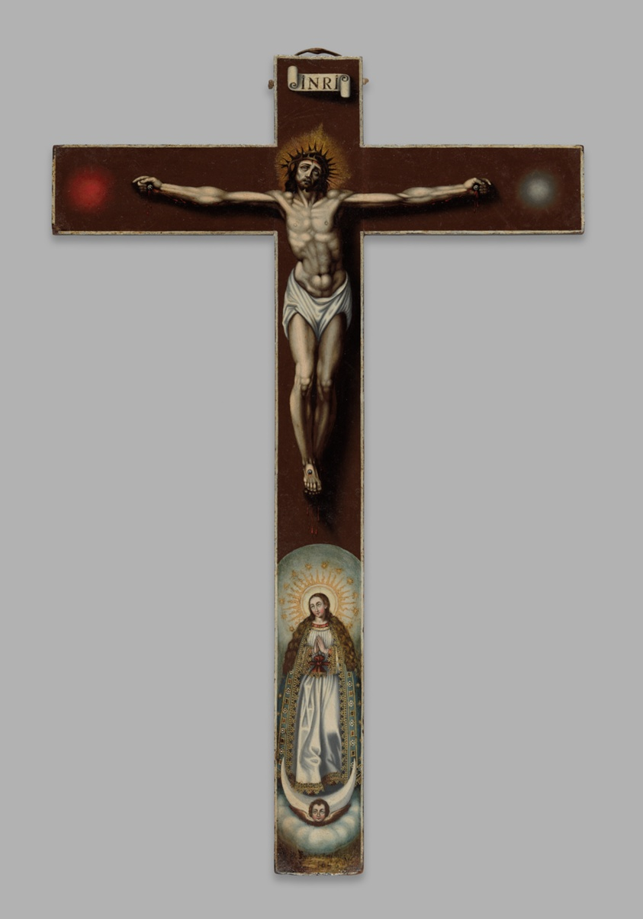
Crucifixion - Maria Josefa Sanchez

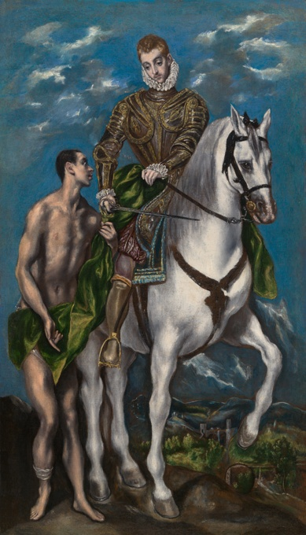Saint Martin and the Beggar - El Greco
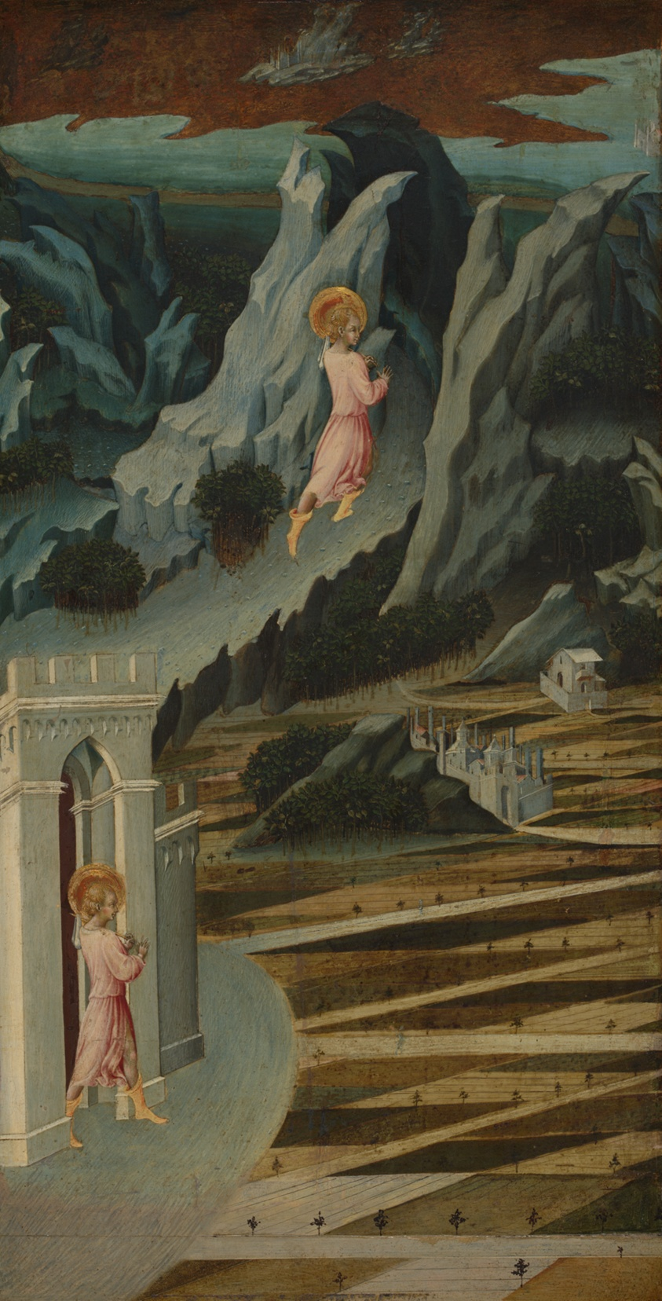
St. John the Baptist entering the Wilderness - Giovanni di Paolo

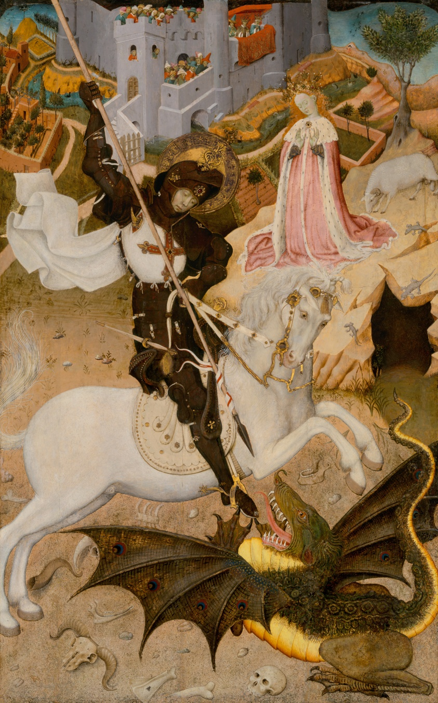
St. George and the Dragon - Bernat Martorell
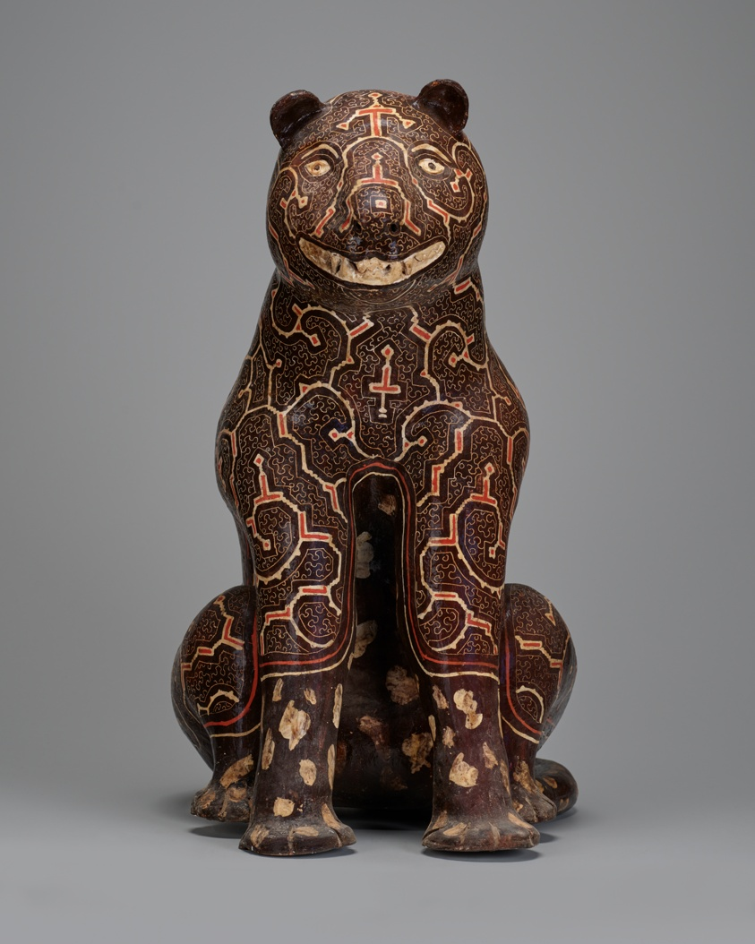
Otorongo - Celia Vasquezz Yui

