Will You Be My Mama – the Story of Kolobe the Warthog (Phacochoerus Africanus)

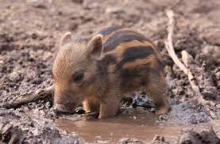
This is a very sad story with a very happy ending about a little warthog called Kolobe who lived in Botswana. Here is a picture of him when he was just new in the bushveld. His Mama guarded him fiercely and loved him deeply and thought he was the most beautiful baby warthog in the whole world. She called him Kolobe, which means Warthog in Tswana, because that is what he was.

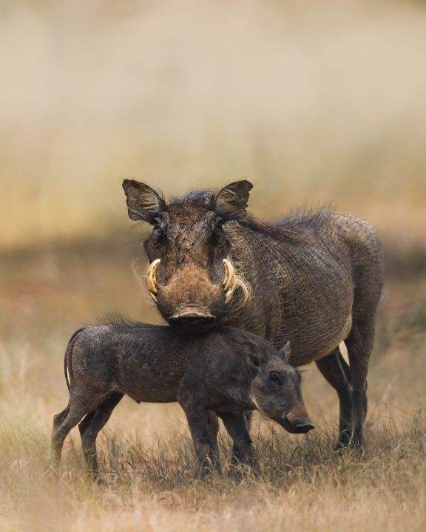

They were very happy together trotting through the bushveld searching for delicious roots and berries, grass and bulbs. Mama warthog taught him to get down on his knees and dig with his nose for roots. She taught him which grasses were succulent and tasted good. She taught him to kneel on his elbows so he could reach the water to drink at waterholes. She watched out for him and always wanted to protect him.

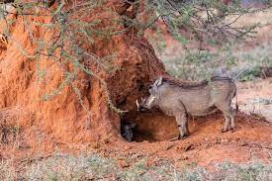
She taught him to go into a burrow she stole from an aardvark every night. Kolobe went in first and then Mama so that she could protect the entrance to the burrow and keep her precious little Kolobe safe. She also had big tusks to fight off anyone who wanted to hurt her and big warts that protected her face from others attacking her.

Little Kolobe didn’t have big tusks or warts yet. He needed his Mama to help him and teach him and protect him.

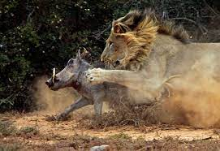

Kolobe was still just a tiny little warthog when the unthinkable horror happened. It was a terrible day that Kolobe never forgot.

A lion caught his Mama and ate her for dinner and little Kolobe was left all alone in the world.
Little Kolobe was so scared and couldn’t do a thing to stop this from happening. He froze in terror and then ran away as fast as he could to the burrow.

Little Kolobe cried and cried. He felt alone in the world, and he was very scared. What if that lion came back and ate him up too. He hid for many days in the burrow in which he and his Mama slept at night.
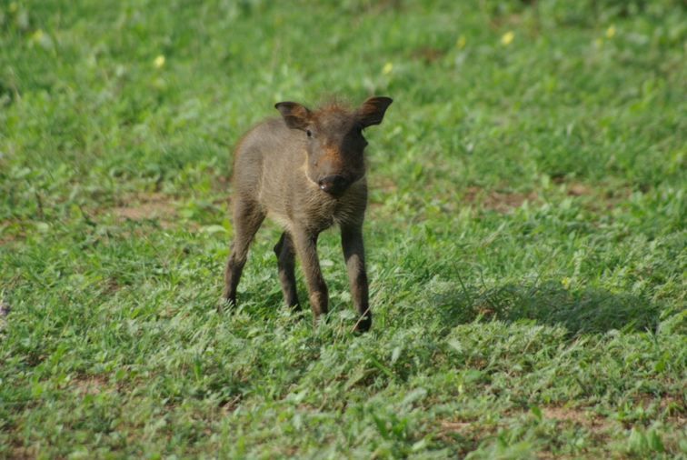
But he was very hungry and thirsty and finally he carefully poked his head out of the burrow to make sure the lion was gone. Very slowly and watchfully he came out and started to dig in the ground like his Mama had taught him to find roots to eat. He found some green juicy grass. He wondered if it was his fault that the lion caught his Mama. Maybe she would have run away faster if he was not there. He felt ashamed and sad and very scared. He felt like he was useless and stupid that he couldn’t save his Mama and fight the lion. It seemed he must be a very bad warthog for this to have happened. But the worst was he felt so alone. Sadly, he went about his days all by himself.

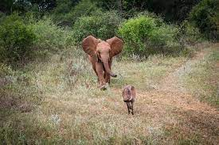
As he wandered through his day, he met other animals. One day he saw a big Mama elephant with a tiny little baby. The baby elephant was still much bigger than him, but he could see the Mama elephant looked after him very well. She helped him out of mud puddles and made sure he was safe. She was so big; no lion would try to eat her! Littler Kolobe went up to the Mama elephant, very cautiously, and said,

“Would you be my Mama?”

The Elephant looked down her long trunk at the little warthog and harrumphed as elephants do.

“I have enough on my plate without taking care of you little warthog.”

Kolobe sadly trotted away feeling stupid for asking. But he didn’t give up because he so badly wanted to belong somewhere.

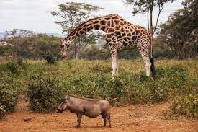
The next animal he saw was giraffe. She was a huge, tall animal and he felt very little and insignificant, but he knew giraffe could run very fast and lions would not get her easily. He wandered up, trying to look as if it was just the most natural thing in the world and asked her,
“Would you be my Mama?”

Giraffe looked down her snooty nose from on top of her long neck at this little bedraggled scrap of a warthog and with grumbling snorts said,

“I can’t be your Mama, go back to your own Mama. You are not a giraffe. You don’t belong here.”
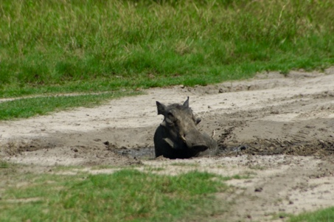
Little Kolobe felt crushed and humiliated. He would never have a Mama. No-one wanted him. He was all alone in the world. He knelt down on his elbows by a waterhole and had a long drink. He rolled in the mud – it felt good. All the ticks on his leathery skin got rubbed off him. But he was all alone, and it felt so sad.

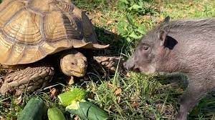
He trotted off into the bush. The next animal he came across was a big slow tortoise. She seemed calm and kind and slow and friendly. She was munching the same grass roots that he liked. He approached her very carefully.. She poked her big horny head out of the shell and regarded him as she chewed on the grass.

“Would you be my Mama?” asked the little warthog.

She kept chewing slowly and then she said,

“ Little warthog, you are fast, and I am slow. You are not a tortoise – I can’t be your mother.”

Kolobe felt despair. There was no-one who cared, no-one who thought he had any value to their lives and no-one to help him survive and look after him in this whole wide world. No one valued him and he did not value himself. No-one loved him and he no longer loved himself .He cried himself to sleep under and thorn bush that night.

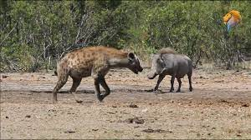
The next morning, he went down to the river. He was thirsty and hot. And there he met hyena. He did not know this animal and he had no mama to warn him about hyena. She looked very kind and interesting with her big ears and spotted fur. Little Kolobe stood his distance and the hyena looked at him with interest.

“Would you be my Mama?” asked Kolobe.

The hyena cackled as hyenas do,

“Yes, I would love to be your mama, why don’t you come over here so I can get to know you?”

Drool was coming down her mouth as she considered this tasty morsel of a warthog for dinner. Kolobe watched and slowly went closer. He wasn’t sure he trusted her, but he so badly wanted to belong to someone.

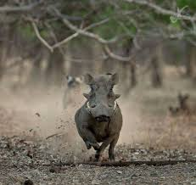
“Come closer, little warthog. It seems you are all alone in the world. We are a big family, and we would welcome you into our family. “

Kolobe felt a warm feeling of happy come over him – at last, a kind stranger willing to be his Mama. He took a few steps closer.

Suddenly, just as he was relaxing, hyena burst into a charge and her jaws nearly snapped shut on little Kolobe. He got a big fright and ran like the wind, with his little tail up in the air. Oh no, he said to himself. This is a dangerous animal like lion. I was nearly dinner like my Mama. As he thought about this, he started crying again. The only person who said she would be his Mama wanted to eat him for dinner. What a horrible thing to do!

It was a few days before Kolobe recovered. He hid all by himself in a deep ditch, too scared to come out into the open. For many days, he rooted for food all by himself. He watched the zebra and the impala, and in his heart, he knew he would not be welcomed. They would let him wander close by, but they did not talk to him, or care for him at all. He was an orphan. He belonged to no-one, and he was all alone.

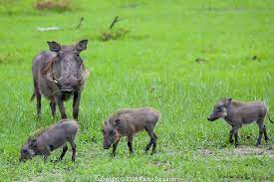
And then one day, Kolobe came across a Mama warthog with three little babies. He was ecstatic. They looked just like him, perhaps she would adopt him together with the other little warthogs. He rushed up to her, but she immediately stood her ground bristling with indignation,

“What do you want warthog?” she grunted fiercely, “You stay away from my babies!”

Kolobe was confused,

“I just wanted to know if you would like to be my Mama?” he beseeched her.

Now the Mama warthog was mad.

“You get away from my babies, I don’t trust you at all!” she lowered her head and squealed a warning, showing her tusks, ready to charge Kolobe.

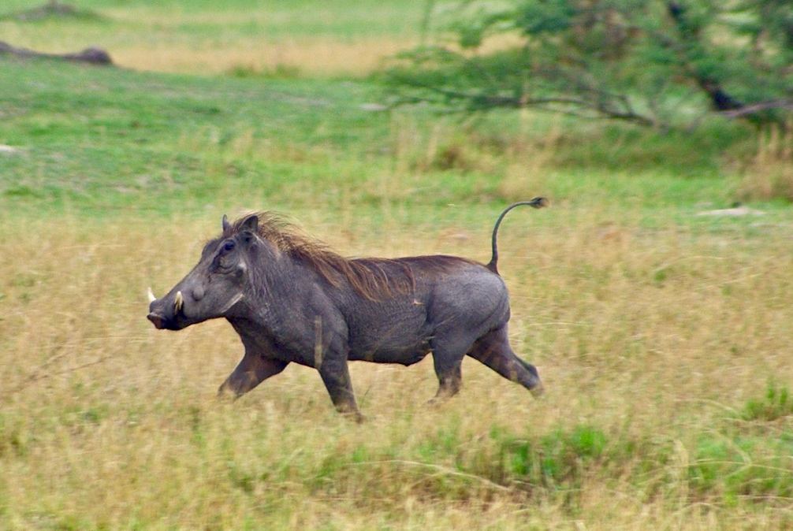
He fled, tail in air. Now he knew. There was something so wrong with him. Not even his own kind wanted him. He had to be the worst animal in the bushveld. He was despicable and hateful, and he hated himself. And he felt completely ashamed.

The days stretch on ahead of him, all alone, sad and depressing.

One day a troop of baboons came by. Kolobe watched them. There were many babies and many Mamas. It was only him that did not have a Mama. He felt very sorry for himself. He watched and watched and wondered if maybe baboons would be friends with him. Somehow, he just could not give up on trying to find a mama. He went up to a big Mama baboon and said,

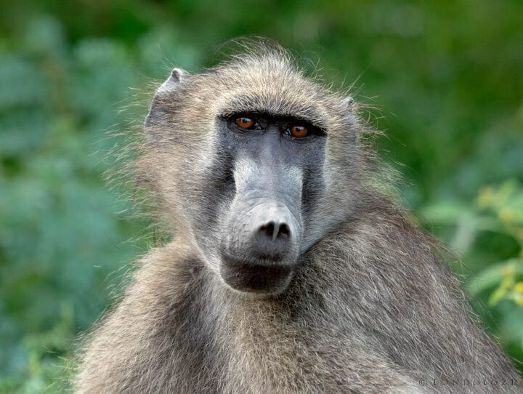
“Would you be my Mama? I am all alone in the world. I am scared. No-one cares about me. A lion ate my mama,”

Mama Baboon squinted up her brows and looked at him with her beady, wise eyes, that glowed like amber. She took a moment before she answered and then she said,

“You are a great big warthog – what do you need a mama for? Look at your tusks, look at your big warts.”

Kolobe was taken aback.

“What?” he said.

“Yes,” said Mama baboon emphatically,

“You are being silly. You can take care of yourself. You can be your own Mama.”

Kolobe gasped – this is not the story he knew about himself.

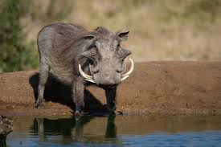
“Go and look in the river and look at yourself,” said Mama baboon. You are a big, beautiful , strong, and very fast warthog. Kolobe trotted over to the river and looked down and there staring back at him was a great big grown-up magnificent warthog! He had big tusks to protect himself, big warts to protect his face, strong fast legs and now he knew he was also smart!He trotted back to Mama baboon. He was astonished! “What the heck,” he grunted and snuffled to himself.

“You are right! I didn’t know I had grown so big,” he said.

“Yes,” she said, “Seems you took pretty good care of yourself even though your Mama was eaten by a lion!”

“You can be your own Mama for the frightened little warthog inside of you. That little warthog belongs to you, not me, silly! You are big – you take care of the little scared, alone you. You are now the Mama for that little warthog… and the Papa.” she added.

“And you are old enough to have your own family. If you can take care of the little warthog inside of you, you can also take care of little baby warthogs you might have!” You don’t ever have to be alone again.
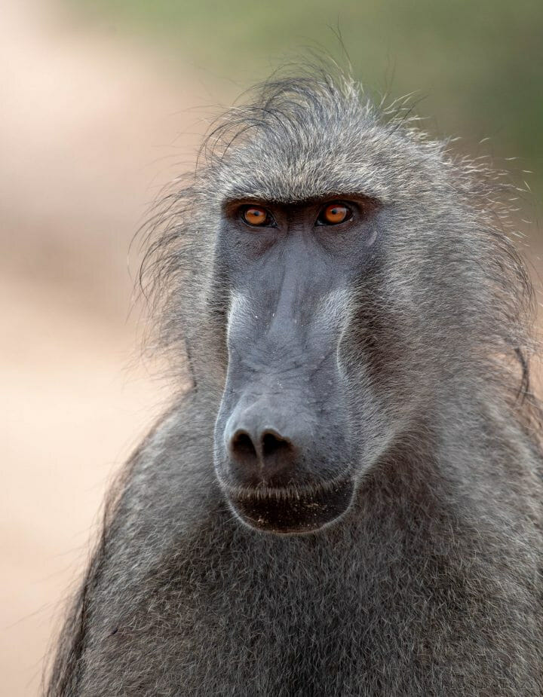
Baboon regarded him from under her bushy eyebrows.

“And by the way,” she went on, and because she was wise, her kind, amber eyes pierced into him,

“It’ wasn’t your fault the lion ate your Mama. You can stop all the silly stories about being bad and stupid and wrong and inadequate. You were just a little baby and couldn’t do anything. “

She knew that warthogs, even though they look like they have thick skins, always thought everything was their fault – so silly!

Kolobe thought this over. True! That little warthog with all its fears still lived in him, but he was big, and he could be there for that little guy who had always been alone. In fact, he had been there, he just didn’t realize it. Suddenly he laughed and snorted, and his tail went straight up in the air. I am a whole family inside of me! I can do this. My Mama would be so proud of me taking care of that little warthog that was left behind when she got eaten! I know she loved me and so I will love me too.

“Thank you, Mama Baboon. You are the first animal that has told me the truth!” And he trotted off into the bush with his tail held high.

Mama baboon watched him go and then gently lifted her baby on to her back and sauntered off into the bush with the troop, thinking to herself that warthogs were kind of dumb – they always thought they caused things to happen, that it was their fault when it is just the way of the bushveld.

