Camp Xakanaxa – October 2023 - Presence

“What you really see, you will remember forever.” ~ Guide and Ranger Taylor

Camp Xakanaxa (pronounced Ka-ka-na-ka) is on the banks of the Khwai River on the Xakanaxa Lagoon in Moremi Game Park, Botswana.

Taylor was our Bushman guide – a direct lineage Bushman. His grandfather still hunted with a bow and arrow and wore a loin cloth, living the life of a hunter gatherer, at one with the land on which he was born. Taylor, just one generation removed from this state of consciousness and way of life, was clearly the superior tracker and most bush-wise of all the trackers, calling in on the radio to the others with his latest observations. He led the chase, so to speak, finding the lion, wild dogs, ostrich, marsh eagle – all sightings that one might ordinarily see or not see, but that he ensured he found for us and all the other vehicles.

He would stop the vehicle, smell, touch and taste the air, feel the atmosphere, look at tracks, listen to the silence and know exactly which way to go. He looked up and down and through the layers of the bushveld. His ancestor’s survival depended on this kind of presence and at-one-ness with the land. They experienced themselves as part of the land, the earth, the animals, the sky, the stars, the universe.

He told a touching story of how he believed as a child that the stars were relatives and distinct beings with whom he was in relationship. As a child there were stories around the campfire telling of all these beings and relatives in the universe. When he went to university to learn to be a game ranger, he learned the science and realized he had been “wrong.” The stars were not people and beings, just dead rocks. He said it with a little embarrassment and ruefulness. I wish I could have told him how what he knew as a child was true and that everyone with him in that vehicle had to stop seeing themselves as separate and the creations of the universe as objects, and realize that they themselves were made of stardust and that stars truly are their ancestors and relatives, and that what he learned in superstitious and magical thinking in unawareness, was in fact true. I wanted him to be able to reclaim this understanding, the wonder and awe and connection he once had as a child, with the knowledge that the science of evolution has brought to our awareness.
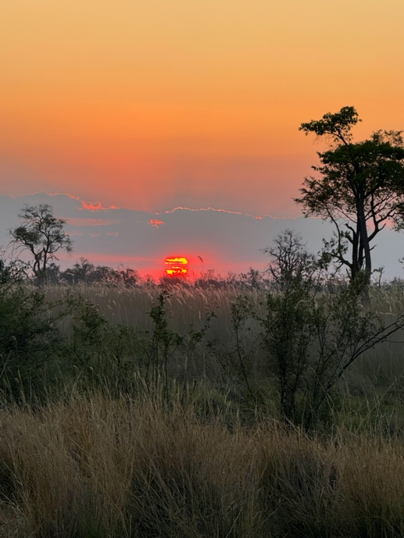
But the Truth of Unity was still alive in him. He was used to the first world coming into his world and disrupting the silence and eco-system with their clamoring for experience – their fears and ignorance of the wild, their excitement and demands for more and more. At one point he just stopped the vehicle towards the end of the day, as we were going to a lion sighting, and asked everyone to watch the great red sun slowly sink beneath the horizon. He encouraged us to feel the silence and beauty of being in this magnificent spot on the planet right in the middle of one of the wildest parts of the African continent. He ignored or was oblivious to the anxiety his guests that they ‘might not get to see the lions.’ The vehicle subsided into silence except for the jostling to get photos. And this is when he said, “ What you really see, you will remember forever.” A simple statement of absolute truth. All of what you experience of the universe and the world, the sunset, and the animals, is all within your consciousness – arises from your consciousness, is created from this consciousness. It is not separate. It is you. Just see and notice, listen and hear, smell and taste, and feel with every cell of your body to awaken what is already within your own vast consciousness. Live and breathe to have this experience. You do not have to get, capture, take, fight for what is already yours.

In that one simple statement and in that single moment of watching his face loving the sight of the sun, lay the question and the answer. Why are you taking pictures, what is your motive, what is your awareness of this moment? Not that one should not have “taken” the picture…. This is not what I am saying. It is simply a matter of awareness. Did you feel the one-ness, did you smell, taste, touch and experience the joy, the beauty, the unity? And take a picture.

Or did you just take a picture without the experience? He went on to say, “The photo you will forget, but what you really see will live in you forever.” © Lyndall Johnson

“The Bushmen in the Kalahari Desert talk about the two "hungers". There is the Great Hunger and there is the Little Hunger. The Little Hunger wants food for the belly; but the Great Hunger, the greatest hunger of all, is the hunger for meaning...
There is ultimately only one thing that makes human beings deeply and profoundly bitter, and that is to have thrust upon them a life without meaning.
There is nothing wrong in searching for happiness. But of far more comfort to the soul is something greater than happiness or unhappiness, and that is meaning. Because meaning transfigures all. Once what you are doing has for you meaning, it is irrelevant whether you're happy or unhappy. You are content - you are not alone in your Spirit - you belong.” ~Sir Laurens van der Post: The Lost World of the Kalahari

Read this website: https://www.survivalinternational.org/tribes/bushmen - for those of you that experienced Taylor and his wisdom, I hope you also felt his deep pain. His language is not even recognized in Botswana anymore. It is not taught in schools and the way of the Bushmen is dying rapidly. What you experienced in this man was a rare glimpse into a way of life that is gone, a state of consciousness that no longer exists except in very rare instances and a wisdom that is not heard or acknowledged. He spoke of this without bitterness or anger, but with acceptance and sadness. It was my great privilege to have shared a little time and space in his beautiful eternal Presence.

