Camp Xakanaxa – October 2023 – Interdependence

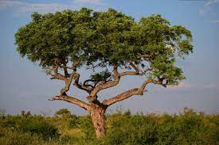
All of life is interdependent and when this balance is broken, everything suffers. It seems like a simple and obvious statement and yet, we fail to see either the cause or the effect of our decisions that disrupt the delicate and highly complex interdependence of all species. Our Bushman guide and ranger, Taylor, gave us a small lesson that was heart brea king.

Moremi in October is dry, and normally game a little scarcer and more scattered as it congregates near water sources, but this year seemed unbearably barren at the end of the winter months. The mopani bushveld seemed very low and barren and was not yet sprouting its beautiful red leaves of spring. It seemed particularly eaten down to about 4 feet everywhere I looked. In this part of Botswana, the Mopane tree can reach 70 to 90 feet and is a magnificent hard wood tree, creating lovely woodland terrain. I asked Taylor, our ranger about it.

“Yes,” the bush is over-eaten. There are too many elephants.” He replied solemnly.
“But where are all the elephants?” I asked. “They are moving on to find food,” he replied. This was disturbing and different. I could feel the change in the air, in the land, in Taylor.

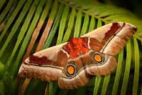
He went on to explain. “Botswana has a “very limited concession for hunting policy,” he said. “But this is not true for Zimbabwe, Namibia, Zambia, South Africa – all the countries around Botswana. Elephants are very smart. They leave these countries and come to Botswana where they are safe. And then they eat a ll the mopane trees and now we have a problem. There is not enough mopane for the elephants, or the giraffe, or the other animals that eat Mopani. And now we are not getting so many mopane worms – you know the mopane worm?” I nodded. I knew this was a source of food and a good business for local people to sell dried mopane worms, the larva of the Emperor moth

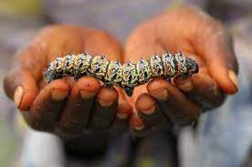
“And so,” he went on, “The people do not have the protein from the Mopane worm and so they have to hunt the animals for protein.” All the countries must co-operate with one policy if the wildlife is going to survive, and the people,” he added.

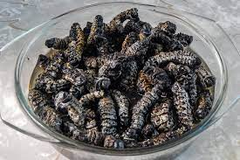

He went on to explain, that his own people, the Bushmen, are no longer allowed to hunt and that their natural hunter /gatherer existence is no longer tolerated. This posed no threat to wildlife – it was merely subsistence- living relegated to a small and nearly extinct population of people. These are not people that posed any threat to big game whatsoever.

Now very expensive licenses are still issued by the government for big game trophy hunting which is highly regulated to a certain number of trophy animals a year, with hunters paying up to $92 000.00 for a two week “safari,” to kill one elephant and one buffalo. The other countries have far less restrictions, making Botswana the safest place for big game.

There was silence in the safari vehicle. What is there to say, what is there to do? We are watching our world die because the heart of humanity has not yet broken open and is not capable of heart intelligence. This is simply not a problem that can be solved from the intelligence of the head, that can only think of ways of fixing symptoms, once the heart and soul hav been betrayed.

© Lyndall Johnson – Moremi, October 23

