The Sacred Ibis (Threskiornis aethiopicus)

One of the most seen birds here in our seaside village of Knysna, is the Sacred Ibis. Flocks will fly by, with the sun shining through their pearly white, translucent wings outlined with a thin line of black feathers, their long black, curved beaks reaching forwards through the air and their long black legs reaching backwards. They are elegant, graceful symbols of the soul, that is not time and earth bound, and that can transcend the time space realm of existence.
When they are in flight, you can so easily see how the ancient Egyptians saw them as sacred – incarnations of the god Thoth. Thoth was the god of the wisdom (and so the moon), knowledge, writing, hieroglyphs, science, magic, art and judgment. They mummified thousands of them to ensure eternal life for Thoth - the god that incarnated as them.
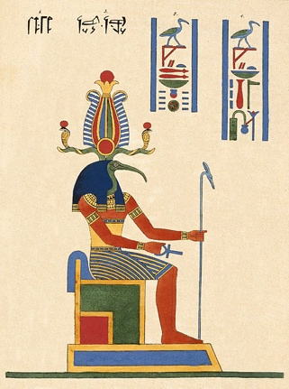
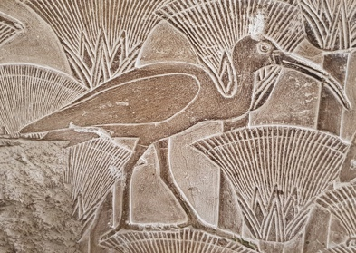


And then the other day, I inadvertently turned down a road where the city garbage was piled high at a transition depot for it to be taken to the dump. I was fascinated by the sight in front of me. Hundreds of these beautiful birds were ripping open the black garbage bags with their strong beaks, used for eating crustaceans, frogs and snails, and were raucously and rapaciously battling the sea gulls for the foul-smelling garbage. The air was filled with stench of old restaurant food. I could make out discarded fish carcasses, sushi, bread rolls and prawn shells – both the gulls and ibises were trying to steal these favorite finds from one another. There was a cacophony of fighting and screaming at one another until they were momentarily frightened by something, and then they would fly up into the air in a wind of alarmed fluttering. For a moment you could recognize their beauty, until they settled back down on to the heap and resumed their quarrelsome search for more garbage. Their tails feathers were all bedraggled with grease and filth. Their behavior was disgraceful and demeaning to who they are.
I spent a long time watching them and I was joined by one of the workers at the depot who asked me the name of this bird and so I told him all about the Ibis, adding, “Just like people, they don’t know they are sacred and so they get greedy for rubbish, fight with one another over rubbish, dirty themselves over rubbish so that you cannot even see their beauty any longer. They think they are so great and so safe at the top of the garbage heap, but they are no longer free, elegant, translucent or beautiful. I didn’t say it quite like this, but he understood what I was saying. “ Ah, ma’am, that is very true,” he said. “We call this one the rubbish bin chicken,” and walked off slowly shaking his head.
My meditation since then has been to consider each day how I demean and disgrace myself by consuming garbage, getting greedy for “stuff,” battling others for dominance in getting what I want, harbor the garbage of judgement, resentment, and irritation within, without examination or awareness.
We see this collectively so easily, but the work is to examine the ways in which we ourselves have bedraggled our feathers so that we cannot fly, have dirt on us for the ways in which we rapaciously and mindlessly consume our environment and fight with other species for dominance and greed.

To the extent that the Ibis has brought attention to this aspect of my own humanity, it has indeed fulfilled its sacred purpose of being the bird of wisdom and writing! My prayer is to see all the ways in which I am opportunistically scrapping for foul smelling garbage on the waste and refuse of our culture. How have I succumbed to the mass mania of consumerism, filling my body and mind with garbage, forgetting that I was made to fly free.

