Out of Africa – Vervet Monkeys and Fostering Dependence

“Indulged habits of dependence create habits of indolence, and indolence opens the portal to petty errors, to many degrading habits, and to vice and crime with their attendant train of miseries.” ~unknown

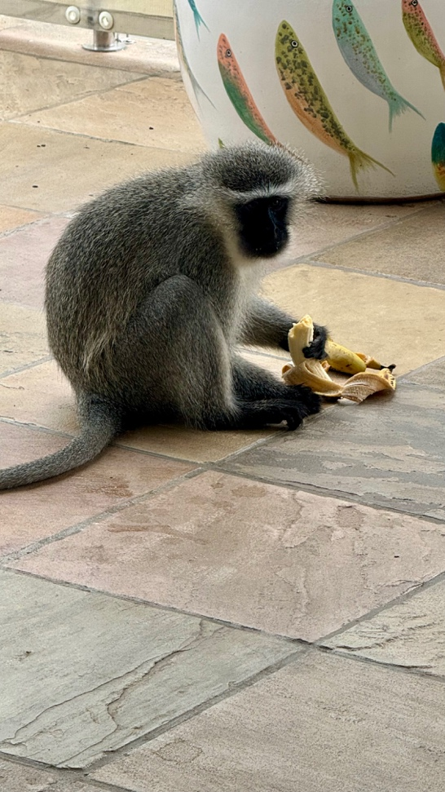
A young male vervet monkey is marauding the neighborhood. Young males leave their natal troop at puberty, around four or five years of age. This is a dangerous transition to adulthood for all primates! This young fellow is alone, searching for a new troop where he will find his place by asserting his dominance and breeding status. He must find his own food and learn to be aggressive to survive. Unbeknownst to us, he watches all the houses for an open door or window so that he can steal food. He snuck in through our patio door, jumped right onto the dining table, and helped himself to some fruit. When I asked him to leave, he grabbed a banana and, watching me the whole time, ate it defiantly before taking off.

I was aware of my delight in him. His traits are so human. I wanted him to have a banana. It made me feel good. I wanted to be friends with him. But there was also another subtle feeling, which is disturbing – one I do not want to recognize. I have power. I have the power of food, and he needs it, and so he “needs” me. It is a subtle, intrusive feeling of superiority and power. If I were not internally attentive to the energies within myself, I would miss it. I would not know how to ask myself whether he “needs” food, or whether he is being an opportunistic beggar and thief. The truth is, he is a wily, opportunistic thief and very wasteful, not that he knows that himself! By finding easy food this way, he does not have to develop his natural capacity to find wild food. He is overeating food that really is not good for monkeys. He is becoming demanding, entitled, and dangerous. People are becoming, for him, competition for the food. He doesn’t know we bought it at the grocery store. He knows we have it, and he wants it. He is at the age when the hormones have kicked in, and if thwarted, he will naturally aggress. This is part of the natural order in a monkey troop. And the minute he bites someone, all the human goodwill towards him will disappear, and he will have to be shot as being a menace to the very humans who thought they were doing something “good.” Goodness turns to hatred very quickly. Good is not necessarily loving.

I notice the same demanding, entitled, and angry behavior in our three-year-old grandchild. She has been given cookies. Now she wants more cookies. It feels “good” to be the granny who gives her cookies. It is so “cute” to see her enjoyment of gross, sugary food that is bad for her health. If I examine this good feeling, it is the feeling of power, superiority, and beneficence. It feels “bad” to be the granny who says, “No cookies, they are not good for you.” It does not feel good to have to face a temper tantrum and the natural aggression of trying to get what you want. Choosing love, which means knowing the real needs of self and other, is not always easy.

At the national level, all of us “good” people who have fostered dependency, entitlement, and the lack of personal responsibility in caring for yourself has turned toxic. Just like the vervet monkey, the recipients of our beneficence do not respect us; they just want more from us. And when it is not given, they will turn like rabid dogs on the very hand that fed them. Why? Because the giving was not loving or respectful of their capacity, their humanity, or their God-given capacities to care for themselves with the appropriate support.
I trust our young male monkey will learn to forage for himself and live a respectable monkey life, instead of being a human curiosity for their entertainment. I will delight in his monkey self. I will stay attentive to open doors and not feed my own superiority by feeding him. I will no longer keep cookies in the house to rot my granddaughter’s teeth and destroy her inborn knowledge of what her body needs. And I vow not to enable people to be dependent and lose their human dignity, but to support them in learning to meet their own needs. The same principles hold throughout the natural world.

I also vow to meet my own needs to the extent that I am able and not demean myself by expecting others to meet my needs.

“If you want to be a slave in life, then continue going around asking others to do for you. They will oblige, but you will find the price is your choices, your freedom, your life itself. They will do for you, and as a result, you will be in bondage to them forever, having given your identity away for a paltry price. Then, and only then, you will be a nobody, a slave, because you yourself and nobody else made it so.”
~Terry Goodkind, The Pillars of Creation

Exercise

- Try to recognize how you depend on others unnecessarily instead of taking risks.
- Explore why this would be?
- How do you enable, caretake, do, and advise others instead of trusting them to find their own solutions, deal with their own feelings, and meet their own needs? Why?
- What has been the consequence of this for yourself and others?
- What is the difference in motive and consequence between independence, dependence and interdependence?
- Can you see how you are the organ grinder and the performing monkey – to expand the metaphor internally in your relationship to yourself? How have you insisted on your being a performing monkey to get emotional money from others? Who is keeping you in bondage now?

