The Issue of Medication

This is a highly complex issue that requires each clinician to be deeply and fully aware, with complete clarity within themselves about what issue they themselves might have that cloud their perception of when to advocate for drugs or not and make them vulnerable to making huge mistakes in pushing drugs or denying the possibility of them being effective in some way.

Your own beliefs around the existential questions of the meaning of life and suffering, and the genesis of human suffering in the psyche are pivotal in formulating your ideas and you must know what you believe and why. Secondly your own history and socialization must be deeply examined. Do you come from a culture and family that sees only external solutions to inner problems, or, on the other hand, do your circles and families flatly deny that efficacy of drugs, medical interventions, and outside help? Is there suspicion and distrust of the medical profession or blind obedience to the authority that the medical profession has? Has your personal history included issues that have required medical pharmacological intervention… and was it helpful or not? Is there a history of addiction? How did you get your own needs met as a child? Were you encouraged to seek within for your own solutions, or were your needs over-indulged, pacified and comforted by substances of all kinds - food, drink, drugs, etc. Were your taught how to have an inner relationship with yourself, or to depend on the external world for all solutions to life?

Psychological diagnoses can be “in vogue” and a catch-all superficial, and comforting label to put on issues that are not deeply understood. The history of interventions for various “disorders,” is not good. Look up the treatment of Hysteria (which we now see as the PTSD of children that were sexually abused, treated by people like Freud). Further research the history of drug experimentation on patients in the so called, mental institutions of this country during the 60’s and all the way until today.) The field is still shrouded in ignorance and abuse and cruelty as well. It is important, as clinicians, to be very humble, very cautious and very self-aware - horrible mistakes are made in the name of therapy and medicine, when it comes to treating the existential fears and shame, the distorted beliefs systems, the unmet needs, the abuse, and horror inflicted on children, and the spiritual bankruptcy of humans.

Fear is fundamental to physical life… it is essential for survival. The generalized experience of this is called anxiety. This is correct. Sometimes it is not correct - we become afraid of things that are not life threatening and then do maladaptive behaviors to cope with our own misperceptions and understanding.

Mostly we are afraid of feeling shame which is directly connected to beliefs of unworthiness and unlovability and we learn all kinds of adaptive and maladaptive ways to cope with this awful feeling. The generalized experience of believing yourself unlovable and unworthy even when your coping strategies for attempting to prove your worth do not work, is what is called depression.

Anxiety and depression can be medicated, and it can work in the short term to make the synapses of the nervous system and the chemicals involved return to some semblance of normal homeostasis. However, the cause, which is the past experiences of a person’s life, giving rise to feelings and beliefs, is not changed and so when the drugs are removed the condition reverts back in accordance with the beliefs, untreated memory states of feeling and need.

The therapist’s job is to bring awareness. With awareness, people have choices about how to relate to themselves in a more enlightened and loving way. Very often when the mind and soul are in harmony, and when a person has an internal relationship of love and respect with every aspect of their own being their physical well-being improves too. Not always. Covid cannot be cured by a change in thoughts and inner relationship, for instance. But to see the fundamental issues of shame and fear as a primarily physical problem is to have a lack of understanding of the entire mind, body, soul connection.

Consider how often you observe a few superficial symptoms and rush to categorize, label and diagnoses to avoid the deep inner exploration needed to bring awareness?

How do you get afraid of making a mistake, afraid you do not know what you are doing or how to do it?

How would you feel shame if you did not “know” and failed to “fix” the other person (fear of shame and using diagnoses and drugs to make you feel secure, is a defense tactic)

How do you try to get your childhood needs met through “knowing” the answer, being the authority and dispensing diagnoses and labels (superficial judgments) on to others?

Being a therapist can be and often is, a huge defense to hide away from your own anxiety and depression, confusion and uncertainty, lack of awareness of unmet childhood needs, and distorted beliefs.

Before agreeing to interventions, especially pharmacological and medical ones, be very sure you have done your own work about your motives, and the possible consequences of your choices.

Your job is not to agree with your patient, fix or give advice to your patient, form an alliance with your patient, be liked by your patient, or even to help or heal your patient. Your job is to be in allegiance with awareness - your own firstly and secondly in relationship to your patient, so as, to facilitate their awareness of themselves and their inner relationship to all aspects of themselves. When your patient has awareness, they will make informed decisions for themselves that are loving and respectful and correct. Everything you do in relationship must be to serving growing awareness of motive, behavior, and consequence. And there are many deep layers to this formula that must be investigated, questioned, and brought to the light. And this is what must be taught to the patient when they try to make you align with them, fix them, advocate and agree with them. This is a limit of which the therapist must be aware at all times and must be able to implement with love and firmness, with themselves firstly and secondly in relationship to their client.

Itinerary

Thursday 30th September, 2021

I placed one foot on the wide plain
of death, and some grand
immensity sounded on the emptiness.
I have felt nothing ever

like the wild wonder of that moment.
Longing is the core of mystery.
Longing itself brings the cure.
The only rule is, Suffer the pain.
Your desire must be disciplined,
and what you want to happen
in time, sacrificed.”

~Rumi

1.30 pm Orientation to Retreat Center with Sister Dorene with time to get settled into your room

3.00 pm Opening ritual and group - meet at three in the meeting room

6.00 pm Bluegrass and BBQ harbor cruise

8.00 pm Free time until morning

For your dinner conversation

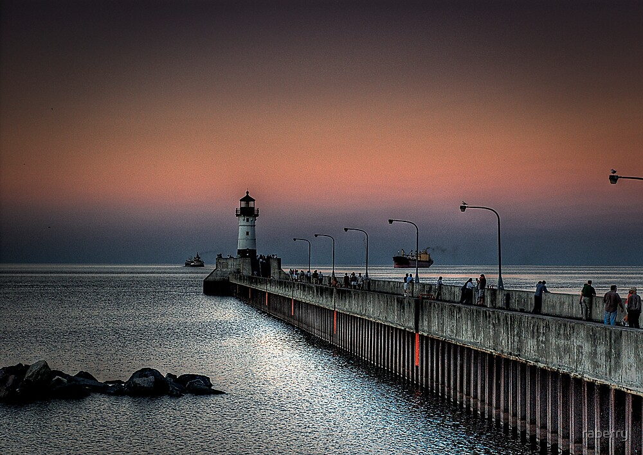
Share with each other all the judgments and expectations for the day and how your happiness was determined by your expectations being met or not being met. What are you willing to sacrifice within so that you may have “wild wonder?”

What did you learn about this incredible lake that you did not know before? Have you had an attitude of, “I’ve done it all and seen it all,” that closed your eyes to immediate wondrous experience. Are you living life, half dead with judgment and expectation or wondrously alive?

Practice: Do not deny your inner life-killing judgments and expectations. Be immediately present to them with the wondrous and infinite embrace of your loving being. Find amusement and humility and bring these to your little mean- spirited judgements and demands.
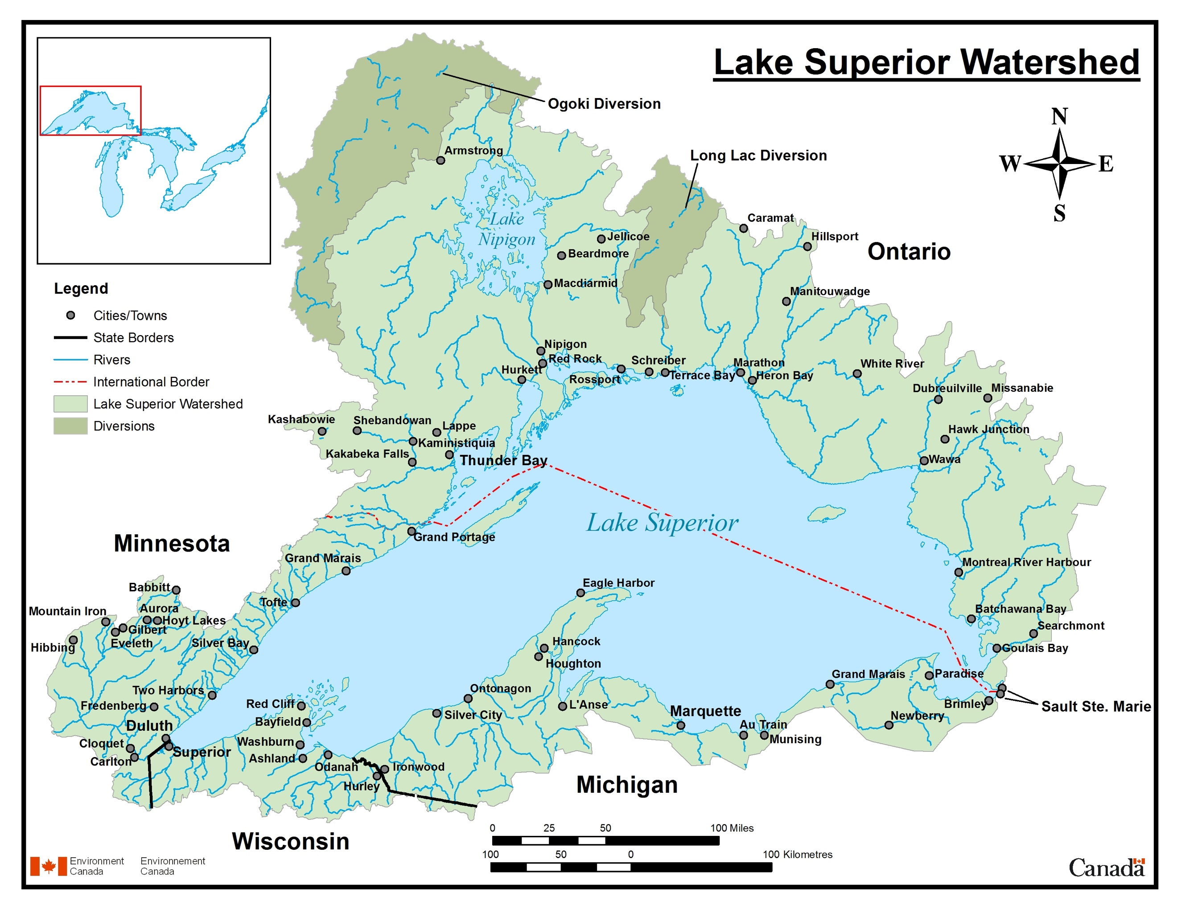
Lake Superior - Over 300 streams and rivers empty into Lake Superior with the largest source being the Nipigon River in Ontario. Contemplate this statement - what makes you superior in anyway?

1. Lake Superior contains 10% of all planet Earth's fresh surface water.
2. It covers 82,000 sq km (31,700 sq mi) with an average depth of 147 metres or 483 feet.
3. The deepest point in the lake is 405 metres or 1,333 feet.
4. There have been about 350 shipwrecks recorded in Lake Superior and Lake Superior is known to not give up her dead. Over 10,000 lives have been lost in her waters.
5. Lake Superior is, by surface area, the largest lake in the world.
6. It contains as much water as all the other Great Lakes combined, plus three extra Lake Eries!
7. There is enough water in Lake Superior to cover all of North and South America with water one foot deep.
8. There are 78 different species of fish that call the big lake home. Can you name them?
9. The maximum wave ever recorded on Lake Superior was 9.45 metres or 31 feet high.
10. If you stretched the shoreline of Lake Superior out to a straight line, it would be long enough to reach from Duluth, Minnesota to the Bahamas.
11. The average underwater visibility of Lake Superior is about 8 metres or 27 feet, making it the cleanest and clearest of the Great Lakes. Underwater visibility in some spots reaches 30 meters.
12. In the summer, the sun sets 35 minutes later on the western shore of Lake Superior than at its southeastern edge.
13. Some of the world's oldest rocks, formed about 2.7 billion years ago, can be found on the Ontario shore of Lake Superior.
14. It very rarely freezes over completely.
15. The average temperature of Lake Superior is 36°F or 2°C... very refreshing on a hot summer day!
16. The Trans-Superior International Yacht Race is the world's longest freshwater sailboat race.
17. Lake Superior has its own tide.
18. Changes in water levels are more noticeable from prevailing winds pushing water to the Eastern shore.
19. The dense basalts of Lake Superior acted like a wall or brake for the glaciers 18,000 years ago, which is why there is a driftless area in Wisconsin today.
20. Lake Superior had a song written by Gordon Lightfoot called The Wreck of the Edmund Fitzgerald. (Thanks to Karen)
21. If all water were drained from the North American continent, the low point of Lake Superior would be the lowest point of land on the continent. (Thanks to Jim I.) By Heather Bot: Heather is a staff writer at Algoma Country.
Friday October 1st 2021

“In all my close friendships, words are the bricks I use to build bridges. To know someone, I need to hear her, and to feel known, I need to be heard by her. The process of knowing and loving another person happens for me through conversation. I reveal something to help my friend understand me, she responds in a way that assures me she values my revelation, and then she adds something to help me understand her. This back-and-forth is repeated, again and again as we go deeper into each other's hearts, minds, pasts, and dreams. Eventually, a friendship is built - a solid, sheltering structure that exists in the space between us - a space outside of ourselves that we can climb deep into. There is her, there is me, and then there is our friendship - this bridge we've built together.” ~ Glennon Doyle Melton, Love Warrior

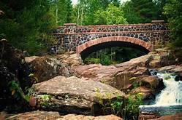

9.00 am Breakfast together in the meeting space

10.00 am Leave for the 7 Bridges drive - lunch on your own

3.00 pm Group

6.00 pm Dinner

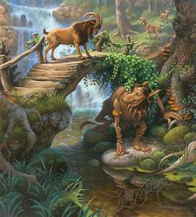
For your dinner conversation:

In building a bridge of words with another, inevitably the troll of fear and shame will rear its ugly head and you will have to befriend it, and see beneath the surface ugliness into the beauty, elegance and necessity of fear and shame in physical life.

To reach a more expansive consciousness you must befriend whatever is beneath the bridge. Consider the story of “The Bridge,” below, and contemplate what you need to sacrifice and die to, in order to move forward on your journey? What exactly was the inner process he needed to be aware of? What limit did he need to set with himself, not with the man who jumped off the bridge. How was this a loving choice, not a selfish choice? Tell a story of how you have lived this story on the bridge because of fear of the troll under your own bridge.

There was a man who had given much thought to what he wanted from life. He had experienced many moods and trials. He had experimented with different ways of living, and he had had his share of both success and failure. At last, he began to see clearly where he wanted to go. Diligently, he searched for the right opportunity. Sometimes he came close, only to be
pushed away. Often he applied all his strength and imagination, only to find the path hopelessly blocked. And then at last it came. But the opportunity would not wait. It would be made available only for a short time, if it were seen that he was not committed, the opportunity would not come again.
Eager to arrive, he stared on his journey. With each step, he wanted to move faster; with each thought about his goal, his heart beat quicker; with each vision of what lay ahead, he found renewed vigor. Strength that had left him since his early youth returned, and desires, all kinds of desires, reawakened from their long-dormant positions. Hurrying along, he came upon a bridge that crossed through the middle of a town. It had been built high above a river in order to protect it from the floods of spring. He started across. Then he noticed someone coming from the opposite direction. As they moved closer, it seemed as though the other were coming to greet him. He could see clearly, however, that he did not know this other, who was dressed similarly except for something tied around his waist.
When they were within hailing distance he could see that what the other had about his waist was a rope. It was wrapped around him many times and probably, if extended would reach a length of 30 feet. The other began to uncurl the rope, and, just as they were coming close, the stranger said,
“Pardon me, would you be so kind as to hold the end a moment?”
Surprised by this politely phrased but curious request, he agreed without a thought, reached out, and took it.
“Thank you,” said the other, who then added, ”Two hands now, and remember, hold tight.”
Whereupon, the other jumped off the bridge. Quickly, the free-falling body hurtled the distance of the rope’s length, and from the bridge the man abruptly felt the pull. Instinctively, he held tight and was almost dragged over the side. He managed to brace himself against the edge, however, and after having caught his breath, looked down at the other dangling, close to oblivion.
“What are you trying to do?” he yelled.
“Just hold tight,” said the other.
“This is ridiculous,” the man thought and began trying to haul the other in. He could not get the leverage, however. It was as though the weight of the other person and the length of the rope had been carefully calculated in advance so that together they created a counterweight just beyond his strength to bring the other back to safety.
“Why did you do this?” the man called out.
“Remember, “ said the other, “if you let go, I will be lost.”
“But I cannot pull you up,” the man cried.
“I am your responsibility,” said the other.
“Well, I did not ask for it,” the man said.
“If you let go, I am lost,” repeated the other.
He began to look around for help. But there was no one. How long would he have to wait? Why did this happen to befall him, now, just as he was on the verge of true success? He examined the side, searching for a place to tie the rope. Some protrusion, perhaps, or maybe a hole in the boards. But the railing was unusually uniform in shape; there were no spaces between the boards. There was no way to get rid of this newfound burden, even temporarily.
“What do you want?” he asked the other hanging below.
“Just your help,” the other answered.
“How can I help? I cannot pull you in and there is no place to tie the rope so that I can go and find someone to help me help you.”
“I know that. Just hang on; that will be enough. Tie the rope around your waist; it will be easier.”
Fearing that his arms could not hold out much longer, he tied the rope around his waist.
“Why did you do this?” he asked again. “Don’t you see what you have done? What possible purpose could you have had in mind?”
“Just remember,” said the other, “my life is in your hands.”
What should he do? “If I let go, all my life I will know that I let this other die. If I stay, I risk losing my momentum toward my own long-sought-after salvation. Either way this will haunt me forever.” With ironic humor he thought to die himself, instantly, to jump off the bridge while still holding on. “That would teach this fool.” But he wanted to live and to live life fully. “What a choice I have to make; how shall I ever decide.”
As time went by, still no one came. The critical moment of decision was drawing near. To show his commitment to his own goals, he would have to continue on his journey now. It was already almost too late to arrive in time. But what at terrible choice to have to make. A new thought occurred to him. While he could not pull this other up solely by his own
efforts, if the other would shorten the rope from his end by curling it around his waist again and again together they could do it. Actually, the other could do it by himself, so long as he, standing on the bridge, kept it still and steady.
“Now listen,” he shouted down. “I think I know how to save you.” And he explained his plan. But the other wasn’t interested.
“You mean you won’t help? But I told you I cannot pull you up myself, and I don’t think
I can hang on much longer either.”
“You must try,” the other shouted back in tears. “If you fail, I die.”
The point of decision arrived. What should he do?
“My life or this other’s?” And then a new idea. A revelation. So new in fact, it seemed heretical, so alien was it to his traditional way of thinking.
“I want you to listen carefully,” he said, “because I mean what I am about to say. I will not accept the position of choice for your life, only for my own; the position of choice for your own life I hereby give back to you.”
“What do you mean?” the other asked, afraid.
“I mean, simply, it’s up to you. You decide which way this ends. I will become the counterweight. You do the pulling and bring yourself up. I will even tug a little from here.” He began unwinding the rope from around his waist and braced himself anew against the side.
“You cannot mean what you say,” the other shrieked. “You would not be so selfish. I am your responsibility. What could be so important that you would let someone die? Do not do this to me.”
He waited a moment. there was no change in the tension of the rope.
“I accept your choice,” he said, at last and freed his hands.

Friedman, Edwin, H. Friedman’s Fables. Guildford Press. 1990

Sometimes, if you stand on the bottom rail of a bridge and lean over to watch the river slipping slowly away beneath you, you will suddenly know everything there is to be known.
~Pooh’s Little Instruction Book, inspired by A. A. Milne

The hardest thing to learn in life is which bridge to cross and which to burn.
~David Russell

We cross our bridges when we come to them and burn them behind us, with nothing to show for our progress except a memory of the smell of smoke, and a presumption that once our eyes watered.
~Tom Stoppard

Walls turned sideways are bridges. ~Angela Davis

People are lonely because they build walls instead of bridges. ~Joseph F. Newton

Let’s build bridges here and there
Or sometimes just a spiral stair.
~ Georgia Douglas Johnson

We are told never to cross a bridge until we come to it, but this world is owned by men who have “crossed bridges” in their imagination far ahead of the crowd. ~Speakers Library

When one burns one's bridges, what a very nice fire it makes. ~Dylan Thomas

Wise Solomon did not give the riches of his house to Shulamite; he gave her The Song of Songs, because poetry is a bridge uniting two hearts - stronger than bridges over waters, as fragile as the falling of a star. Solomon knew that, and poets who have come after him have known it, so poets should be seen as builders of bridges ... but never show them the complicated calculations for the construction, they won’t understand a thing. ... Whatever the waters underneath, people come to bridges and to poetry, their hearts, in all the rush, neglected, with their loneliness and their secret wishes. Unless they wish for power, glory and money. Those have no place on the bridges of poetry. Bridges of poetry, as all bridges, are love and understanding, two banks holding hands. ~Vizma Bel-evica

The spiritual is that realm of human experience which religion attempts to connect us through dogma and practice. Religion is a bridge to the spiritual - but the spiritual lies beyond religion. Unfortunately, in seeking the spiritual we may become attached to the bridge rather than crossing over it. ~Rachel Naomi Remen

"All the world's a stage,
And all the men and women merely players.
They have their exits and their entrances,
And one man in his time plays many parts,
His acts being seven ages. At first the infant,
Mewling and puking in the nurse's arms.
Then, the whining school-boy with his satchel
And shining morning face, creeping like snail
Unwillingly to school. And then the lover,
Sighing like furnace, with a woeful ballad
Made to his mistress' eyebrow. Then, a soldier,
Full of strange oaths, and bearded like the pard,
Jealous in honour, sudden, and quick in quarrel,
Seeking the bubble reputation
Even in the cannon's mouth. And then, the justice,
In fair round belly, with a good capon lined,
With eyes severe, and beard of formal cut,
Full of wise saws, and modern instances,
And so he plays his part. The sixth age shifts
Into the lean and slippered pantaloon,
With spectacles on nose and pouch on side,
His youthful hose, well saved, a world too wide
For his shrunk shank, and his big manly voice,
Turning again toward childish treble, pipes
And whistles in his sound. Last scene of all,
That ends this strange eventful history,
Is second childishness and mere oblivion,
Sans teeth, sans eyes, sans taste, sans everything."
-Act II, Scene VII, Shakespeare's As You Like It

