The Joy of Archbishop Desmond Tutu

“Discovering more joy does not, save us from the inevitability of hardship and heartbreak. In fact, we may cry more easily, but we will laugh more easily too. Perhaps we are just more alive. Yet as we discover more joy, we can face suffering in a way that ennobles rather than embitters. We have hardship without becoming hard. We have heartbreaks without being broken.” ~Desmond Tutu

This quote speaks to Tutu’s expanded state of consciousness of joy that is a big enough container to hold suffering, which is then transformed by the embrace. The greater our capacity to hold suffering in love, joy, peace, and truth, the greater our capacity to transform our suffering and then by extension the suffering of the world. How much more alive and awake is that experience than constricting down to a limited experience of life in ego defenses.
Joy is the natural expression of the Soul that is connected in awareness to Spirit. As is compassion, wisdom, and peace. The Pure Energy of Consciousness (God) is the great Shining Forth of Infinite Joy and Love within which each human life is held, has its origin, and will return to when the outer container of the body falls away. This is essentially what and who you are - a creation of this energy of joy, love, peace, and truth.

All aspects of your physical life and existence must be in allegiance and submission to this TRUE SELF who will lead you on a path to freedom in Joy.

The ego self is merely the thoughts and defenses that were created to protect you at a very young age from instinctual energies of shame and fear. It is a FALSE self, a very constricted and limited self, and the ego cannot be the leader or ruler of your life. If the ego leads, it will lead you down a path to prison, darkness, and destruction. Many ego defenses bring temporary “happiness and pleasure.” However, this is not joy …. It is an escape that leads further into the maze of inner misery. Tutu says, “Joy is much bigger than happiness.” This quote speaks to an expanded state of joy that he can be the container for experiences of happiness and pleasure and speaks to the fact that he did not try to find happiness to cover up misery, but intrinsically finds happiness in the pleasures of the world - does not use them to mask deep inner suffering as most people do. To use the pleasures of the world to mask suffering is to live in addiction and defense. This is very different to knowing yourself as joy and experiencing all pleasure and happiness in a state of JOY.

Archbishop Tutu, in complete submission to Spirit, lived from his TRUE SELF. It was completely evident in the sheer joy and exuberance he exhibited, and the complete authenticity with which he related to himself and others. As he said, “Become a reservoir of joy, an oasis of peace, a pool of serenity that can ripple out to all those around you.”

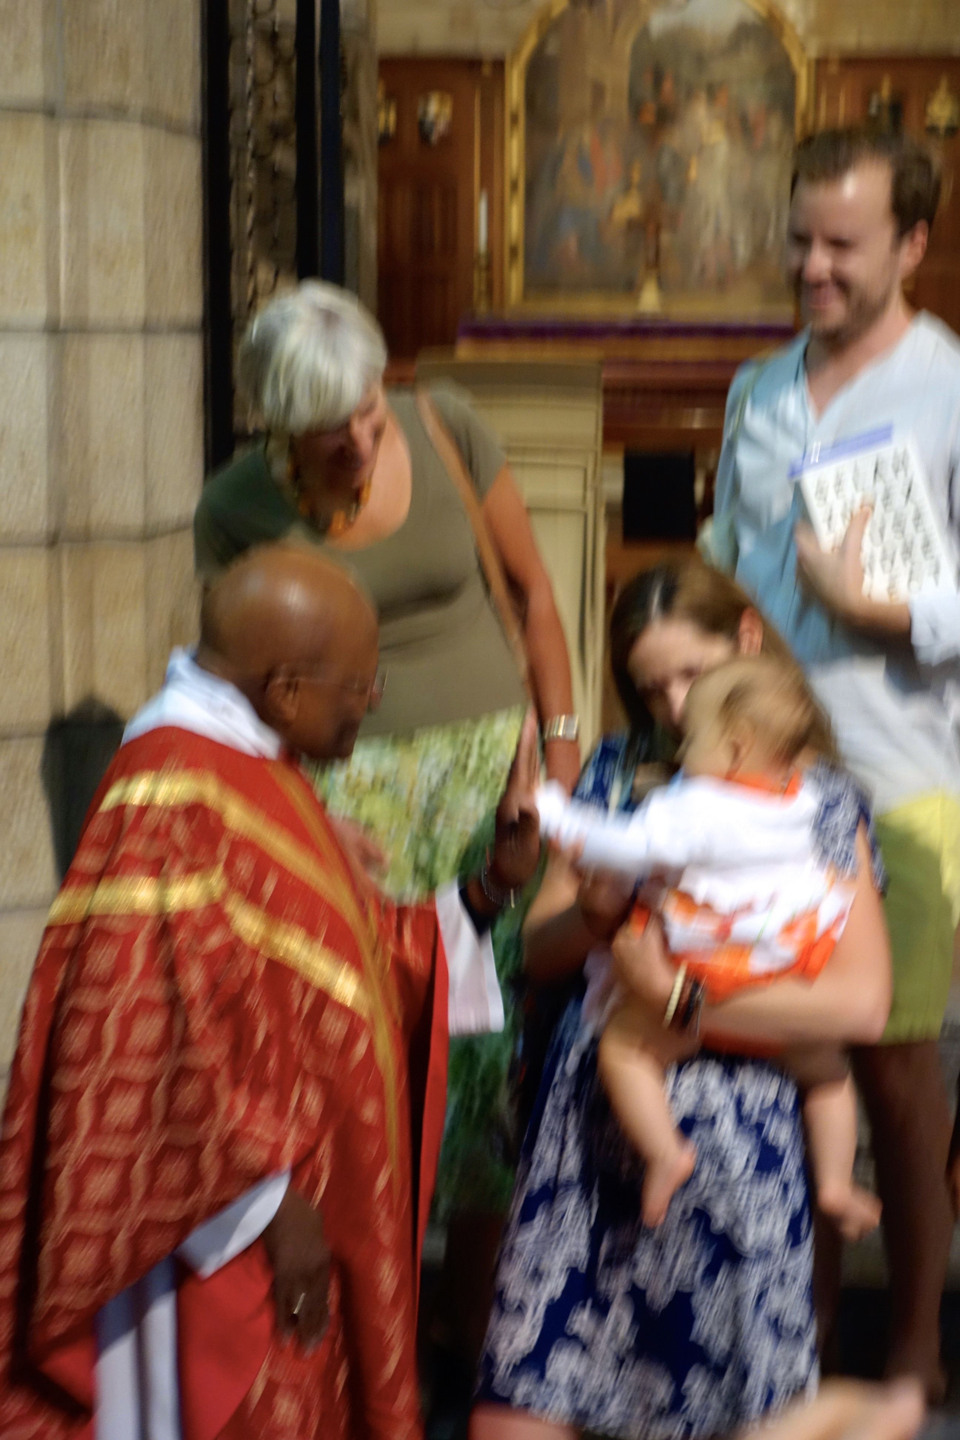
One of my most treasured memories of him was of him catching the eye of a baby of perhaps 8 months of age, being held by its mother after a service in St. George’s cathedral. It was as if the pure energy of God in the baby’s eyes, met the pure energy of God in Tutu’s eyes and they were, for 10 minutes, inseparable. They both chortled and laughed and made baby sounds of sheer delight at one another. It was communication in Spirit. His entourage of security and administration stood by impatiently - they had a schedule to keep for his day. He would have none of it. He waved them away and continued his visit with the baby. It is not that the Arch did not have sorrow and sadness in his life - it is just that he did not lead from it. He brought his joy to his inner sorrow and helped others find their joy and bring it to their suffering.

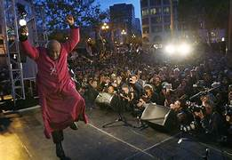
Dancing was another expression of his joy and his inner power. In South Africa it is called to toyi-toyi. It is a means of political protest that averted death and violence. Often multiple funerals of political dissidents, murdered by the security forces, were presided over by the Arch - perhaps 40 thousand people would gather in a soccer stadium for these events. The white security forces would be called out, knowing that mass violence could erupt. However, the Archbishop could feel the energy, understood the rage and underlying restlessness of the people gathered to mourn the loss of comrades. He would start the service with toyi-toyi-ing and singing that would channel the energy of violence by being expressed in song and dance averting outbreaks of rage into violence and more death, many, many times. Imagine the inner authority of a man who could do this. His soul was in command, not his fear and ego. He was afraid and angry, like any of us would have been, but his joy and his inner power and peace prevailed and lead the way, not his fear and rage. It is ironic that this crowd control terrified the South African forces.

Tutu had deep friendships around the world - with other remarkable people like Kofi Anan and the Dalai Lama. As with the incident with the baby, he would lock eyes with his friends in recognition, welcome, joy, laughter, and humor. These are men that did not sit riling each other up about the injustices of the world, but instead recognized in one another the Soul that will lead the way for the world to follow. The Soul that desires harmony, acceptance, mutuality, equality and love between all humans and species - and he showed what it could look like for all of us.

“We are fragile creatures, and it is from this weakness, not despite it, that we discover the possibility of true joy.”

Exercise

- Consider the ways you pursue outer pleasures, excitement, and addiction to cover up feelings of inadequacy, inferiority, and fear.

- Practice imagining yourself to be a container of joy within which you can hold your feelings of sadness, unhappiness, shame, fear, and misery. Do this every day with a specific feeling.

- Look others in the eye and smile - make it a practice

- Practice the art of welcome, joy and hospitality to others

- Do you live in your ego, or your Soul? What leads the way in your everyday life? Just notice without judgment.

