Ubuntu - the Vision of Tutu
“We are all connected. What unites us is our common humanity. I don’t want to oversimplify things - but the suffering of a mother who has lost her child is not dependent on her nationality, ethnicity, or religion. What, black, rich, poor, Christian, Muslim or Jew - pain is pain - joy is joy”. ~Desmond Tutu
It is impossible to understand the scope of Tutu’s humanity without understanding his deep roots in tribalism and a life lived close to the earth in an extended family life and village life where interdependence is lived and breathed, and most particularly when you are an oppressed people - your very survival is dependent on an understanding that we all suffer together, and we all have joy together - we are one. In our modern 3rd world existence, we have become ever more independent, individualistic filled with ego and self-interest, lacking in empathy and mutuality. We are gradually learning to recognize that this is destroying the planet. Tutu exhorted us repeatedly to have humility and recognize our deep interdependence on each other and all aspects of creation. We are one vast network of oneness.
Read the quote above. What Tutu knew was that we are ONE in our humanity - our fears, pain, grief, shame, inadequacies, distorted lenses, bad behaviors…. Our physical, genetic DNA. We all inherit this earth of suffering and duality. AND we are also ONE in joy - and love and peace and truth. We are ONE in our spiritual DNA. We are beings that can be present to our suffering and our joy and know both in full awareness - we mediate Heaven and Earth - see the attachment in Week 2.
The concept of Ubuntu or interdependence is summed up by him when he says, “A person with Ubuntu is open and available to others, affirming of others, does not feel threatened that others are able and good, based on a proper self-assurance that comes from knowing that he or she belongs in a greater whole and is diminished when others are humiliated or diminished, when others are tortured or oppressed.”

Interdependence is and ought to be as much the ideal of man as self-sufficiency. Man is a social being. Without interrelation with society, he cannot realize his oneness with the universe or suppress his egotism. His social interdependence enables him to test his faith and to prove himself on the touchstone of reality. ~Mahatma Gandhi

Here is a summary of some of the key concepts of interdependence and co-operation:

- Interdependence and collaboration do not mean consensus or even democracy - this might or might not be subsumed under the idea of interdependence. For instance, a democratic vote might mean choosing the most unloving outcome for the most people by the most people. E.g., to go to war out of revenge. Interdependence seeks the most loving solution for all parties concerned and seeks the best interests of all even if it does not win the popular vote or does not seem “fair.”
- Nor is interdependence about fairness or even equality in how we are treated and what we get in life. It is about learning to meet the genuine human needs of another freely and lovingly, including our own, and meeting people where they are at. (For example, a toddler may not think it is fair that mom spends more time with an infant.)
- It is to not submit to bullying or to comply with what another person decides they want from us to prove that their need is being met. It is not demanding that others comply with behaviors that we think will prove to us that our needs are being met. It is recognizing the difference between our genuine needs and our wants. E.g. I might want you to do some chores for me and then I will interpret this to mean that my need for love is being met. Wanting someone to do chores and needing love are two different things.
- Interdependence is about learning to meet our own needs by reconnecting with ourSelves and our Source. If we are not internally interdependent, self-loving, and self-respecting, chances are we will not be with other people either.
- It is dependent on the ability to have empathy and compassion for the experience of self and other without feeling the anxious desire to control, fix, rescue, enable, help, advise, change, self or other, trusting that presence, listening, and awareness are all that are required.
- Interdependence has a focus first and foremost on relationship and process, not commodity and outcome.
- Interdependence requires knowledge of the difference between control (trying to change self and other to manage my own fears) and limit setting (protecting self out of self-regard against the abuses of others and self)
- The capacity to be comfortable and non-threatened by difference - whether this is a stage of development, race, ethnicity, culture, or world view. The capacity to heal and bridge splits and breaks without in anyway being threatened by difference.
- The capacity to act in an interdependent and collaborative way presupposes an expanded state of consciousness that can understand and hold in awareness the paradox of both/and, instead of slipping into the dualistic thinking of either/or, black or white, right, or wrong.
- It is based, not on the morality of the dualistic mind, but the spirituality of embracing all as holy/whole with love and acceptance. This does not preclude but includes judgments (morality) - of behaviors, not persons. This is paradox that is hard for the intellect to grasp.
- The capacity to hold both/and in consciousness with the intention to be loving to myself and to the other. To be conscious of what is best for you and for me. To see that I have both masculine and feminine energies, whether male or female, that I operate at many different levels of awareness and am neither good nor bad by identity or definition but might act in ways that can be considered “wrong/bad/destructive” - in other words, again, to be comfortable and have insight into the realm of paradox.
- The ability to observe ego transactions in self and other with compassion, lightness and humor and firm limit setting when necessary. The ability to have fierce compassion for self and other.
- To be able to express with authenticity and humility ego functioning (fear, shame, need, dualistic thoughts and defenses) - neither owning them as identity, nor blaming others, rationalizing, excusing, projecting, or denying (etc.) this inner ego function.
- The capacity for self-observation with acceptance of self and willingness to change and grow.
- To not be abusive to self or other
- To not allow another to be abusive either to self or other
- Interdependence does not mean a lack of initiative, leadership, or hierarchy. It does mean that leadership, initiative, and decision making is done with respect, from a “win/win” attitude and from a clear and loving space that is not hindered by ego issues. Hierarchy is subsumed under a larger state of consciousness that sees all people as of equal value no matter what the differences in capacity or ability might be. Expertise is valued and there is a hierarchy in terms of education, knowledge, stage of development etc., subsumed under the value of mutual respect and value.
- The ability to listen deeply and be fully present to self and other with an understanding of motivation and the circular nature of cause and effect
- The ability to think creatively and out of the box to connect and find solutions, build bridges, and create connection
- The ability to understand similarity and difference but to find the common ground of our humanity

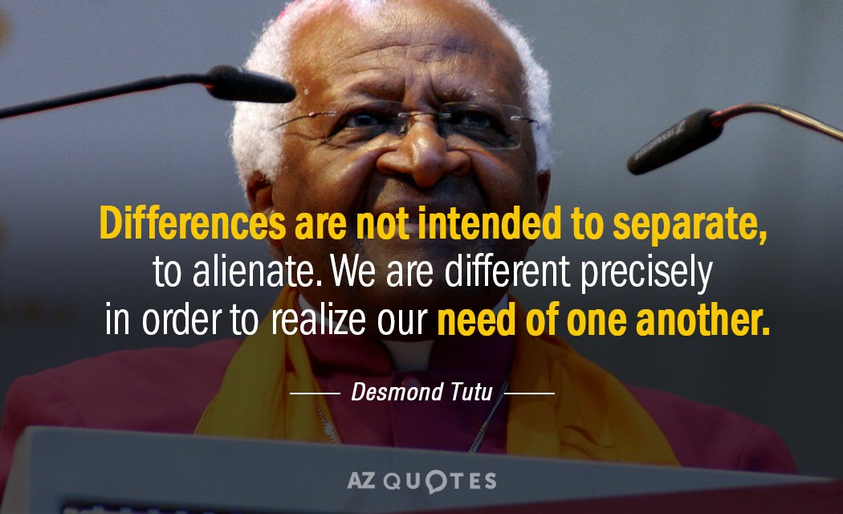

This is an advanced vision for humanity. Tutu not only understood it and preached it. He lived it in his work for equality for all regardless of any categorizations we have of humans on our planet.

"The infinite vibratory levels, the dimensions of interconnectedness are without end. There is nothing independent. All beings and things are residents in your awareness." ~Alex Grey

Exercise

Google and study the art of Alex Grey

Go through the list given above and assess your own life - how are you living a dependent/co-dependent, independent, or interdependent life. Can you recognize your dependent/codependent and independent patterns and dynamics? Can you write down goals for the year to work towards living within a unitive and integrated paradigm of interdependence in conscious and intentional awareness?

Try to understand and become aware of the motives, behaviors and consequences that destroy interdependence in your family system, society, and the world at large.

And if all this feels too heady for you read the story below and contemplate the ways in which you have faced the consequences of a narrow and selfish ego-centric and independent way of life.

THE MOUSE STORY

A mouse looked through the crack in the wall to see the farmer and his wife open a package.
"What food might this contain?" The mouse wondered. He was devastated to discover it was a mousetrap.
Retreating to the farmyard, the mouse proclaimed this warning:
"There is a mousetrap in the house! There is a mousetrap in the house!"
The chicken clucked and scratched, raised her head and said, "Mr. Mouse,
I can tell this is a grave concern to you, but it is of no consequence to me. I cannot be bothered by it."
The mouse turned to the pig and told him, “There is a mousetrap in the house!
There is a mousetrap in the house!" The pig sympathized, but said, "I am so very sorry, Mr. Mouse,
but there is nothing I can do about it but pray. Be assured you are in my prayers."
The mouse turned to the cow and said, "There is a mousetrap in the house! There is a mousetrap in the house!" The cow said, "Wow, Mr. Mouse. I'm sorry for you, but it's no skin off my nose."

So, the mouse returned to the house, head down and dejected, to face the farmer's mousetrap -alone.

That very night a sound was heard throughout the house - the sound of a mousetrap catching its prey.
The farmer's wife rushed to see what was caught. In the darkness, she did not see it.
It was a venomous snake whose tail was caught in the trap.
The snake bit the farmer's wife. The farmer rushed her to the hospital.
When she returned home she still had a fever.
Everyone knows you treat a fever with fresh chicken soup.
So the farmer took his hatchet to the farmyard for the soup's main ingredient:
But his wife's sickness continued.
Friends and neighbors came to sit with her around the clock.
To feed them, the farmer butchered the pig.
But, alas, the farmer's wife did not get well...
She died.
So many people came for her funeral that the farmer had the cow slaughtered to provide enough meat for all of them for the funeral luncheon.

And the mouse looked upon it all from his crack in the wall with great sadness.

So, the next time you hear someone is facing a problem and you think it doesn't concern you,
remember ---

When one of us in the world is threatened, the whole world is at risk.
We are all involved in this journey called life.
We must keep an eye out for one another and make an extra effort to encourage one another.

EACH OF US IS A VITAL THREAD IN ANOTHER PERSON'S TAPESTRY.

OUR LIVES ARE WOVEN TOGETHER

