Self-Forgiveness

"Self-forgiveness is a profound act of self-love and self-compassion that lightens our burden of guilt, (shame) calms our feelings of self-rejection, and ends our need for self-destructive behavior. It also frees our heart from self-inflicted pain and suffering." ~Marion Moss Hubbard, From The Heroic Path to Self-Forgiveness

Internal Steps to Take

- Become aware of the “sin” or “crime” – which may or may not be in accordance with the morality of the culture. So how do we even know when we have sinned? Whenever we create separation and conflict within ourselves or between ourselves and others out of our own unaware fear, shame and need. This is a much broader definition than obeying the rules of society. It might include your entire way of relating to yourself and current state of being.

- Own the behavior (confession) without denial, excuses, rationalizations, justifications, blaming or minimization. “Yes, I did it.” This is the first courageous step in self-responsibility requiring the quality of humility. If we feel so much shame for what we did then it is hard to humble ourselves and own it. Shame leads to defensiveness and to find the humility to take full responsibility requires a mature soul that does not decompensate into self-pity and shame. Shame can lead to further sins and crimes against yourself. If you become superior and judgmental about what you did, then you become a perpetrator to yourself E.g., “I can’t believe I was so damn stupid.” If you collapse into shame and self-pity, you abandon your own responsibility to be present to yourself with understanding and empathy as well as firm correction and so are both victim and perpetrator to yourself.

- Question yourself as to the feelings and needs underlying the “sin.” This is what motivated the reactivity in you and is what must be re-experienced, accepted, and loved.

- Ask yourself, “To what does this go back?” All feelings and needs that are still being acted on in an externalized way go back to childhood. They are in fact memory states.

- When you can see the deep suffering underlying the actions examine what is awakened in you? Judgment? Or the willingness to feel the pain of that suffering and love the one who is suffering? Judgment creates more separation, splitting, shame and hatred. In other words, you are now perpetrating on the victim and compounding the original sin with more sin. You are at war within yourself having become both perpetrator and victim, by introjecting the original judges in your life (authorities in your childhood).

- Self-forgiveness again requires a mature soul with a wide, open heart of love willing to revisit the original fear, pain and shame that was created in the young child-soul part of yourself through judgment by others. When your arms reach out in embrace of that wounded younger part of your own soul, you are indeed the mother reconciling with the child instead of chastising the child. (Create an image of the Madonna and child that shows this relationship – or find one that is a constant reminder to you of the work required here.) This work requires a certain maturing of the soul – a part that can witness suffering, be present to suffering, hold the suffering in a calm, non- anxious, loving way. There must be the sense of two – just sinking into the suffering with no witness present is self-pity and re-traumatization, not compassion.

- Once the feelings and needs are acknowledged, accepted, and loved by you, the acting out behaviors will naturally stop. You do not have to castigate yourself for defending against the pain in whatever way you have been doing and denying the suffering soul. (Sin and separation). The defenses served a purpose of protection until you were mature enough to relate to yourself in a loving and accepting way.

- When you reconnect, in love, with the suffering you experienced as a child and defended against until now in behaviors that are no longer needed, you have reconciled with yourself and there is nothing but insight, love, and so forgiveness. The pattern of unaware need and pain leading to behaviors that are destructive, is broken. Guilt and shame are replaced by acceptance and love and without guilt and shame there is no reason for the pattern of behavior to be repeated ever again. Change happens with the expansion in awareness.

- With this kind of deep understanding of yourself you will easily see how your actions may have harmed and hurt another leading to compassion for them, apology and restitution.

Only unaware people are unable to forgive themselves

"...if you feel that you have been "unjusted" and are looking for 'justice', you may be looking for the wrong thing. What would happen if you sought love instead? And what would happen if you gave love instead of seeking it? This might require a bit of forgiveness. Yet if you start with yourself, if you begin by forgiving yourself for all the things you may have done that were not okay with another, you will find it much easier to forgive another for what was done that is not okay with you." ~Neale Donald Walsch

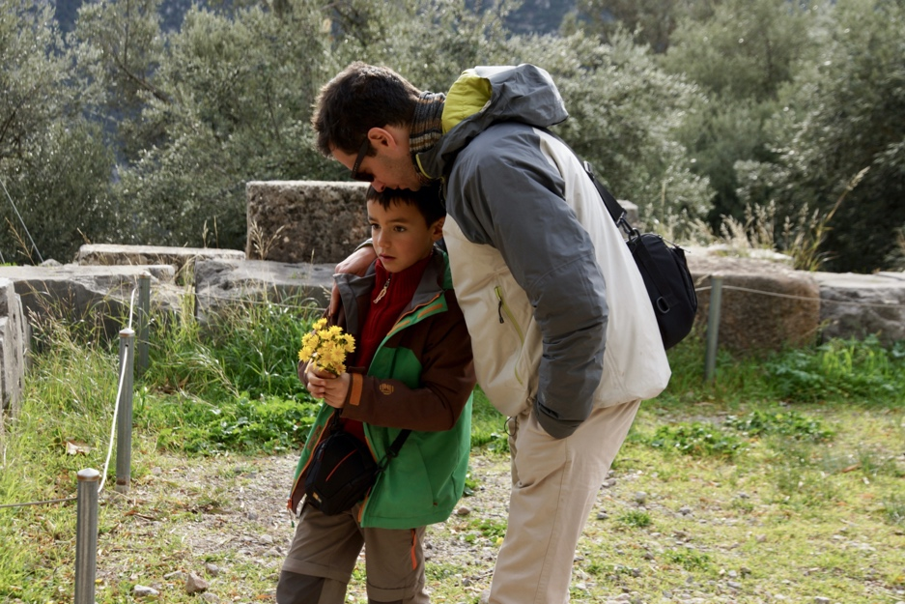

Exercise

A couple of years ago when I was at the ancient temple of Delphi, this little boy was chastised by his parents for being mean to his younger sister. He was filled with shame and guilt and started picking flowers to give to his sister as an act of contrition and apology. Then his father came over to him and I captured this tender moment. I do not understand Greek and do not know what he said, but his body language said a great deal. Create the imaginary dialogue of the forgiving father to his little boy – who is just a symbol of his own inner little boy. Use the steps above to create the dialogue of this modern-day Prodigal Son story.

“Take a walk through the garden of forgiveness and pick a flower of forgiveness for everything you have ever done. When you get to that time that is now, make a full and total forgiveness of your entire life and smile at the bouquet in your hands because it truly is beautiful.”
~ Stephen Richards, Forgiveness and Love Conquers All: Healing the Emotional Self

"Know all and you will pardon all." ~Thomas a Kempis

