Eight Principles of the Evolution of Consciousness

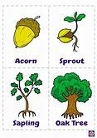
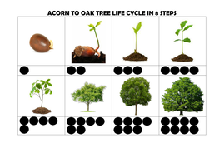
The first principle of evolution is elucidated in the quote by Rumi at the beginning of this section and alluded to in the first teaching. Every stage is enveloped and included in every previous stage - like Russian nesting dolls.

Nothing ever dies, it merely evolves and within this evolution, every previous stage is included and transformed. As I mentioned before, the acorn has not died, it’s potential has just grown into the oak tree. And so, it is for us. Every stage of development remains a part of the evolving self. Every stage and state of evolution is embedded within the soul in our ongoing growth, and our work is to relate to every aspect of this emerging self with complete acceptance, without shame, like an oak tree. It could be said that the acorn “died,’ but in fact it transformed and grew, achieving more and more of its innate and original potential. It might hurt the acorn to crack and grow, but “acornness,” must be sacrificed or surrendered to enable the next stage. Co-operation with the natural course of evolution is required. Unfortunately, we as humans have the capacity to refuse to co-operate. Think about this in your own life, where you have chosen to thwart the natural inclination and impulse to grow.

Exercise: Read this sweet book: Lori C. Froeb. The Acorn and the Oak Tree.

It is true that every living thing might or might not reach its potential - in humans as full awareness of themselves as consciousness - before the body dies and the spirit of the living thing joins again with the Spirit. Think about seeds - many are eaten or die before they even begin to grow. Many young trees are eaten and die before they reach maturity and so it is for humans too. Think of sperm - out of 9 million, only one will penetrate an egg and conceive a baby. Nature is necessarily prolific so that one or two might reach its fullest potential. It takes luck of environment. This is the parable of the seeds as taught by Jesus. Some seed falls on rocky ground, other seed is choked out by weeds and so on. Humans have a huge added advantage over nature. As the pinnacle and highest stage of evolution they have the capacity to co-operate with the process and manipulate the environment for maximum physical, emotional, intellectual, and spiritual growth, for the biggest number of people. See principle #8. To what extent have you, in full awareness, chosen to co-operate with Spirit in attaining your highest physical, emotional, intellectual, and spiritual growth?

The second principle is that Consciousness is not the same as awareness through all the stages of development. The goal of our earthly existence is for awareness to be as infinite, all inclusive, all powerful, ever present, and pure as Consciousness itself.

The entire evolution of the human starts with complete unawareness of itself as either being spiritual DNA /potential i.e., Consciousness, or having physical DNA. Awareness expands throughout the human lifetime if we co-operate with the process of becoming aware which is a prime purpose of Life and Consciousness, or if you like, “God.”

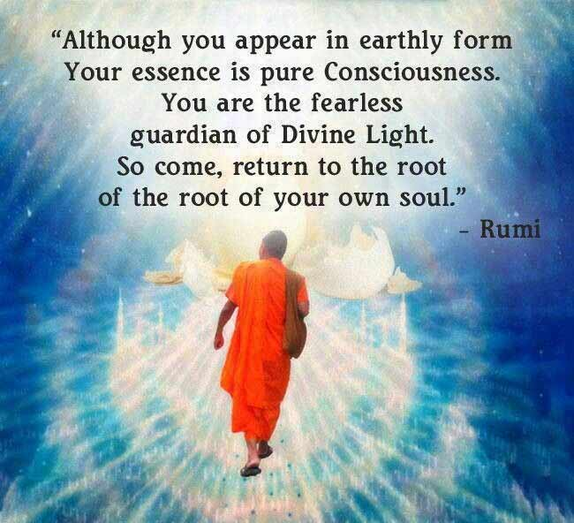
The task is, that over a lifetime you will come to realize yourself as a son or daughter of the Great Mother/Father, from whence you came. The purpose of life is for your awareness to fully match your Consciousness and be in harmony with Divine purpose and Divine Will - the energy of Absolute Love and Truth. When our lived experience in awareness is that we are Consciousness, then we have attained what is referred to as union with “God,” “Salvation,” or “Enlightenment.” It is when the flame joins with the Sun, the drop of the Ocean is One with the Ocean, when the child is reconciled to the parent as in the parable of the Prodigal Son.

Awareness goes through the experience of being in a finite body, this earthly experience. It is the very purpose of your life. The experience of a small drop of God involuting into matter, is the start of the evolving experience of becoming aware of oneself as Consciousness itself and returning to that original state with full awareness, through the lived experience of being a creature of matter.

The third principle is that an immutable law of Physicality in external Space and Time, is the principle of duality. Or an immutable law of creation is duality. We have already discussed the first duality. From the moment of conception, there is now matter and Spirit, married together in the form of a developing fetus. There is no longer ONE, but in experience and awareness, only, of TWO.

All the great creation myths of the world will allude to this. It is the story of the book of Genesis. Very simply, when we leave the realm of Spirit (the Garden of Eden, Paradise) and are born into the world, we have eaten of the tree of knowledge and experience of suffering that knowledge brings. We are embarking on the journey of gaining awareness of ourselves through our emotions, thoughts, needs and behaviors. The Great Mother of the Universe gives us the gift of life in form, which is a life of immense suffering in the dualities of this realm of consciousness and great pleasures in this realm of consciousness. We have “fallen,” so to speak into the earthly (or hell realms) realms of dualities in matter. The original split from Spirit to matter, is then replicated in every aspect of creation. There is not up, without down, no male without female, no good without bad and on and on. We can either be nailed to this cross of dualities (tree of knowledge) in unawareness feeling forgotten, rejected, shameful, frightened, and alone, or we can resolve the inner dualities in consciousness and become the Tree of Life. Within this cycle of life in duality, we have choice at every moment. We have the free will to decide to become aware of who we really are as spirit beings, or to stay unaware and enjoy the suffering and pleasures of life in unawareness.

Before we can ever become aware of the State of Consciousness of Spirit, we must experience the mirror image of this in the realms of physicality. It is the dualities of the experience of life, that brings us back to Unity with full awareness of who we are. Now awareness is matched to KNOWING, through experience, that we are infinitely Spirit and only temporarily and finitely matter. The entire experience was an exercise in awakening to knowing ourselves as infinite beings of Absolutely Love.

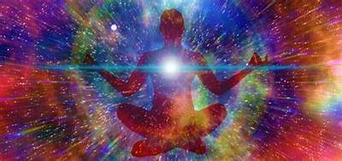
“We shall not cease from exploration
And the end of all our exploring
Will be to arrive where we started
And know the place for the first time.
Through the unknown, remembered gate
When the last of earth left to discover
Is that which was the beginning;
At the source of the longest river
The voice of the hidden waterfall
And the children in the apple-tree
Not known, because not looked for
But heard, half-heard, in the stillness
Between two waves of the sea.
Quick now, here, now, always—
A condition of complete simplicity
(Costing not less than everything)
And all shall be well and
All manner of thing shall be well
When the tongues of flames are in-folded
Into the crowned knot of fire
And the fire and the rose are one.”
~T.S. Eliot, Four Quartets

It is hard to express these principles in words of the intellect. T.S. Eliot the great mystic and poet conveyed this principle beautifully in the Four Quartets, that led to his recognition as the greatest living English poet and writer. In 1948 he was awarded both the Order of Merit and the Nobel Prize for literature. In this poem he uses the words of the great mystic, Julian of Norwich. The words “And all shall be well, and all shall be well, and all matter of thing shall be well,” are the words she uttered after sequestering herself in a tiny cell built next to the cathedral of Norwich to contemplate internally and relate to “God.” This was her revelation that she received through her many years of deep inner contemplation and inner work.

Basically, she is saying that in the end, when we are fully enlightened beings on this planet, when we the flames, are enfolded back into the great Fire, and when there is an integration of each soul with the Great Mother/God symbolized by the Rose, then all shall indeed be well, but not till then. This short poem outlines the cycle of life, the purpose of life, and the end purpose of evolution.

A fourth principle of evolution is that there is increasing capacity for self-agency in terms of movement. A rock is incapable of moving itself. A plant or tree stays firmly rooted in the ground. Gradually life forms evolved that could creep on the ground, like snakes, swim in the seas, fly in the sky, swing from trees, and finally walk on land. Consider how this is replicated in your own life. As a newborn you could not even hold your own head up by yourself or sit alone. Gradually you evolved, through an innate drive, with which you co-operated, to crawl or scoot and finally you persevered until you could walk. We are talking here about physical development, but the same is true of our emotional, intellectual, and spiritual growth in awareness and learning. Innately, you are programmed to greater and greater movement and autonomy. You become more and more capable of meeting your own needs through this movement, instead of being dependent on others to meet your needs.

Watch this adorable short video on evolving capacity for movement:

https://video.search.yahoo.com/yhs/search?fr=yhs-ima-remarklist&ei=UTF-8&hsimp=yhs-remarklist&hspart=ima&p=the+evolution+of+movement&type=q3020_D3MYO_gps_bsfq#id=3&vid=ac7a778894bf99925fd92377171b0dc2&action=click

and then this one:

https://video.search.yahoo.com/yhs/search;_ylt=AwrCwGG4tXJiyVMAxRUPxQt.;_ylu=Y29sbwNiZjEEcG9zAzEEdnRpZAMEc2VjA3BpdnM-?p=gymnastics&type=q3020_D3MYO_gps_bsfq&hsimp=yhs-remarklist&hspart=ima&ei=UTF-8&fr=yhs-ima-remarklist#id=2&vid=1b1fd0c047cfcb3097b22c2db01ff3e9&action=view

Greater freedom brings inherently bring with it greater freedom, greater differentiation, individuation, separation and dis-identification with the natural world. Think about this statement carefully and see if you can see how this is true in your own life. A tree does not know itself as separate from its environment. Can you see how you became aware of yourself as a separate being, and how you then asserted yourself as this separate being around age two? We will cover much more on this in understanding our own human development later.

The fifth principle is integrally linked to the fourth and that is evolution moves from less complexity to much greater and greater complexity. The evolution from amoeba to Human represents a staggering development of complexity of functions, processes, and dynamics. And this is true in terms of emotions, intellect, and spiritual development too.

Greater complexity goes hand in hand with more fragmentation and dissection of life. This means that the whole is broken into pieces in perception and experience. You can get focused on one aspect of the whole and mistake it for the whole, because attention cannot hold the whole complexity in awareness at certain stages of development. This is what we see in modern medicine, for example - specialization with an awareness of deeper and deeper understanding of the complexity of each part of the body. Start noticing this in yourself - how do you focus in on a detail and forget the whole. How does this, for example, impact our environment? Example, I see that a tree also has multiple uses - from furniture to paper as I discover the complexity of a tree. It is no longer just a plant that gives shade. I focus on the goal of furniture and paper and do not even see the complexity and interconnection of that one tree to the forest, or the forest in relationship to the environment. Becoming aware of complexity withing the whole is a both/and that is hard to achieve in awareness.

Greater complexity and differentiation then give rise to relationship between separate beings. Separation and differentiation can then lead to relationship and connection. Without this separation there can be no aware relationship. It is this separation from Oneness that results in the possibility of loving relationship and unity again, in awareness.

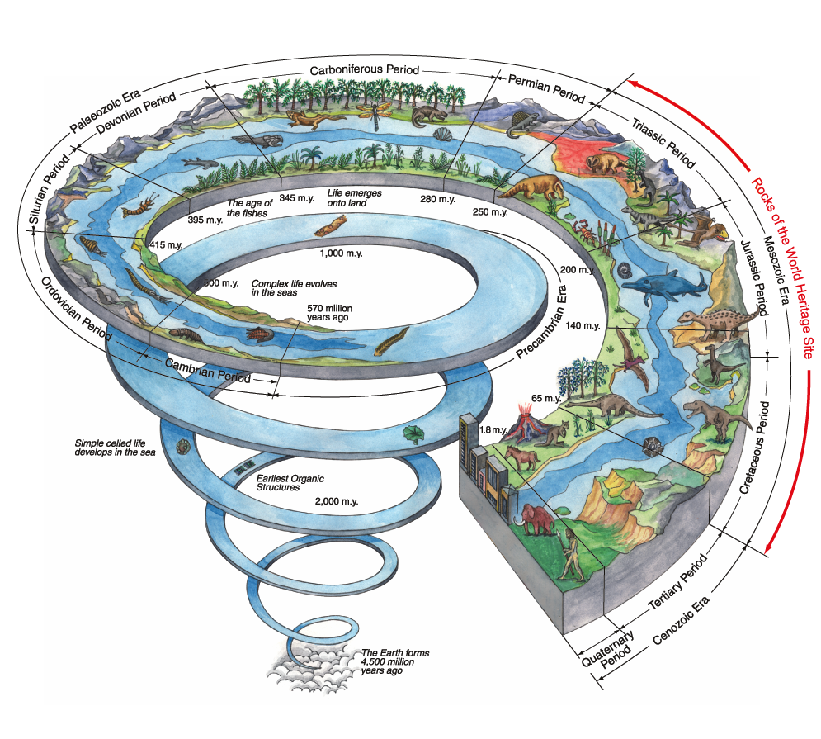

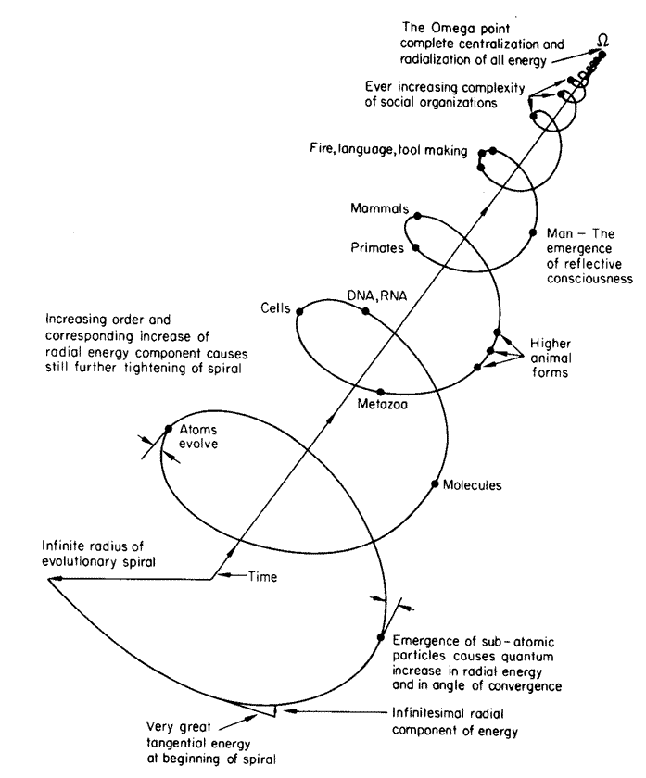
For additional reading: https://tomprof.stanford.edu/posting/1110

The sixth principle of evolution is that no stage of development can be skipped. It is an organic process of growth. All we can do is co-operate and produce the optimal conditions for growth to happen, through our inner work and practice. However, humans see the end goal and try to skip all the way there. They try to cheat! It cannot be done. And even if your artificially attain a higher state of consciousness, your stage of development will not match the state and so you will fall off the ladder all the way down to the stage at which you are naturally are. Sort of like the game of Snakes and Chutes! This attempt at spiritual by-pass is very common. We as humans can get an idea of what an enlightened being should look like and then act that way with some success, until you are triggered into some dark unaware issue and then you tumble from the lofty idealized place right down into the wound and untended suffering of your life. The work psychologically and spiritually is as stage dependent as the natural course of evolution. You cannot jump from acorn to oak tree - that is fantasy. Knowing all the stages and states of this process is incredibly helpful in helping you know where you are and what the next step is. But every step must be walked. The map is not the terrain. The finger pointing at the moon is not the moon.

The seventh principle of evolution is that every stage of universal evolution is replicated in the life of every new human born to the planet in an amazingly accelerated way. Modern science has enabled us to track this evolutionary process in the developing fetus. We watched our granddaughter evolve from something as big as a poppy seed to a full human being, in the course of 9 months. Each ultra-sound image showed greater complexity, greater freedom, greater differentiation, greater self-agency (e.g. sucking her hand in the womb), until she could survive as a separate human life. Every single principle was evident and this amazing capacity of humans to create the possibility to watch this in the womb gave us a greater capacity to relate, to connect to love. She went through all the stages of evolution from the big bang (conception) to being a little fish like being with gills all the way to being a fully-fledged human within 9 months. Look at the diagram above and see if you can feel the wonder of a human traversing 14 billion years of evolution within 9 months. Every single stage of evolution is enveloped and included in her creation. Humans first appeared on the planet approximately 100 00.00 years ago. The evolution of the human being is utterly miraculous and brings us to the eighth principle of evolution. Not only is every previous stage of evolution within, but within the last
12 000.00 years the earliest humans have evolved from primitive hunter gathers without language to the highly sophisticated tool users we are today with the capacity for self-awareness. We are the only species capable of such a quantum leap in evolution - self-awareness. And self-awareness - being at the very top of the evolutionary chain brings great responsibility

The eighth principle of evolution - the highest stage of development means the greatest amount of choice and therefore the greatest responsibility. For the first time evolution is not evolving naturally according to the innate spirit and consciousness within everything, but this process is now shared with humans that have choice through awareness. We can choose to co-operate with the natural creation towards love and unity, or we can choose to remain ignorant, unaware and use our choice to destroy all that Spirit has created.

Read this paragraph again. Feel the depth and breadth and scope of this choice. Consider how this choice is used daily in our world, and daily by you. How do the scales fall for you personally?

This is not comprehensive - it is a brief introduction. You can do further research and reading and learn to co-operate with the inner natural drive to self-actualizing your potential!

