Fruits of the Spirit – Patience/Forbearance, (not apathy and despair)

Once a small boy was playing by the river when he saw an old, old man with a long beard sitting with a stick in his hand. He was drawing on the sand a completely perfect circle.
The boy was impressed, and he ran over to the old man and asked him, “Hey old man, how did you manage to draw such a perfect circle?”
The old man looked at him and simply said, “Well, I tried and tried and tried. Here you try.” He handed the little boy his stick and the boy tried.
At first his circles were all crooked, long, or wide, but slowly, slowly he got better and better. He kept trying and trying until one day he managed to draw a completely perfect circle.
He then heard a little boy’s voice behind him saying. “Hey there old man, how did you manage to draw such a completely perfect circle?”

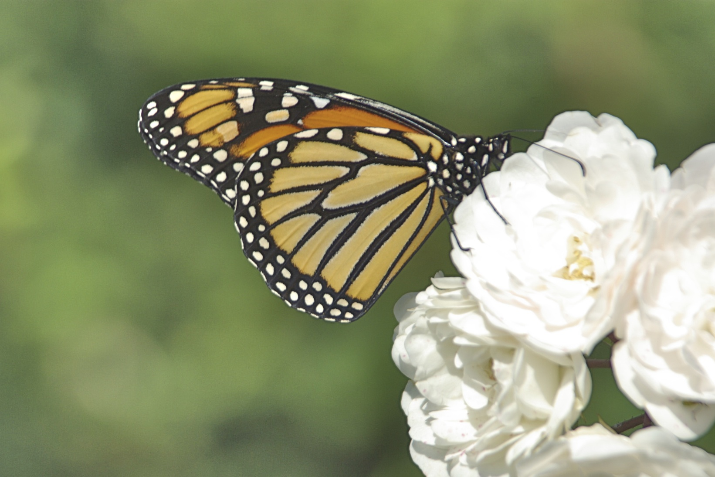
I am hoping that all of you will get to see the movie on the Monarch butterfly at the Science Museum. It is the moving story of Fred Urquhart’s life-long pursuit of trying to discover to where the Monarch butterflies flew each fall, down from Canada. The movie starts with him as a small boy, fascinated and in love with all nature around him- but especially with the monarch butterfly. It shows the free, spontaneous joy and curiosity of a child and goes on to talk about how Fred followed his love of nature to become a zoologist. He married Norah Patterson, a fellow teacher and lover of nature, and together they worked tirelessly and patiently to find out everything about the monarch butterfly. It ends when he is an old man and finally sees and discovers the spot in the Sierra Madre mountains in Mexico where the butterflies winter. The movie is a feast for the eyes and the heart. It is also a metaphor of the hero/ine’s journey and the patience that is born of great love and passion. It shows us what spiritual discipline really looks like – being a disciple of your heart with forbearance, patience, dedication, and persistence. Fred followed this golden thread of passion until he stood, as an old man, in the midst of millions of monarchs. As he glanced down, he saw the proof of his work – a butterfly with a tab on its wing that had been tagged in Minnesota by one of his volunteers.
One of the ways my child’s heart was captivated was the first time I saw a ballet. I wanted to stand on my toes in little pink shoes and have a tutu and dance in Swan Lake. My heart was afire with desire and a vision of beauty and the freedom of flying, as I had seen the dancers in Swan Lake do.
My mother warned me, “If you start, you need to continue – I am not wasting money buying all you need and lessons if you are going to just give up. If you start something, you finish it to the best of your ability!” I promised faithfully and happily. Little did I know what lay in store for me!
Duly warned, I endured the shaming of the ballet teacher rather than the wrath of my mother. My 5-year-old passion was quickly doused in the ice-cold water of a fierce and demanding teacher from the Royal Ballet School. She terrified me. I couldn’t keep time to the music. She had a stick to poke in your back if you posture was not correct. She barked at and shamed the kids. I felt humiliated and stupid most of the time. I quickly realized that getting pretty pink toe shoes required years of hard work in black pumps with a witch from hell. I was miserable.
I did not learn discipline/discipleship; I learned obedience to fear and shame. I learned to not give up but push through despite my dread of her classes. It was one of the ways I was being prepared me to be able to endure disrespect later in my life. I thought of myself as good, brave, strong, and persevering. Later in life I had to learn that patience does not mean allowing others to treat us poorly. It requires of us a firm and loving ability to set limits – no patience with bad behavior and endless patience with those that are struggling to birth their loving selves.
My joy was extinguished. I became mechanical and correct. I finally, happily, escaped when the teacher told my mother that I was absolutely tone deaf and would never amount to anything, even if I could do the moves. I was clearly not going to meet her need to have successful students that passed exams and made her look successful.
Years later, one of my spiritual teachers- who had not heard this story- looked at me and said, “Lyndall, why does a dancer dance across a stage?” I had no idea… to earn money, to succeed, to be famous? The thoughts raced through my mind, but I stared at her blankly. She looked at me gently and said, “For the joy of it. Not to move from one side of the stage to the other, but just for the joy of it.” And I remembered – yes, for the joy of it!
There is a world of difference between high achievement because of fear and shame and the creativity that flows freely through a relaxed body and soul.
Each one of you has a story like this in your lives. How many times have you not tried something because of your fear of not being able to do it, or because you believed you could not do it perfectly, or at least “well enough?”
How often have your own judgments, anger, and impatience welled up inside of you? Far better to just avoid trying, right? This is a stance of despair, discouragement, and hopelessness towards yourself.
And how have you driven yourself to succeed at something, even when it was not really an interest, just to prove to yourself or someone else that you “damn well will master this?” Both of these thought patterns are in response to shame and fear, and neither serve us well.
Of course, our impatience is projected on to everyone else in our lives. We are impatient if it takes too long, is not done to our satisfaction, or if there is failure. How have you projected your impatience onto others? Do you believe that things must be done perfectly and NOW?
Patience is born of love and longing. It is born of vision for and of an ideal of freedom, harmony, and beauty. It is a function of the creative soul. I wonder when this whole evolutionary process might have ended if the creator was as impatient as my ballet teacher!
How impatient are you with your own spiritual practice? Meditation didn’t bring any magnificent results in a week? A month? A few years? Hmmm. Are you like my ballet teacher with yourself? Or can you be lovingly present to and patient with yourself, neither giving up nor driving yourself with demands, expectations, and criticism?
Patience is a state of being both relaxed and attentive. Being patient with yourself means accepting even when you head is full of judgments and “to do” lists. Do you get impatient with yourself for still being obsessed and attached to fear and shame? You are creating more fear and shame with this attitude.
The inner teacher is one who encourages you and is patient with failure, knowing that only failure will ever bring success. Failure is learning. The inner teacher is the one who accepts you and reminds you to stay attentive and relaxed; the one who says, “just stay with the process, it is the process that matters- not the end result,” even as you hold the vision and longing as sacred. The real teacher within is the one who reminds you of your infinite worth and lovability – and that this worth is intrinsic, not extrinsic, given and not earned. The inner disciple is the one who submits to this teaching with faith and follows the golden thread of patience and practice. It is the one who is disciplined to the vision, the heart, and the ideal- with no guarantee of outcome.
The more patient you are with yourself, the more you are co-operating with your own evolution in consciousness.
Fred followed his dream to find the butterflies with no guarantee that in his lifetime he would ever find their wintering place. Even if he had not experienced the joy of finding the butterflies, his work would have laid the ground for others to do so and his life would still have been filled with purpose and meaning. This whole evolutionary process is not about you personally – it is far larger than you and your life. You must just be a willing and patient participant in the process – whatever benefits this brings or does not bring. Like the butterfly, your own metamorphosis will happen despite you, so you may as well co-operate with the process. Your patient practice contributes to the entire process, not just your individual life. And this is enough.
~ ©2014 Lyndall Johnson


“I beg you to have patience with everything unresolved in your heart and to try to love the questions themselves as if they were locked rooms or books written in a very foreign language. Don’t search for the answers, which could not be given to you now, because you would not be able to live them. And the point is to live everything. Live the questions now. Perhaps then, someday far in the future, you will gradually, without even noticing it, live your way into the answer. Make your ego porous. Will is of little importance, complaining is nothing, fame is nothing. Openness, patience, receptivity, solitude is everything.” ~Rainer Maria Rilke

Prayer of an Anonymous Abbess

Lord, thou knowest better than myself that I am growing older and will soon be old. Keep me from becoming too talkative, and especially from the unfortunate habit of thinking that I must say something on every subject and at every opportunity.
Release me from the idea that I must straighten out other peoples' affairs. With my immense treasure of experience and wisdom, it seems a pity not to let everybody partake of it. But thou knowest, Lord, that in the end I will need a few friends.
Keep me from the recital of endless details; give me wings to get to the point.
Grant me the patience to listen to the complaints of others; help me to endure them with charity. But seal my lips on my own aches and pains - they increase with the increasing years and my inclination to recount them is also increasing.
I will not ask thee for improved memory, only for a little more humility and less self-assurance when my own memory doesn't agree with that of others. Teach me the glorious lesson that occasionally I may be wrong.
Keep me reasonably gentle. I do not have the ambition to become a saint -- it is so hard to live with some of them - but a harsh old person is one of the devil's masterpieces.
Make me sympathetic without being sentimental, helpful but not bossy. Let me discover merits where I had not expected them, and talents in people whom I had not thought to possess any. And, Lord, give me the grace to tell them so.

Exercises

Write your own prayer for patience – Remember to address it to your Self _ the Lord/Lady within.
When in your life have you experienced “flow” – when things happened effortlessly?
When in your life have you put up with bullshit – and called this patience?

Look up and read about the endangered Brenton Blue Butterfly in Knysna: http://www.brentonblue.org.za

